
Jolly Helmet
Make your Helmet Happy Again!
Clean it. Dry it.
Wear it happy.
Coin-operated helmet cleaning and drying stations
MEJES, JERAHMEEL ALZEL M.
CRUZ, DEAN RYAN P.
MENDOZA, RICAH S.
MARTOS, KRISTINA E.
DEVELOPERS AND DESIGNERS
USER MANUAL

Contents
Customer guide 2
Meet the machines 2
Before you start 3
Box 1 - Cleaner 5
Box 2 - Dryer 8
Box 3 - Cleaner + Dryer 9
Prices and time 11
Special screens and safety 12
Admin guide (Control Center) 14
Connecting 15
Home page 15
Box settings (rules, levels, phases) 16
Screen refresh and maintenance 19
Refill station (ACS) 21
Troubleshooting and care 23
Online page (Monitor, Alerts, Reports) 24
Technician guide (Hardware, online monitoring and maintenance) 30
How it is built 31
Component list 33
Pinouts 35
Circuit and wiring 39
Firmware and flashing 44
Online monitoring 46
Maintenance 53
Hardware troubleshooting 55
Reference (Safety, charts, settings and index) 56
Safety and emergencies 57
Box flowcharts 60
Troubleshooting decision trees 67
Settings reference 75
Circuit schematics 80
Policies 86
Glossary 88
Version and revisions 91
Index 93

Customer guide

Welcome to Jolly Helmet!
A self-service station that cleans and dries your motorcycle helmet while you wait.

Meet the machines
There are three Jolly Helmet stations. Each one has a touch screen, a coin slot and a door. Pick the one that fits what your helmet needs.

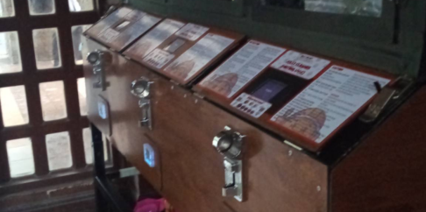 | 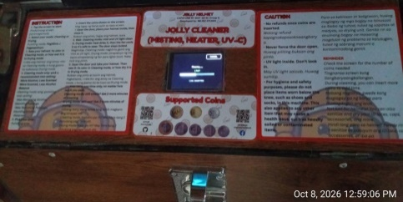 | 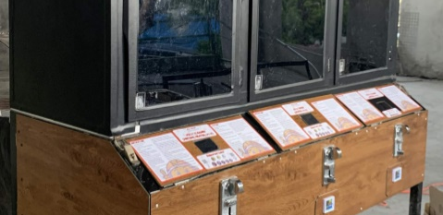

Station | What it does
Box 1  Cleaner | Removes odor. UV light plus a fine mist of alcohol, scented liquid, or both.
Box 2  Dryer | Dries a wet helmet with warm air, then cools it down before you take it out.
Box 3  Cleaner + Dryer | One station, two modes. Choose CLEANING or DRYING on the SELECT MODE screen. CLEANING is offered only when the cleaning liquid is high enough; otherwise only DRYING.

Tip / Paalala: Pwede mong gamitin ang Box 1 at Box 2 nang magkasunod: linis muna, tapos tuyo.

Which machine is free?
Look for the QR sticker on the machines. Scan it with your phone camera. A page opens that shows Box 1, Box 2 and Box 3 as FREE, IN USE (with about how many minutes are left) or OUT OF ORDER. You do not need an app or a password. The button at the top changes the language between English and Filipino. When a machine is running your cycle you may also tap Add your name on its card and type a nickname (12 letters at most). Everybody who opens the page sees it, so use a nickname, not your full name. It disappears by itself when your cycle ends.
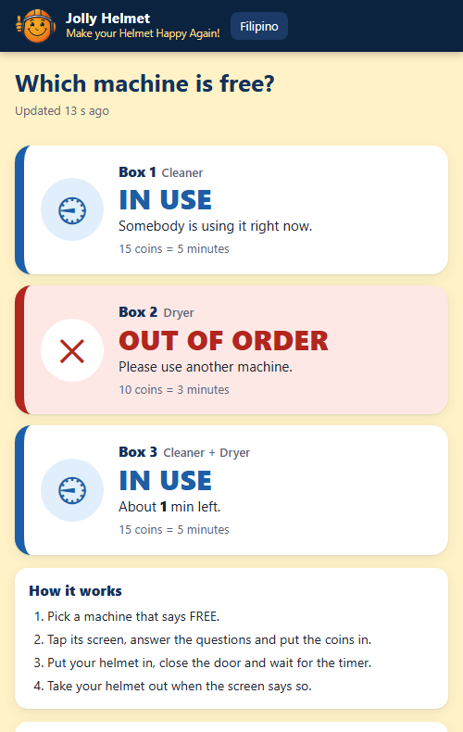
The customer status page: which machine is free (phone)

Tip / Paalala: I-scan ang QR sticker para makita kung aling makina ang libre. Pindutin ang "Filipino" sa itaas ng page.

Before you start
You need: your helmet and coins. The machine counts coins by value: a one-peso coin counts as 1.

How the touch screen works
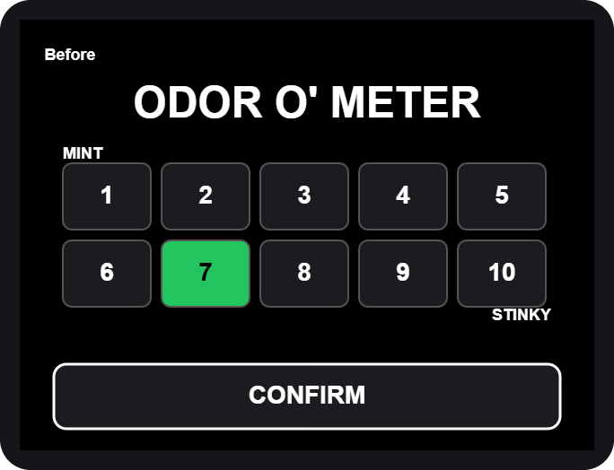  Rating grid: tap a box 1-10, then CONFIRM | 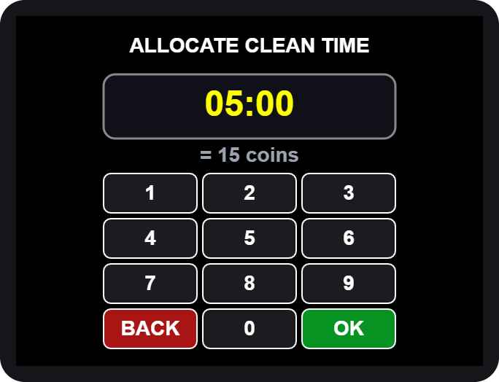  Number pad: type the minutes and seconds, then OK

- Big words (yellow) tell you what to do next: OPEN, PLACE, CLOSE, TAKE.
- Buttons are the dark boxes with white words. Tap them once.
- The screen blinks briefly now and then. This is normal, it refreshes itself.

Never put your hand in while the machine runs. If you open the door, the machine pauses by itself.

Box 1 - Cleaner
  1. Tap anywhere to START | 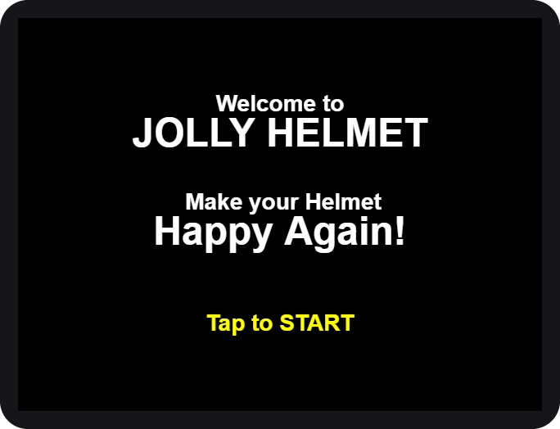  2. Welcome

- Wake the machine. Tap anywhere on the screen. For a moment it says "Please Wait" while it checks its alcohol and scented liquid.
- Tap to START on the welcome screen.

If the screen says OUT OF ORDER, the station needs refilling or service. Please tell the staff.

Rate it and choose the mist
3. ODOR O' METER | 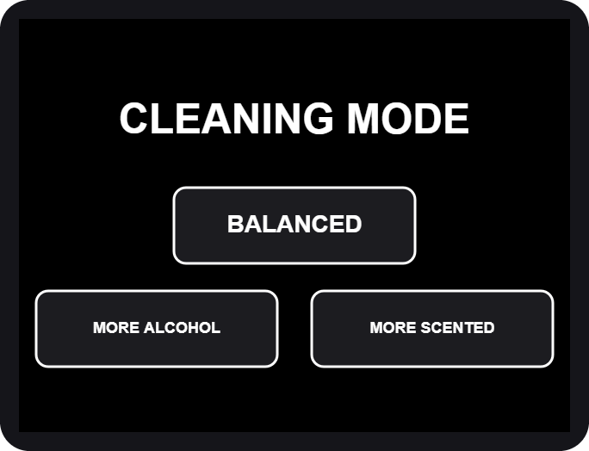  4. CLEANING MODE

- Rate the smell. Tap 1 (MINT, fresh) to 10 (STINKY), then CONFIRM. The worse the smell, the more time we suggest.
- Choose the mist. BALANCED uses both liquids, MORE ALCOHOL is stronger against germs, MORE SCENTED leaves a fresher scent.

Pick the time and pay
5. ALLOCATE CLEAN TIME | 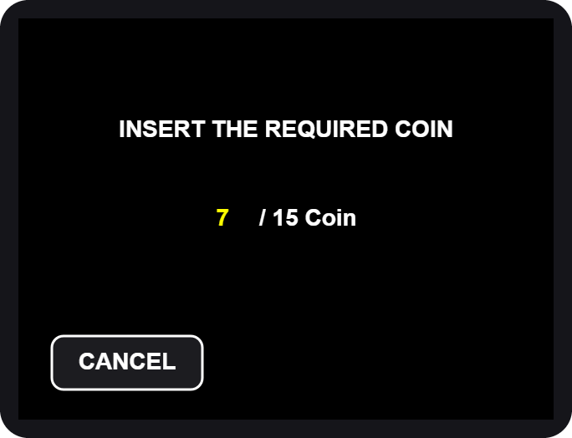  6. INSERT THE REQUIRED COIN

- Allocate time. The pad shows the time we suggest for your rating. Type a different time if you like, then tap OK. The shortest time and the longest time are shown if you go outside them.
- Insert the coins. The screen counts up: coins inserted / coins required. When it is enough, the machine moves on by itself.

Extra coins beyond the price give no extra time and are not refunded. Tap CANCEL before paying if you change your mind.

Load your helmet
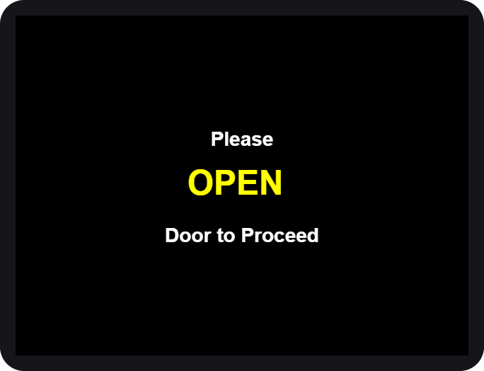  7. OPEN | 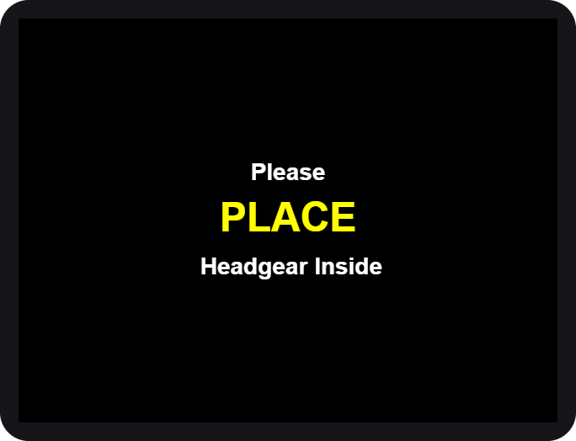  8. PLACE | 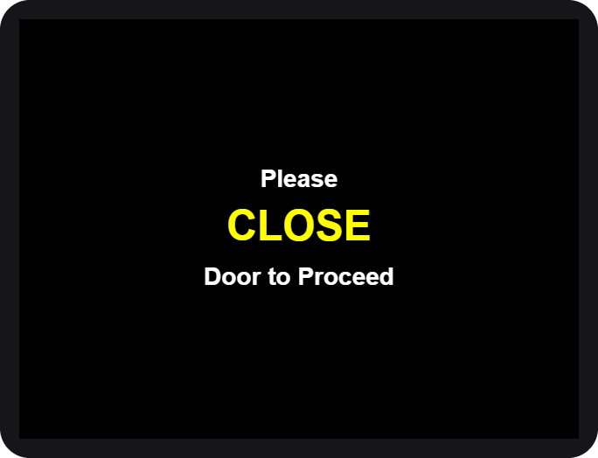  9. CLOSE

- OPEN the door when the screen asks.
- PLACE your helmet inside, opening facing the front, then step back.
- CLOSE the door. The machine checks that the door is shut and the helmet is inside, then starts.

If you see HELMET NO DETECTED, the machine did not see your helmet. Open the door and place it again.

While it cleans
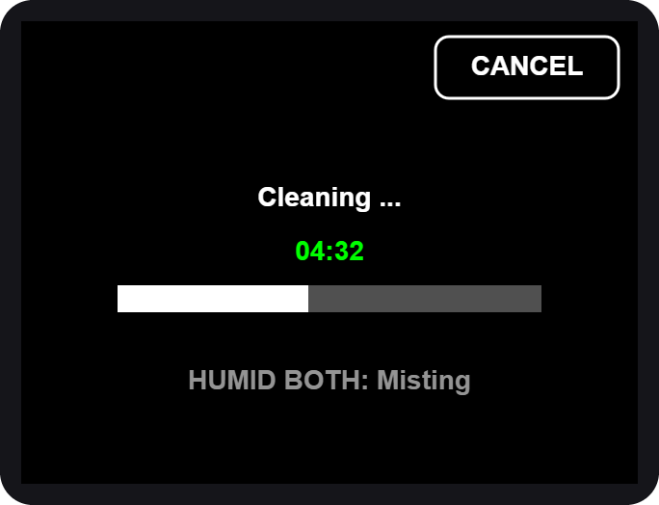  10. Cleaning... time left | 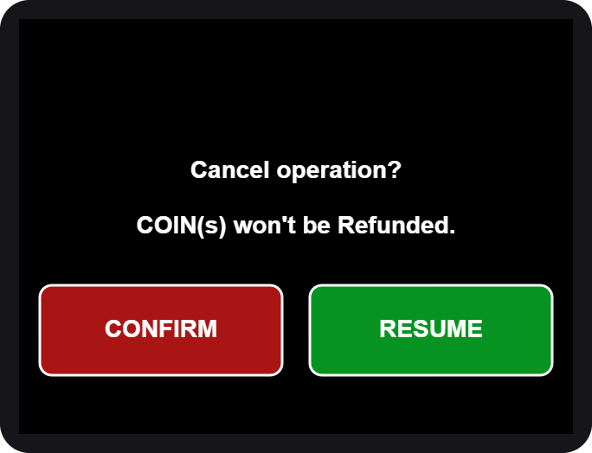  CANCEL asks first

- The big green number is the time left. The bar fills as it goes.
- The small grey line shows what is on: the mist, the UV light.
- To stop early tap CANCEL, then CONFIRM. Coins are not refunded. RESUME keeps cleaning.

If the door is opened during a run, everything pauses (SAFETY PAUSE). Close the door and it continues where it stopped.

All done
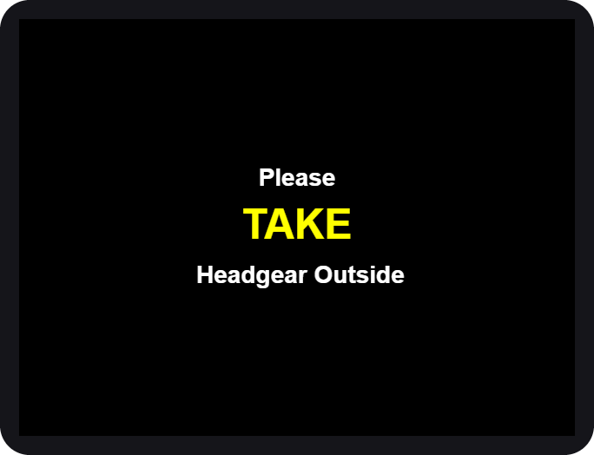  11. TAKE your helmet | 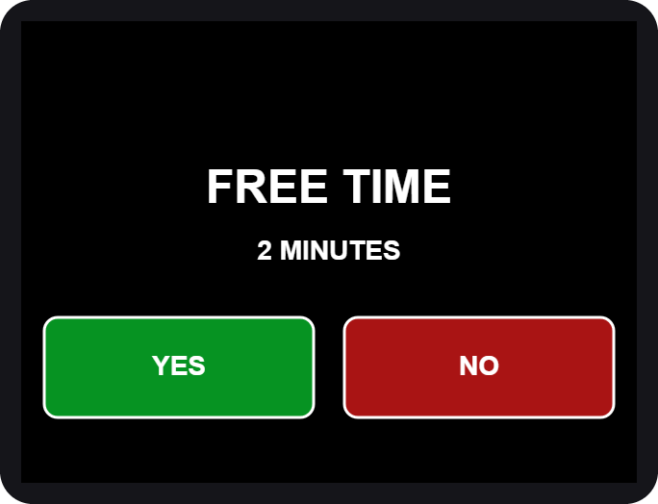  13. FREE TIME?

- OPEN the door and TAKE your helmet. Close the door again.
- Rate it again on the same 1-10 grid, then CONFIRM.
- Free retry. Not happy yet? The machine may offer a short FREE TIME (2 minutes). Tap YES to run once more, or NO. It is offered once per visit.
- The screen thanks you and returns to the start.

Box 2 - Dryer
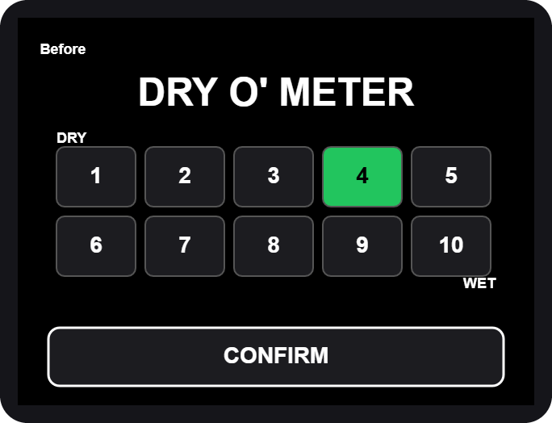  DRY O' METER | 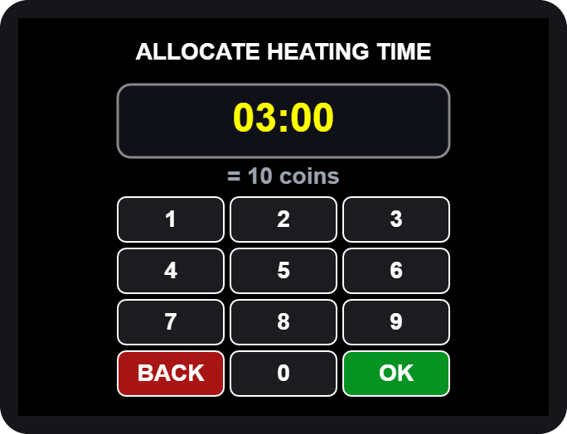  ALLOCATE HEATING TIME

- Tap anywhere, then Tap to START (same as Box 1).
- Rate how wet it is: 1 = DRY ... 10 = WET, then CONFIRM.
- Allocate heating time on the number pad, then OK.
- Insert the coins shown on the screen.
- OPEN, PLACE, CLOSE the door, same as Box 1.

Heating and cooling
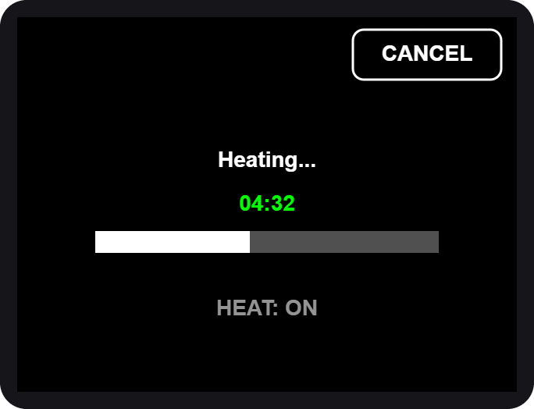  6. Heating... | 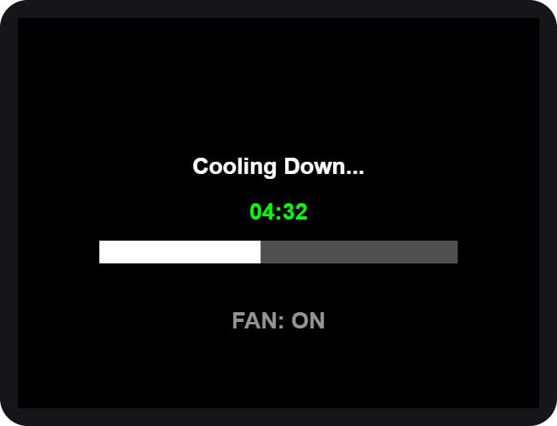  7. Cooling Down...

- Heating. Warm air dries the helmet and UV light freshens it. You can CANCEL, but coins are not refunded.
- Cooling down. A fan runs alone so the helmet is not hot to wear. The door stays locked until it ends.
- OPEN the door, TAKE your helmet, CLOSE the door.
- Rate it again, then use the free retry if you want one.

If you cancel while heating, the machine still cools the helmet down first, for your safety.

Box 3 - Cleaner + Dryer
Box 3 does both jobs. It cleans (UV light and a fine mist), then dries the helmet, or it only dries. There is nothing to rate and no time to type: you pay the coins and the machine runs for the time they buy.

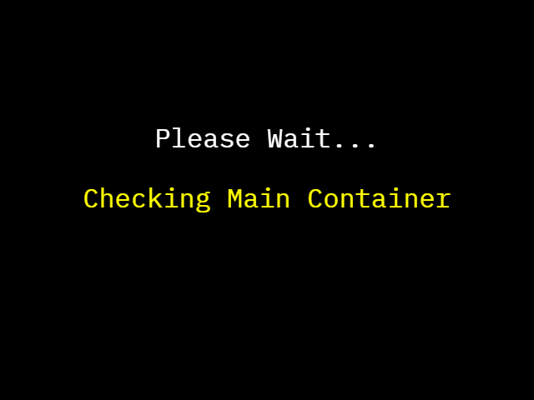  1. CHECKING (2 seconds) | 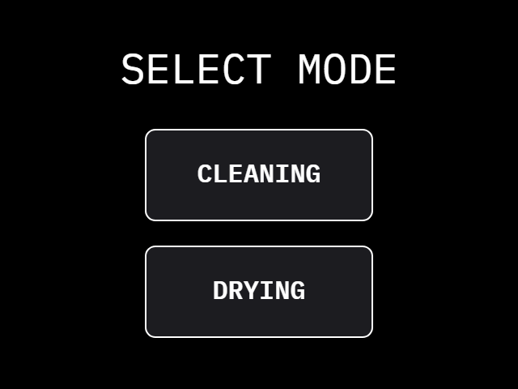  2. SELECT MODE | 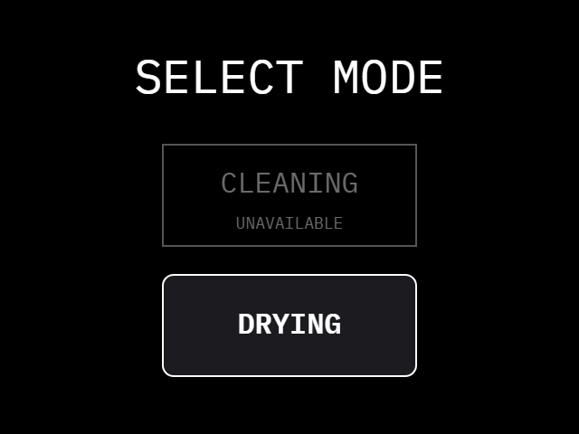  2b. CLEANING greyed out: dry only
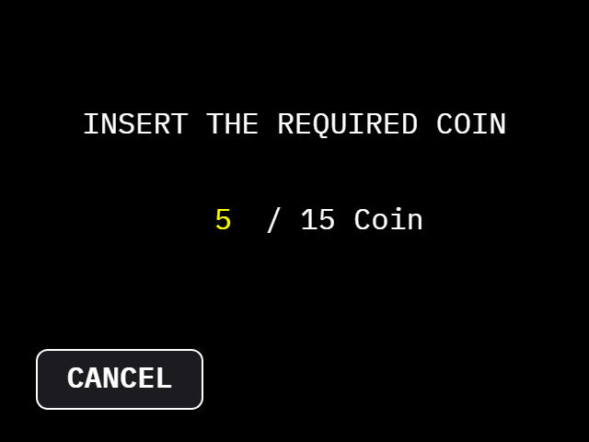  3. INSERT THE REQUIRED COIN | 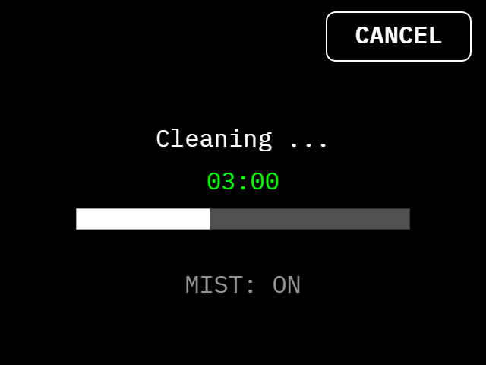  4. CLEANING (CANCEL top right) | 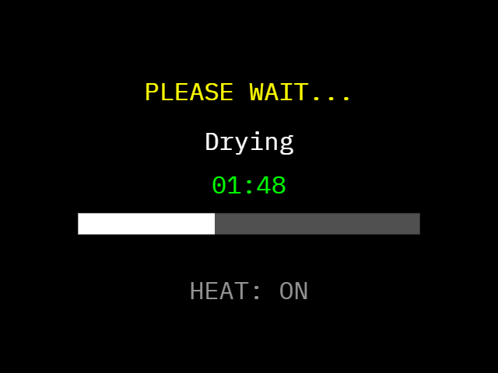  5. AUTO DRY after a cleaning
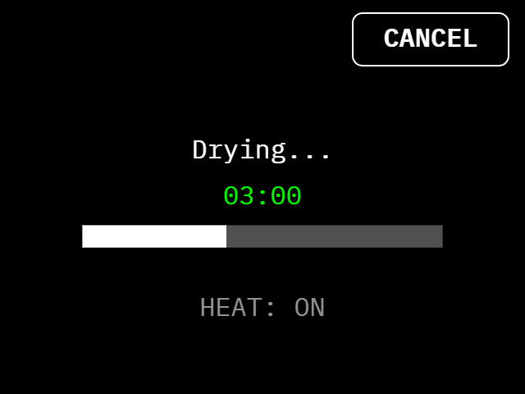  DRYING mode: warm air and UV | 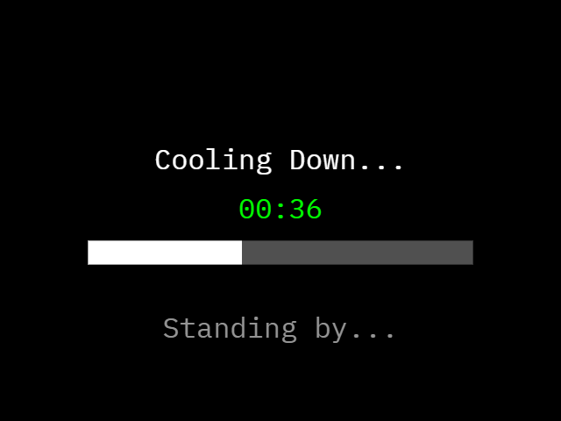  COOL DOWN after drying | 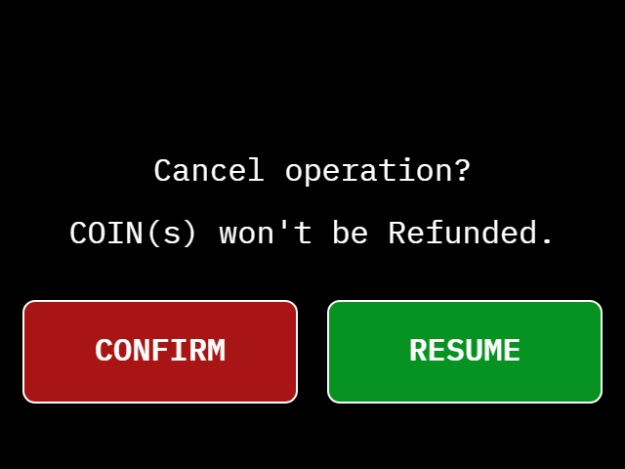  CANCEL: CONFIRM or RESUME

- Tap the screen. For 2 seconds it says Checking Main Container: the machine asks the Refilling Station whether the cleaning liquid is high enough. Tap again at WELCOME.
- SELECT MODE: tap CLEANING or DRYING. If CLEANING is grey (SELECT DRY ONLY), the liquid is low or the Refilling Station is not answering: only DRYING can be chosen.
- INSERT THE REQUIRED COIN: insert coins until the count reaches the number asked (15 coins = 5 minutes). CANCEL takes you back to the start.
- OPEN, PLACE, CLOSE: the door unlocks and the buzzer beeps. Open it, put your helmet in, close the door.
- The machine runs for the time your coins bought. CLEANING uses UV light and mist, then AUTO DRY dries the helmet for 3 minutes with UV light and warm air (the warm air stops for the last 30 seconds). DRYING uses warm air and UV light, then COOL DOWN lets the helmet rest for 60 seconds.
- OPEN, TAKE, CLOSE: the door unlocks again. Take your helmet out and close the door. The screen says "Thank you for your patronage!".

Adding coins and cancelling
- You can add coins while a cleaning or a drying is running. Every coin adds time, up to 90 coins (30 minutes) in all. Coins are not taken during AUTO DRY and COOL DOWN.
- CANCEL (top right) asks "Cancel operation? COIN(s) won't be Refunded." CONFIRM stops the run, RESUME carries on. A cancelled cleaning still goes through the 3-minute AUTO DRY, because the helmet is wet. A cancelled drying goes through the 60-second COOL DOWN. Then the door unlocks.
- If you open the door while the machine runs, it pauses (SAFETY PAUSE) and switches the UV light and the heat off. Close the door and it carries on.
- There is no rating and no free retry in Box 3.

If the power goes out or Box 3 shows OUT OF ORDER
Box 3 never keeps a helmet locked in. If it cannot work, the screen shows OUT OF ORDER. When your helmet is inside and the door is shut, the screen also says "Your helmet is still inside. Take it out, then close the door.", the door unlocks by itself and the buzzer beeps (100 ms on, 500 ms off) until you open the door. If the door stays locked, slide the safety lock down (lower left of the door). A session that was paid but cut by a power failure is not restored.

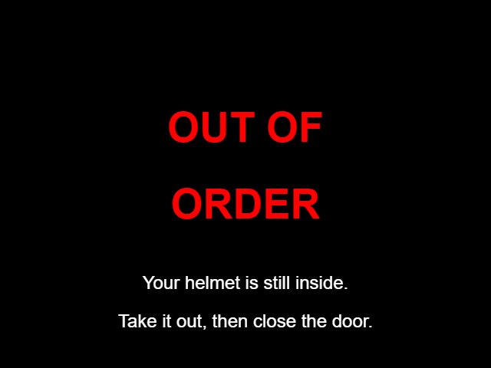
OUT OF ORDER, helmet still inside

Tip / Paalala: Kung kulay abo ang CLEANING, DRYING lang ang magagamit. Subukan muli ang CLEANING mamaya. Kung may nakalagay na OUT OF ORDER at nasa loob ang helmet mo, bubukas ang pinto nang kusa at tutunog ang buzzer: kunin ang helmet at isara ang pinto.

Prices and time
Box 1 (cleaning): 15 coins = 5 minutes.

Rating | Suggested time | Coins
1 - 5 | 5 minutes | 15
6 - 7 | 10 minutes | 30
8 - 9 | 15 minutes | 45
10 | 20 minutes | 60

Longest session: 30 minutes (90 coins).
Box 3 (cleaning or drying): 15 coins = 5 minutes, and nothing else to choose. INSERT THE REQUIRED COIN asks for the first 15 coins; every extra coin adds 20 seconds, up to 90 coins (30 minutes). The 3-minute auto-dry that ends every cleaning is free.
Box 2 (drying): 10 coins = 3 minutes.

Rating | Suggested time | Coins (about)
1 - 3 | 3 minutes | 10
4 - 6 | 5 minutes | 17
7 - 8 | 8 minutes | 27
9 - 10 | 10 minutes | 34

These are the starting prices. The admin can change them, so always check the INSERT THE REQUIRED COIN screen for the exact amount.

Special screens and safety

Special screens
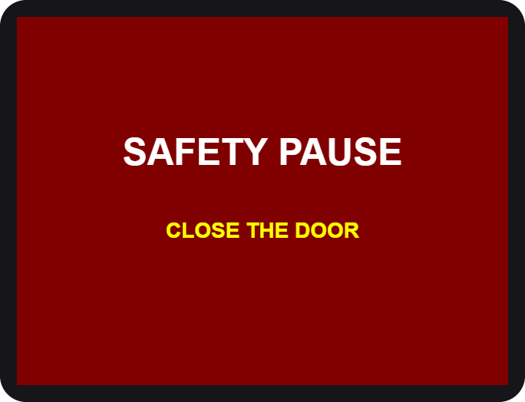  Door opened during a run | 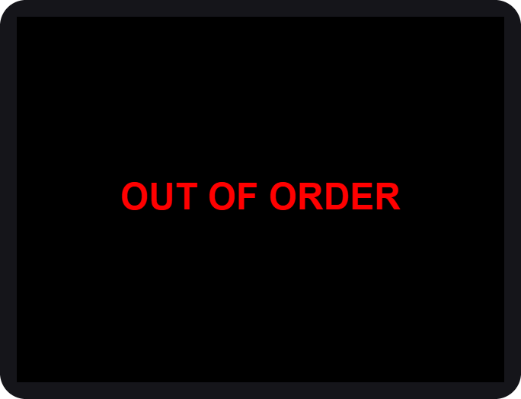  Station needs service

You see | What it means / what to do
SAFETY PAUSE | The door was opened. Close it and the run continues.
HELMET NO DETECTED | No helmet seen. Open the door and place it again.
OUT OF ORDER | The station cannot work now. If your helmet is inside, the door unlocks by itself and the buzzer beeps: take the helmet out and close the door. Then use another station and tell the staff.
CLEANING greyed out (SELECT DRY ONLY) | The cleaning liquid is low, or the Refilling Station is not answering. DRYING still works. Try CLEANING again later.
MAINTENANCE | A technician is working on the station.
Checking Main Container | Two seconds after your first tap the machine checks the liquid. Wait.
AUTO DRY (Drying...) | The cleaning is over. UV light and warm air dry the helmet for 3 minutes. Wait.
COOL DOWN | After DRYING nothing runs for a minute so the helmet can cool. Wait.
Your helmet is still inside | The machine is out of order. The door is unlocked and the buzzer beeps: take the helmet out and close the door.

Safety first
- Helmets only. Do not put bags, gloves, liquids or anything else inside.
- Keep your hands out while the machine runs. Hot air and UV light are used.
- UV light is strong. Never look into the chamber while it is on. The door must be closed.
- Do not force the door. It is locked on purpose while the machine runs. To stop, use CANCEL on the screen. If the screen does not answer, use the safety slide (see "If the door will not open").
- Remove your helmet's accessories (camera, speaker, visor tint film) if they are not heat-safe.
- Children should use the machine with an adult.
- In an emergency, tap CANCEL, then CONFIRM. The machine stops. After the short auto-dry (Box 3 cleaning) or cool-down (dryers) the door unlocks. If you cannot wait, use the safety slide.

If your helmet is stuck after a power cut or a fault, do not pull on the door. In Box 3 the door unlocks by itself and the buzzer beeps while the screen says OUT OF ORDER. In every box you can also slide the safety lock down (lower left of the enclosure door): the door unlocks at once. Then tell the staff.

If the door will not open
The door is locked on purpose while a machine runs. If the screen does not answer, the power is off, or the lock is broken, you can always open the door yourself with the safety slide.
- Look at the lower left corner of the enclosure door. The safety slide is there.
- Slide it down. The door unlocks at once, with or without power.
- Open the door and take your helmet out. Tell the staff afterwards.
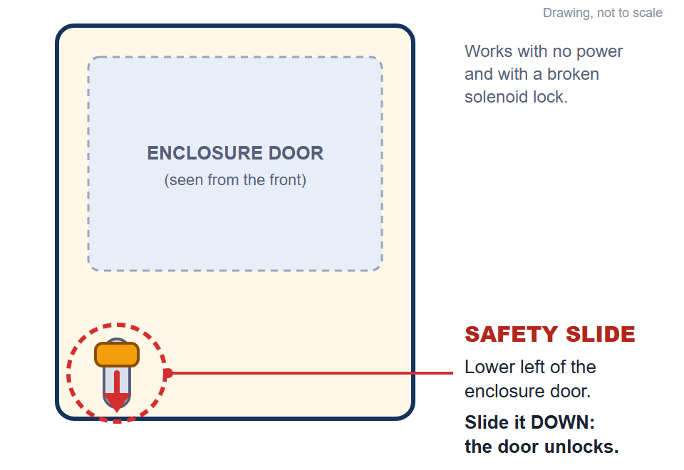
The safety slide: lower left of the enclosure door. Slide it down to unlock (drawing)

If the machine was running, opening the door stops it (SAFETY PAUSE) and switches the UV light and the heat off. The UV light is strong: do not look into the chamber until it is off. The helmet may be warm.

Questions

Question | Answer
The screen went white. | Wait a moment, it restarts itself. If it stays white, tell the staff.
I inserted a coin but nothing changed. | Insert the coin again slowly. Tell the staff if the count does not move.
Can I get a refund? | Coins are not refunded after the run has started or been cancelled.
The time is too long / too short. | On the number pad, type the time you want before tapping OK.
Why was I offered a free retry? | Because the helmet may need one more round. It is offered once per visit.
Which station should I use? | Smelly: Box 1 or Box 3 CLEANING. Wet: Box 2 or Box 3 DRYING.
The door will not open. | Wait until the run ends, or tap CANCEL. If the screen does not answer or the power is off, slide the safety lock down (lower left of the enclosure door).
Why can I only choose DRYING in Box 3? | CLEANING is greyed out when the liquid is low or the Refilling Station is not answering. Dry only works. Try again later.
Can I add coins while Box 3 runs? | Yes. Each coin adds time, up to 90 coins in all. Not during AUTO DRY and COOL DOWN.
The power went out with my helmet inside. | Box 3 unlocks the door by itself and beeps: take the helmet out and close the door. If the door stays locked, slide the safety lock down. A paid session that was cut by the power is not restored.

Admin guide (Control Center)
The Control Center: settings, calibration and maintenance
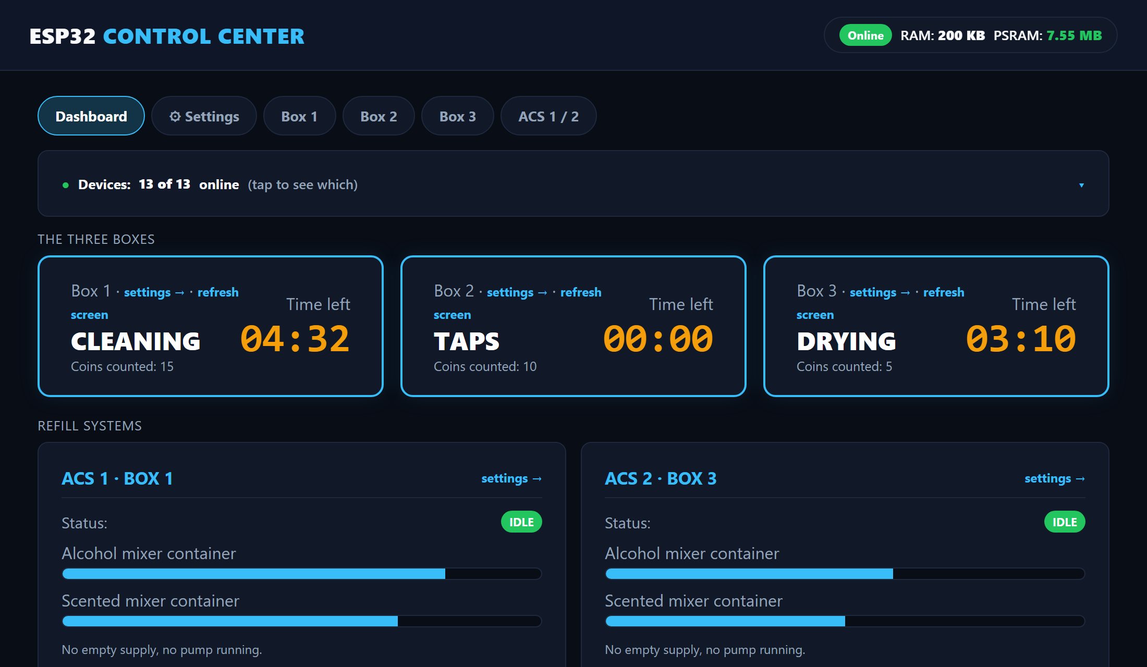
WEB PANEL FOR ADMINS AND TECHNICIANS

Connecting
The Control Center is a small web server (the LocalServer) inside the machine. You connect to it with a phone or laptop. It does not need internet.
- Switch on the machine and wait about 30 seconds.
- On your phone, join the Wi-Fi JollyHelmet-Local, password 12345678.
- Open a browser and go to http://192.168.4.1. On most phones the page opens by itself (a captive portal); if it does not, type the address.
- The Dashboard appears. The bar at the top (Dashboard, Settings, Box 1, Box 2, Box 3, Refilling Station) takes you to every page; the same bar is at the top of every settings page.

The machines keep running and keep every setting even when the LocalServer is off or being replaced. It only shows, and sends your changes.

The Wi-Fi password is printed here for admins. Change it in the LocalServer program if this manual is shared outside the team.

Home page
- Dashboard (older pages and the flowcharts call it Home): the first tab of the Control Center. The bar at the top takes you to every other page.
- Alert banners (red): the Refilling Station offline, a refill that failed, a box out of order, and the two memory and log-storage notes (see Warnings and crash reports).
- Navigation bar: Dashboard, Settings, Box 1, Box 2, Box 3 and Refilling Station (the same bar is on every page).
- The three boxes: current step, coins counted, time left, plus settings and refresh screen links.
- Refilling Station: the three main containers (EMPTY to MAX), who is waiting, which valve is open and a failed refill. Its settings link opens the Refilling Station page.
- Statistics: users served, total revenue, average cycle time and coins, the Daily and Weekly usage chart, the day viewer and the Finished and cancelled tally.
- Devices line: how many boards are online. Tap it for the online or offline badge of every board.

Navigation bar and the Devices line
The same navigation bar sits at the top of every page: Dashboard, Settings, Box 1, Box 2, Box 3 and Refilling Station. Tap a name to go there; the page you are on is highlighted. Below it the Devices line tells you how many boards answer (for example 12 of 12 online). Tap it to open the list with an ONLINE or OFFLINE badge for every board.
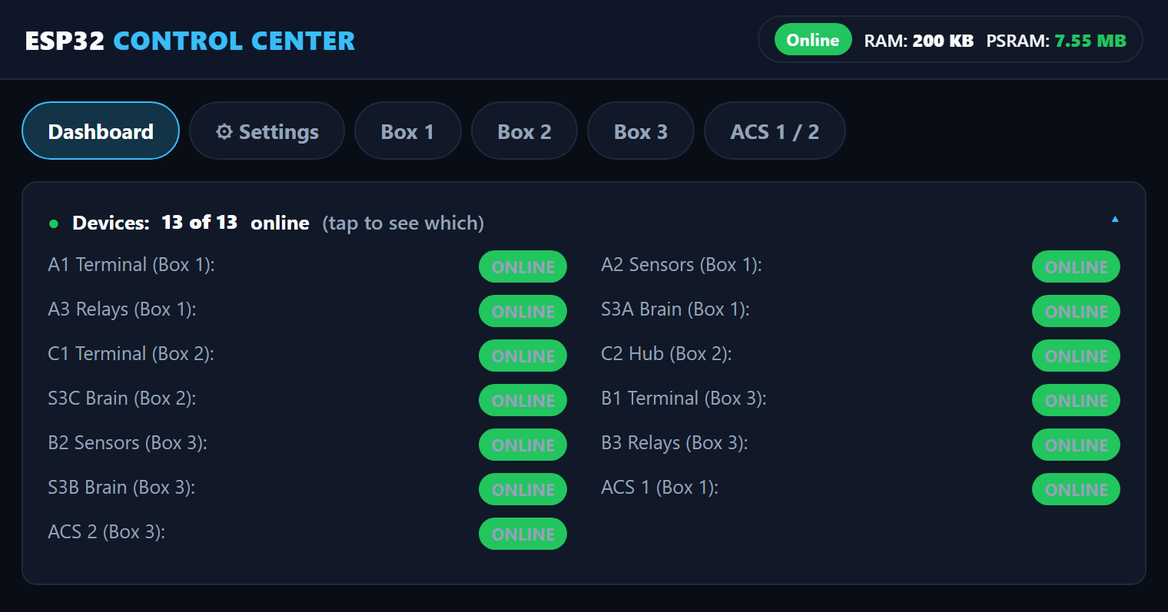
The navigation bar and the Devices list (tap the Devices line to open it)

Daily usage and the day viewer
The chart shows how many customers came each day (Daily, the last 7 days) or each week (Weekly). Orange is the part that was cancelled. A lighter shade is the previous data collected by the team after the upgrade (see the Settings tab below).
- Tap a bar of the Daily chart, or pick a date and tap Show the customers, to open that day customer by customer: time, box, coins, pesos, Finished or Cancelled, and minutes.
- The two tabs Machine and JSON only tell you where each row came from: Machine is what the machines recorded, JSON is what the team added from its own records. Both are real customers.
- Sessions without a date finished before a phone set the clock. They get their date as soon as the clock is set.
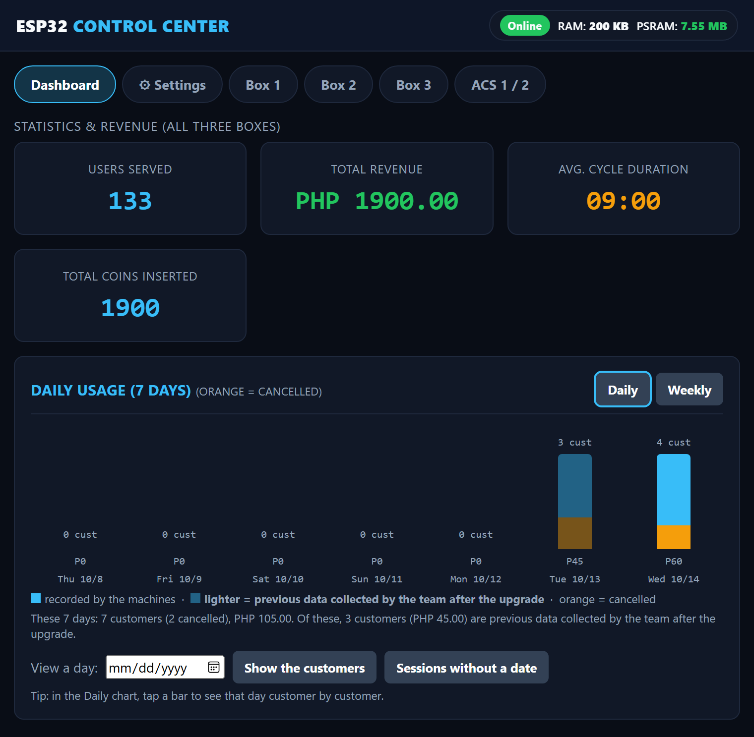
Statistics and the usage chart (lighter bars = previous data)

Finished and cancelled sessions
This card is the whole tally from the first day in one table: users served, coins, revenue and average time, for Finished and for Cancelled. Finished means the cycle ran to the end. Cancelled means the customer aborted in the middle; the coins that were paid still count as revenue. The line under the table says how much of the numbers came from the JSON file and how much the machines counted themselves, so nobody has to add two tables together.

A payment that is cancelled on the INSERT COIN screen is not counted as a session.

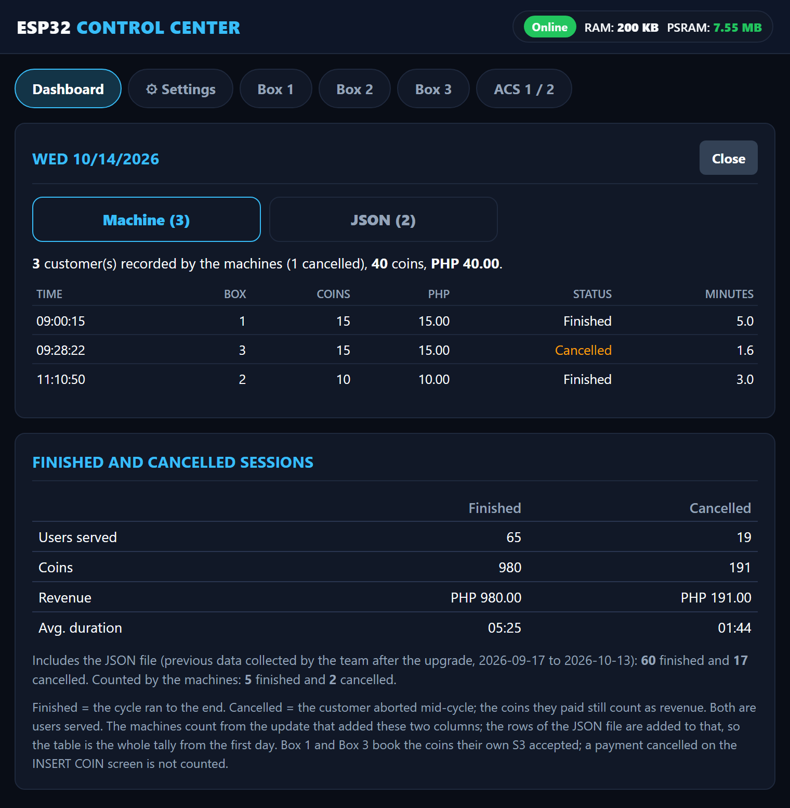
One day opened customer by customer (Machine tab), and the Finished and cancelled tally below it

Settings tab: clock, session log, backup and previous data
The Settings tab holds what you set once and rarely touch.
- Clock: the LocalServer has no clock of its own. A phone sets it when the Control Center is opened after a power-on, or you type the date and time. A power cut loses it.
- Session log: every session the machines report is saved with its date and time (never a name). The bar shows how much storage is used. Entries older than a year are dropped by themselves.
- Download log (CSV): this is the backup. Download it now and then and keep the file.
- Restore from backup CSV: if the log is ever lost (a power cut damaged the storage, or Reset Stats was tapped by mistake), choose the CSV here and tap the button. Only an unchanged download is accepted: the last line of the file is a check that is refused if anything was edited or the file was saved again in a spreadsheet. Sessions already on the board stay, nothing is added twice, and the totals are raised to at least the log's tally.
- Previous data (history.json): customers from before the log existed. The team builds the file with the ENTRY board (see below) or on a PC and uploads it here. The chart draws it lighter and the Finished and cancelled card adds it. It never changes the machine log, the totals or the CSV.
- Coin value (pesos per pulse) and Reset Stats: Reset Stats empties the counters and the machine log, so download the CSV first. The history file stays.
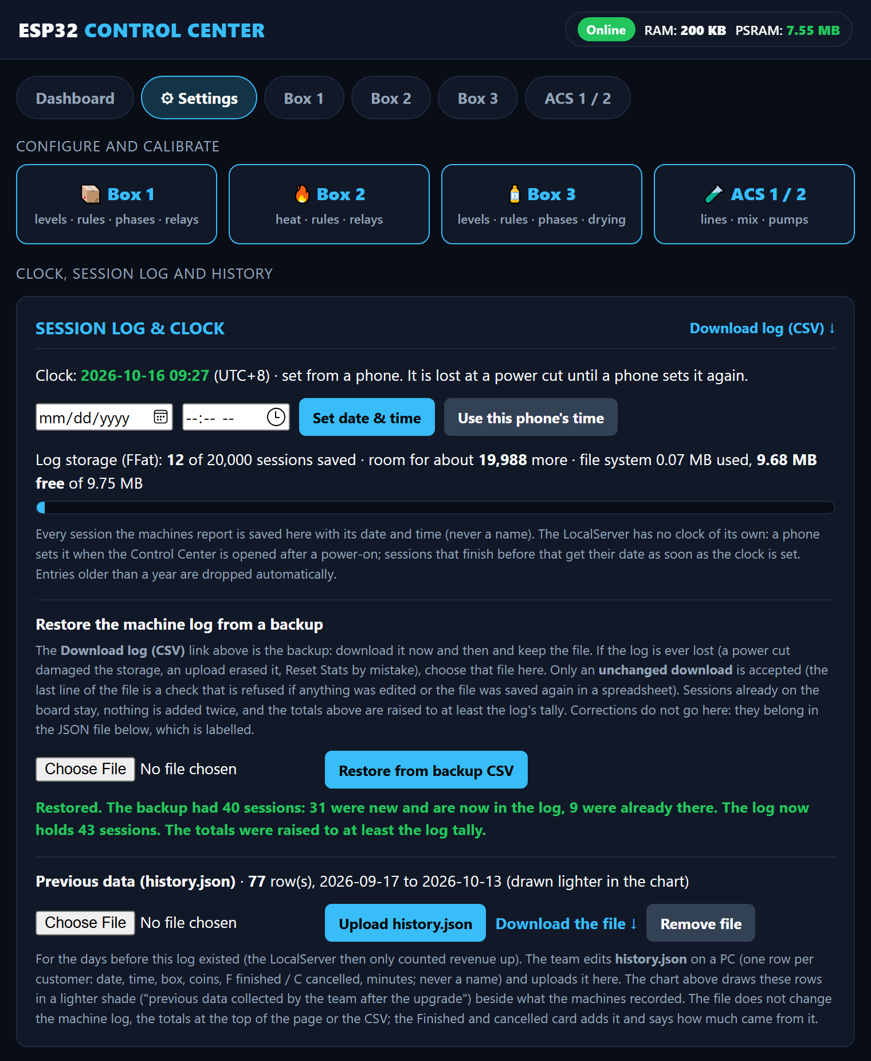
Settings: clock, session log, restore from a backup CSV and the previous data

The check line of the CSV stops mistakes and casual edits. It is not a lock. A correction to the data does not go into the machine log: it belongs in the JSON file, which is labelled as the team's own records.

Warnings and crash reports
Two red notes can appear on top of the Dashboard. The first says the board found damage in its memory. The second says the log storage was damaged and was re-created empty at the last start: open Settings, restore your last backup CSV, and send the history file again from the ENTRY board if you use it.
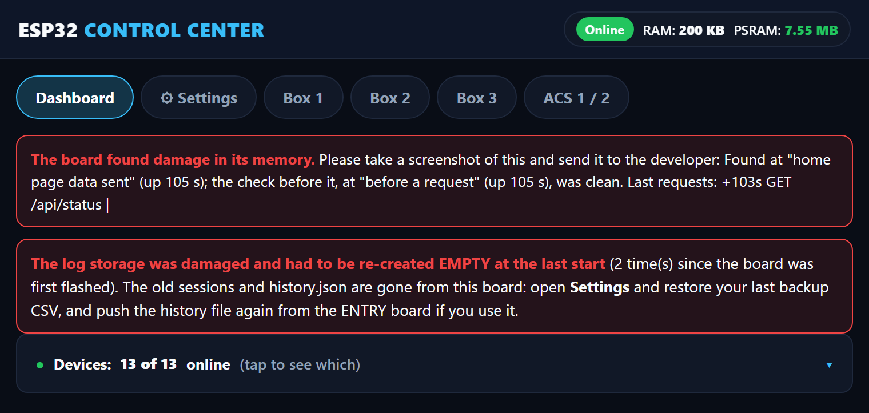
The two red notes on the Dashboard
If the unit ever restarts by itself you do not need a laptop. Open Settings and look at This board. The last restarts are kept in the board's own flash (a power cut does not erase them). Tap Crash reports kept on this board, take a screenshot and send it to the developer. Delete these reports clears the list.
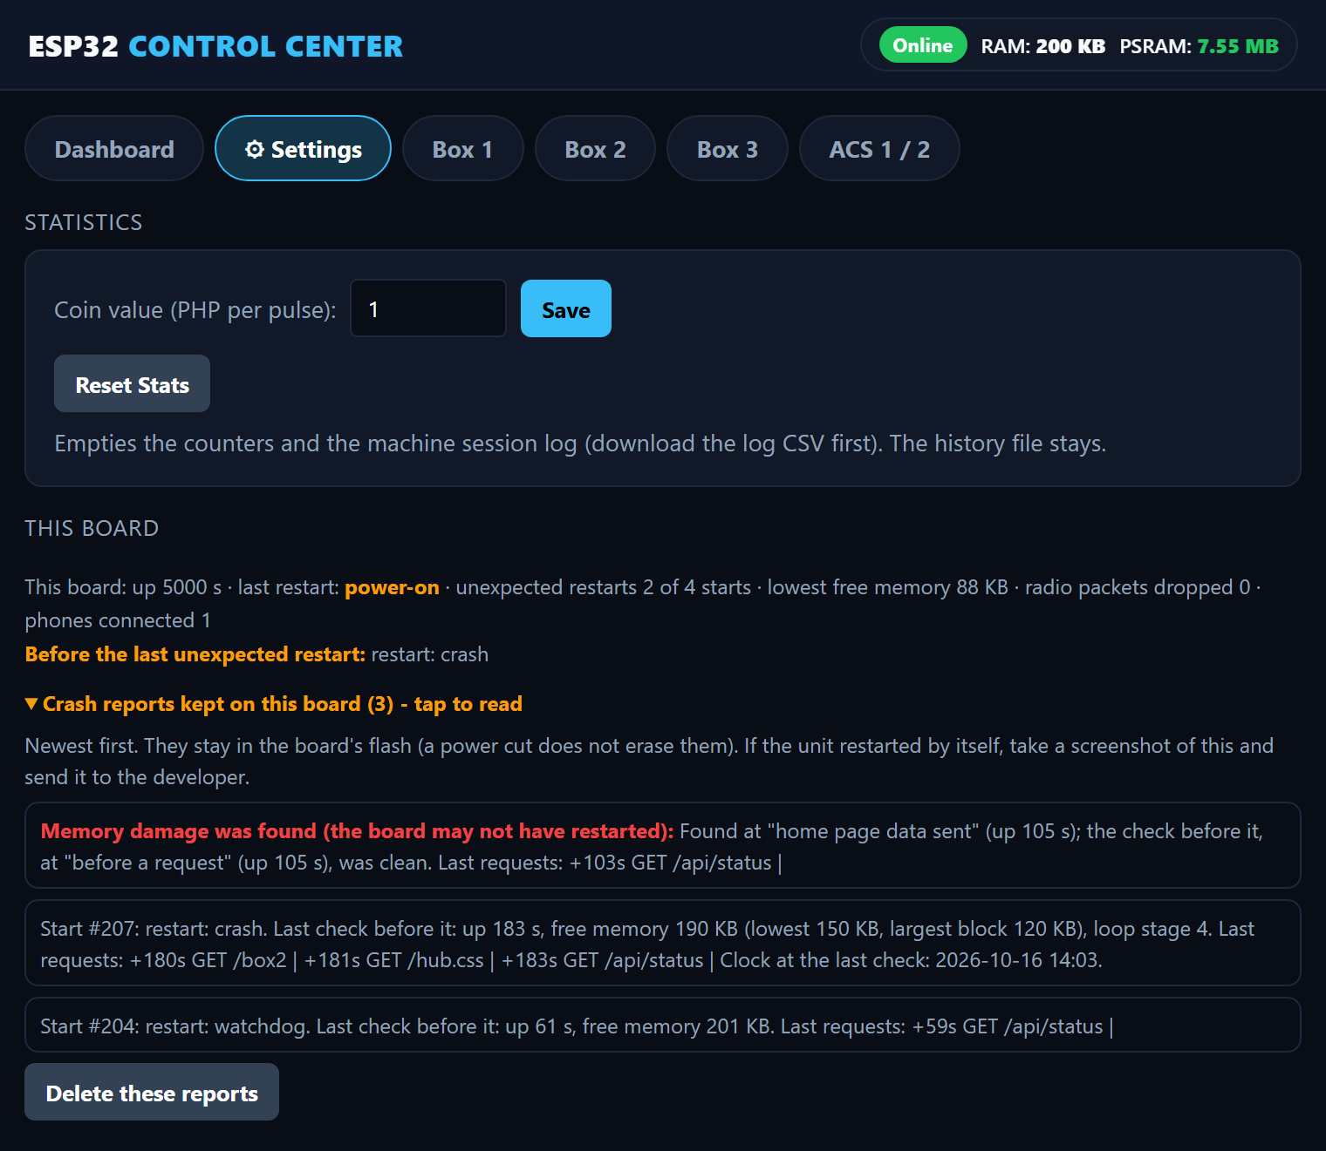
Settings, This board: the stored crash reports

ENTRY board (spare board for past customers)
The ENTRY board is a spare ESP32 with a simple form. With it the team types in the customers of the days before the LocalServer kept dates, from the team's own records (survey forms, photos, videos and so on), and sends them to the LocalServer as the previous-data file. It is not one of the 14 boards of the installation and nothing in a box needs it.
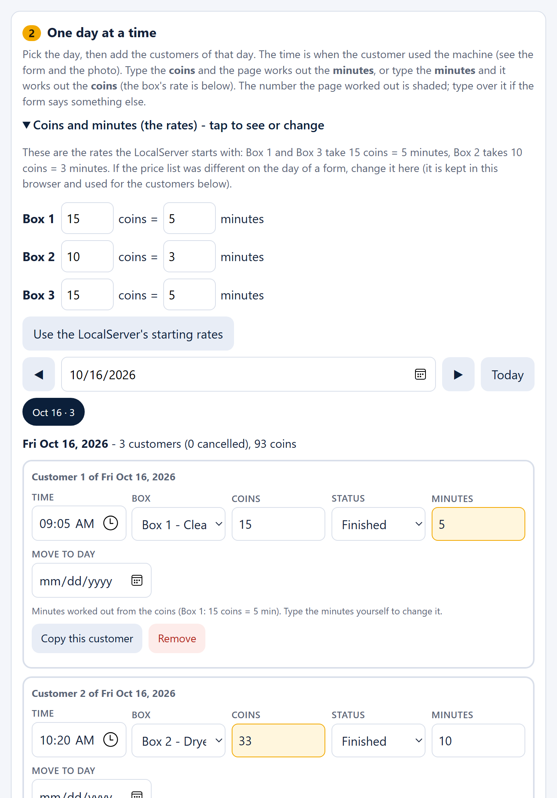
The ENTRY form: the rates box and customer cards (a shaded number was worked out by the page)
- Power the ENTRY board and the LocalServer.
- On a phone, join the Wi-Fi JollyHelmet-Entry (password 12345678). The form opens by itself. If it does not, open a browser and go to http://192.168.5.1.
- Pick a day, then tap Add a customer on this day. Each customer is one card: time, box, coins, Finished or Cancelled, minutes.
- Type the coins and the page works out the minutes, or type the minutes and it works out the coins. The rates start with the LocalServer's values (Box 1 and Box 3: 15 coins = 5 minutes; Box 2: 10 coins = 3 minutes). The number the page worked out is shaded: type over it if the form says something else.
- Copy this customer repeats a card and sets the new time to the first time plus its minutes.
- Tap Push to the LocalServer. The board joins JollyHelmet-Local by itself and sends the file. The LocalServer checks every row first and keeps its old file if anything is wrong.

A push replaces the previous data on the LocalServer with what is on the form. Tap What is on the LocalServer now first before you add more. Never type a name. If the LocalServer's Wi-Fi name or password is changed in its firmware, change LS_SSID and LS_PASS at the top of ESP32_ENTRY.ino too.

Box settings (rules, levels, phases)

Rules and prices
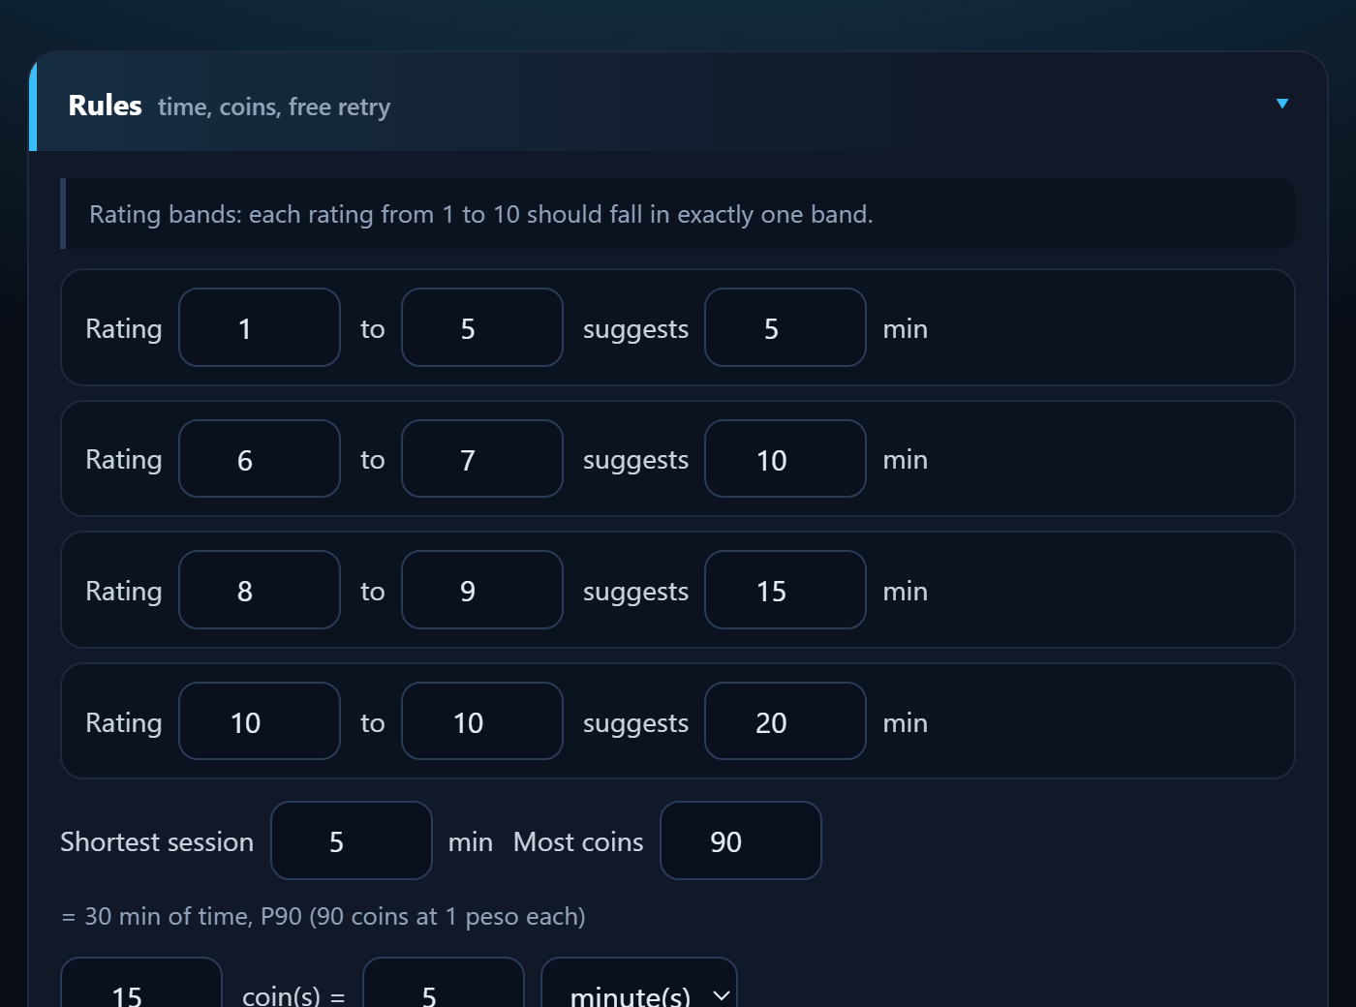
How to use it (Box 1 and Box 2 have this section; Box 3 is simpler, see "Box 3 settings" below):
- Open the box page, scroll to Rules.
- Set the rating bands (which ratings suggest how many minutes), the shortest session, the most coins and the coin rate (N coins = X minutes).
- Set the free retry (from which rating, for how many minutes).
- Tap Send RULES. A green tick means the box has saved them.

Containers and sensors
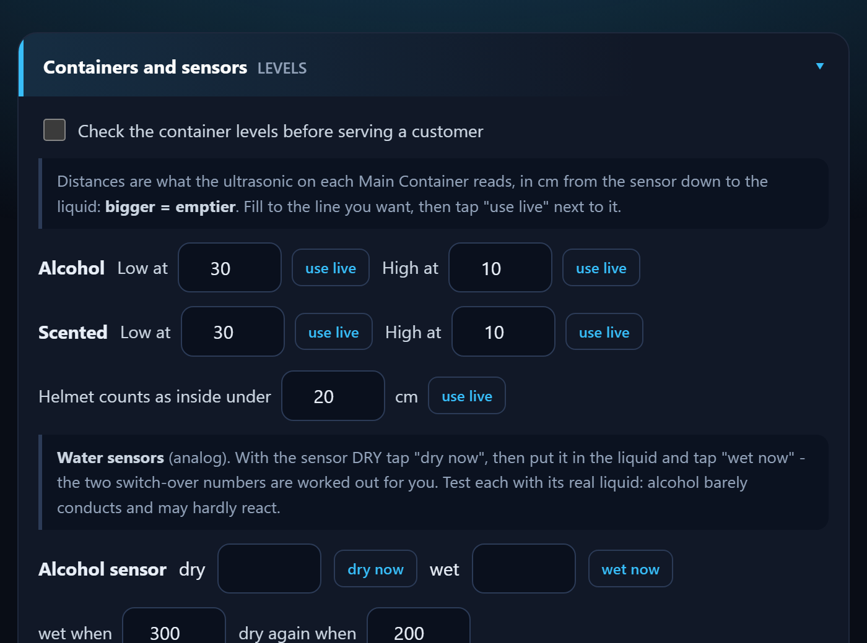
- Check the container levels: keep OFF until the numbers are measured.
- Low / High at: fill to the line, tap use live. Bigger number = emptier.
- Helmet inside under: put a helmet in, tap use live, raise it a little.
- Water sensors: dry now, then wet now in the real liquid (alcohol conducts poorly).
- Refill tries (Box 1 and Box 2, older program): the request to a refill station is only sent when that station works. Box 3 has no container sensors of its own: the Refilling Station reads its container. Then tap Send LEVELS.

Cleaning phases
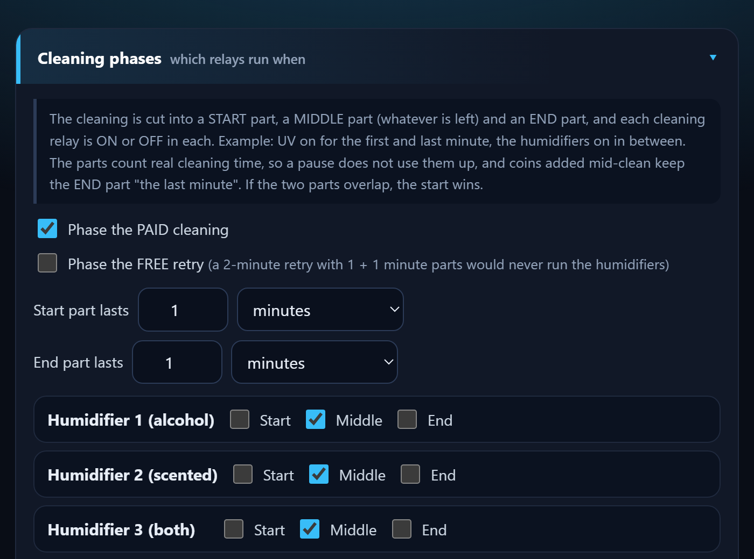
A cleaning is cut into a START part, a MIDDLE part and an END part. Tick when each relay is on.
- Example: UV on in Start and End, mist in the Middle.
- Always on = tick Start, Middle and End.
- Box 3 has no phases: a cleaning always runs UV 1, UV 2 and the three humidifiers, and the auto-dry that follows runs UV and the heater (see Box 3 settings).
- Paid cleaning and the free retry have their own tables.
Tap Send PHASES.

Heating and drying
- Box 2 - Heating: set the helmet distance (put a helmet in, use live) and the cool-down seconds (default 60, 5 to 900). Tap Send HEAT.
- Box 3 - Drying: set the cool-down seconds, then Send DRYING. The drying time itself is what the customer's coins bought (see Box 3 settings).

Good to know
- Every setting is saved inside the box's own board, so it survives a power cut or a LocalServer replacement.
- If a number is outside its allowed range, the box refuses it. The green tick will not appear.
- Use Reload beside a Send button to bring back what the box really has.

Change one thing at a time and test it with a short session before leaving it.

Box 3 settings (coins, sensors, auto-dry)
Box 3 runs the trimmed flow: no ratings, no time picker, no mist choice, no free retry. Its page (Box 3 in the navigation bar) has four sections that matter; the Screen, OPEN A / OPEN B beep and Maintenance sections below work like the other boxes.
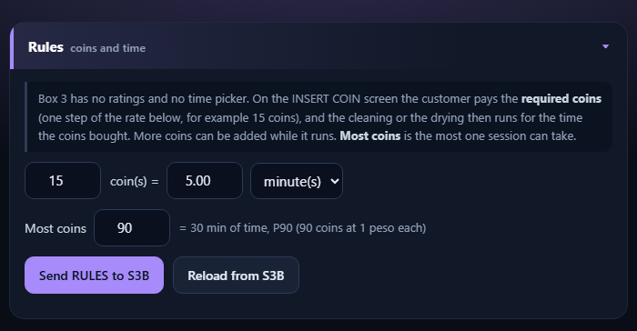
Box 3, Rules (coins and time)
- Rules (coins and time): N coins = X minutes (default 15 coins = 5 minutes) and Most coins (default 90). The first N coins are the required coins on the INSERT COIN screen; each coin buys the same share of time (20 seconds at the default). Tap Send RULES to S3B.
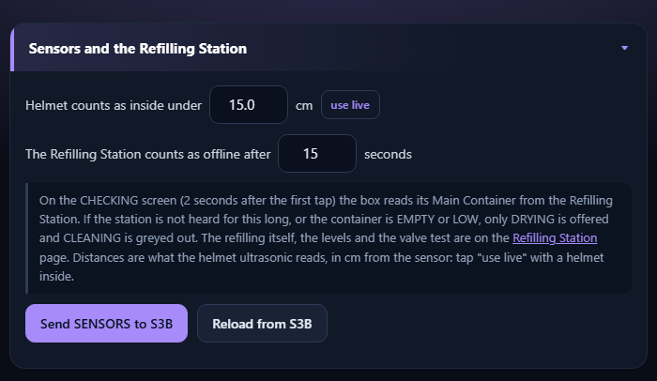
Box 3, Sensors and the Refilling Station
- Helmet counts as inside under: put a helmet in, tap use live, raise the number a little (1 to 200 cm, default 15). The screen board and the relay controller use the same number to decide when a helmet is trapped during OUT OF ORDER, and keep it in their own memory, so a power cut does not lose it.
- The Refilling Station counts as offline after: 5 to 120 seconds (default 15). If the station is not heard for this long, or the container is EMPTY or LOW, only DRYING is offered. Tap Send SENSORS to S3B.
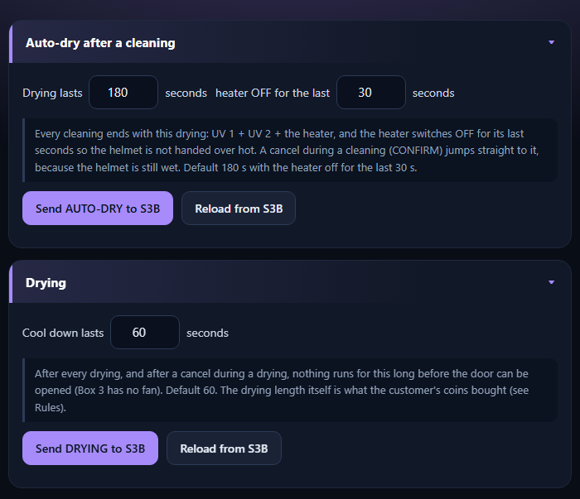
Box 3, Auto-dry after a cleaning and Drying
- Auto-dry after a cleaning: how long it lasts (10 to 900 seconds, default 180) and how long the heater is off at the end (0 to 900, default 30). A cancel during a cleaning jumps straight to it. Tap Send AUTO-DRY to S3B.
- Drying: the cool-down seconds (5 to 900, default 60), also after a cancelled drying. The drying time is what the coins bought. Tap Send DRYING to S3B.

Box 1 and Box 2 still run their earlier program (ratings, time picker, free retry) and keep their own sections above. They are to be rebuilt to the Box 3 flow.

Screen refresh and maintenance

Screen (touch display)
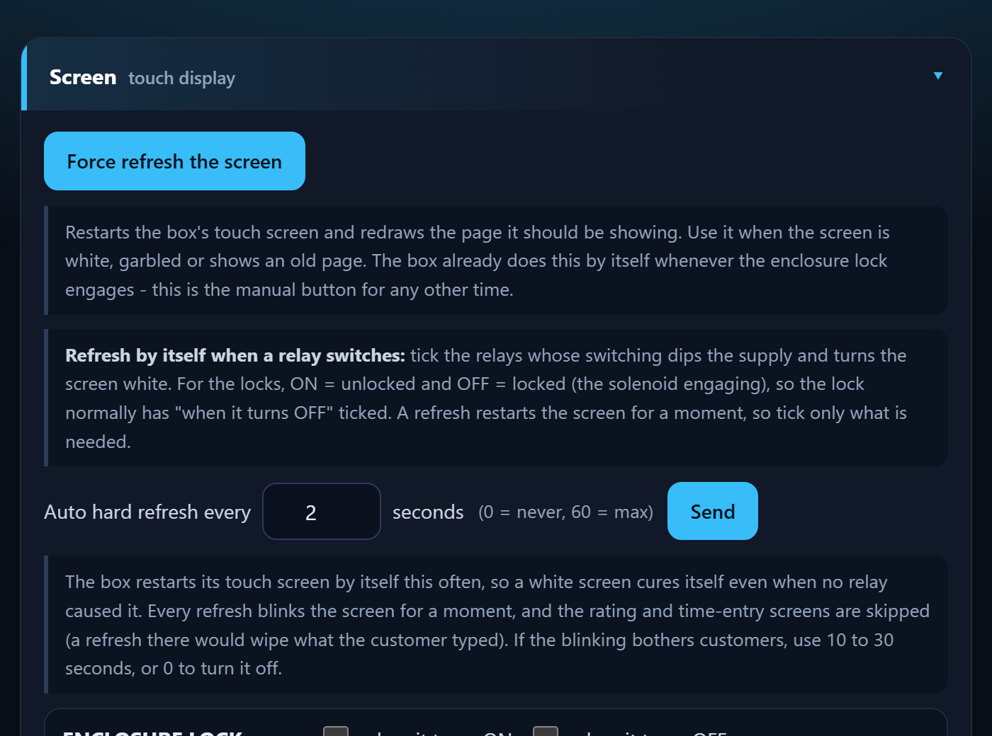
A heavy load switching on can make the touch screen go white. Three tools cure it:
- Force refresh the screen: restarts it now.
- Auto hard refresh every N seconds: restarts it by itself (0 = never, 60 = max). Rating and number-pad screens are skipped.
- Refresh when a relay switches: tick the relays (ON and/or OFF) that should trigger it. The lock is normally ticked OFF.

OPEN A / OPEN B beep
While a box waits at OPEN A or OPEN B for the door to be opened, it beeps again and again (beep, wait, beep, wait) until the door opens. You set the length of the beep and of the wait on each box page, in the section OPEN A / OPEN B beep.
- Beep for 20 to 1000 ms, then wait 0 to 10000 ms. A wait of 0 gives one beep only.
- Tap Send. The box keeps the values in its own memory. The default is a beep of 100 ms and a wait of 500 ms.
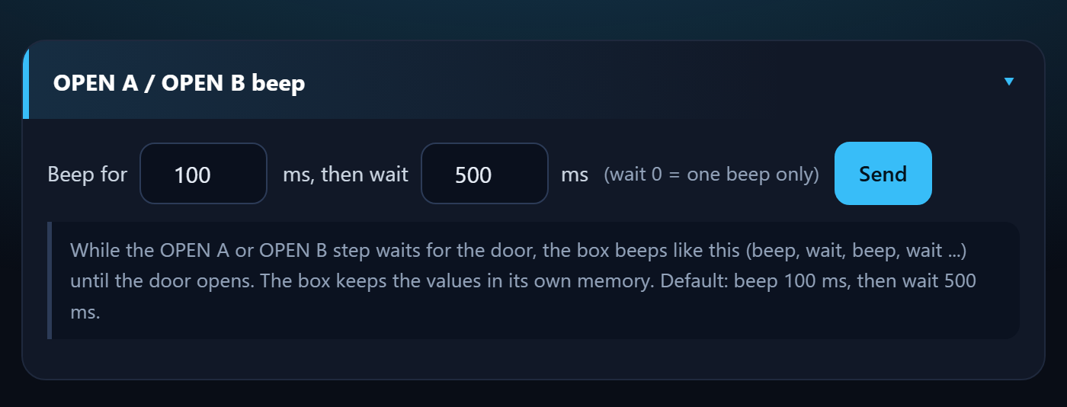
The OPEN A / OPEN B beep section of a box page

Maintenance mode
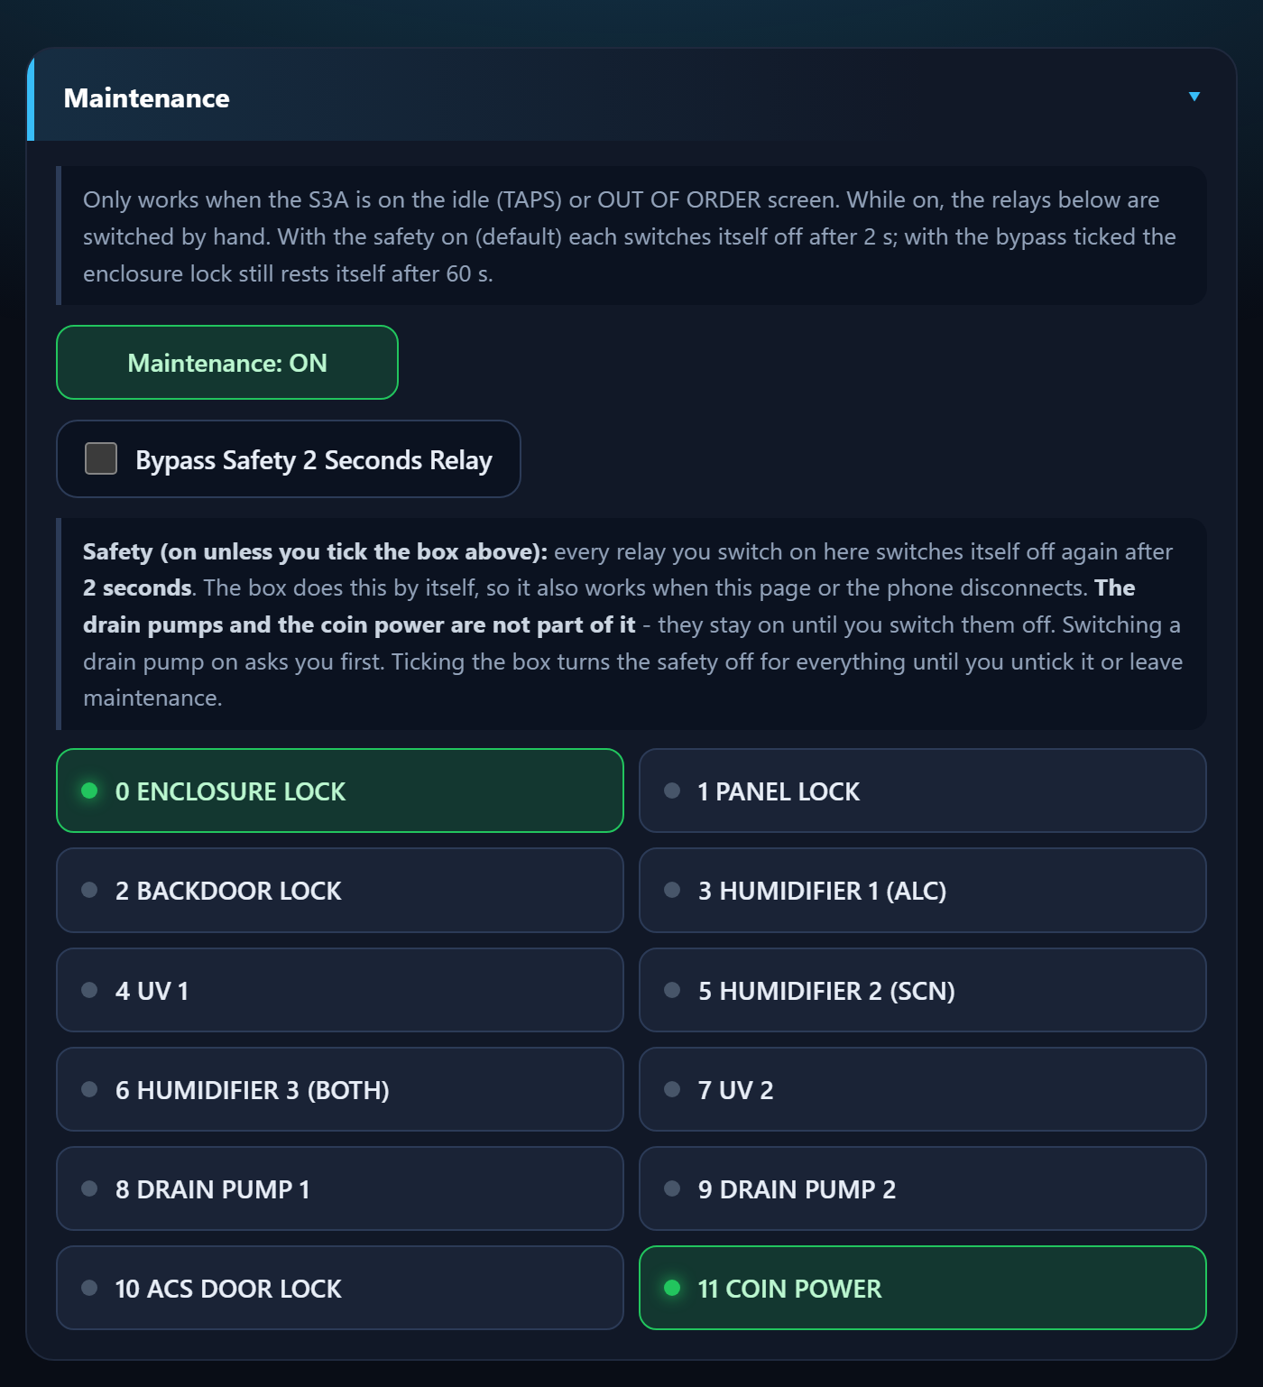
- Make sure the station is on its start screen (TAPS) or OUT OF ORDER.
- Tap Maintenance. The machine shows MAINTENANCE.
- Tap a relay button to switch it on by hand. Green = on. With the safety on it switches itself off again after 2 seconds (see below); tap it again to repeat.
- Tap Maintenance again. Everything switches off.

With the safety on, a relay you switch on by hand goes off by itself after 2 seconds. With the bypass ticked the heater turns itself off after 5 minutes and the lock after 60 seconds. Keep the door shut and clear when testing the heater.

The 2-second safety and the drain pump warning
So that a forgotten tap cannot leave a lamp, a humidifier, the heater or a lock running, every relay you switch on in Maintenance switches itself off again after 2 seconds. The box does this by itself, so it also works if the phone or the page disconnects.
- Bypass Safety 2 Seconds Relay: tick it when a relay must stay on, for example to watch a humidifier make mist. The safety is then off for every relay until you untick the box or leave Maintenance. The heater still turns itself off after 5 minutes (Box 2 and Box 3) and the enclosure lock rests after 60 seconds.
- Drain pumps (Box 1 only) and the coin power (Box 1 and Box 3) are not part of the 2-second safety. They stay on until you switch them off.
- Drain pump warning: tapping a drain pump first shows a WARNING window ("You are now toggling Drain Pump 1 ON"). Tap Yes, turn it ON only when the drain tube is connected and the container can take the liquid. No, cancel (or Esc, or a tap outside the window) does nothing, and No is the default.
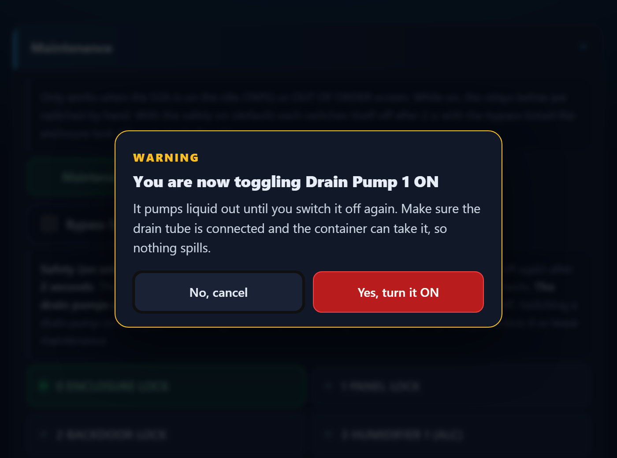
The drain pump warning in Maintenance (No is the default answer)

Check the drain tube and the container before you tap Yes. A drain pump that is left on keeps pumping until you switch it off.

Refilling Station
One small board (the Refilling Station) keeps the main container of every box full. It has three water-level sensors, one in each container, and three valves, one for each box, all fed from one water supply. It works alone: the boxes never ask it for anything. Box 3 already reads it; Box 1 and Box 2 will do the same when they are rebuilt.
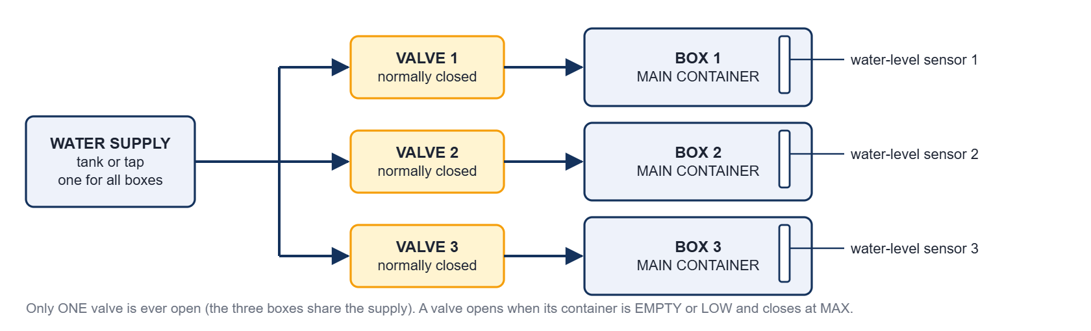
The water path: one supply, three normally closed valves, three main containers with a water-level sensor each

How it works
- Every second the station reads the three sensors and works out each container's level: EMPTY, LOW, MID, HIGH or MAX.
- A container that is EMPTY or LOW joins the queue. EMPTY containers go first, LOW second; inside a group the one that waited longest goes first.
- Only one valve is ever open. A refill that is running is never interrupted. The valve closes when the container reaches MAX.
- If the level does not rise (30 seconds while EMPTY, 5 seconds while LOW, or the valve has been open 3 minutes) the refill FAILED: the valve closes, a flag is set and the station tries again after 60 seconds, for ever.
- The station tells everybody the levels every second. A box offers CLEANING only when the station was heard in the last 15 seconds and its container is MID or higher; otherwise only DRYING.
- The water supply has no sensor of its own. An empty supply shows as a refill that does not rise.
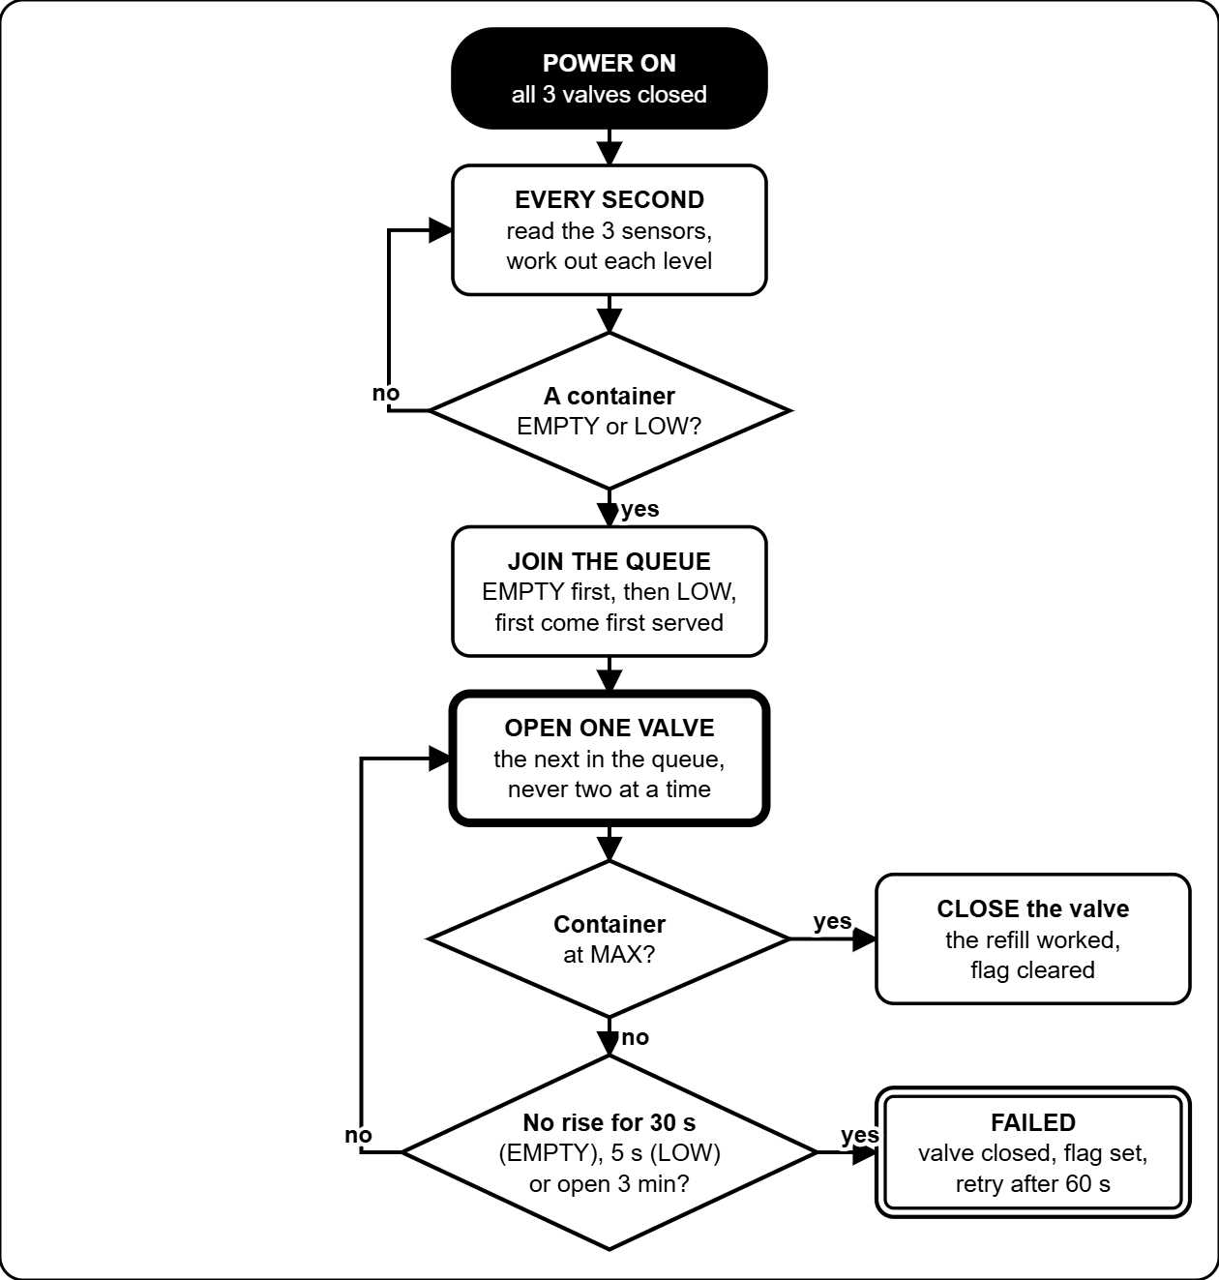
What the Refilling Station does, from power-on

Reading the Refilling Station page
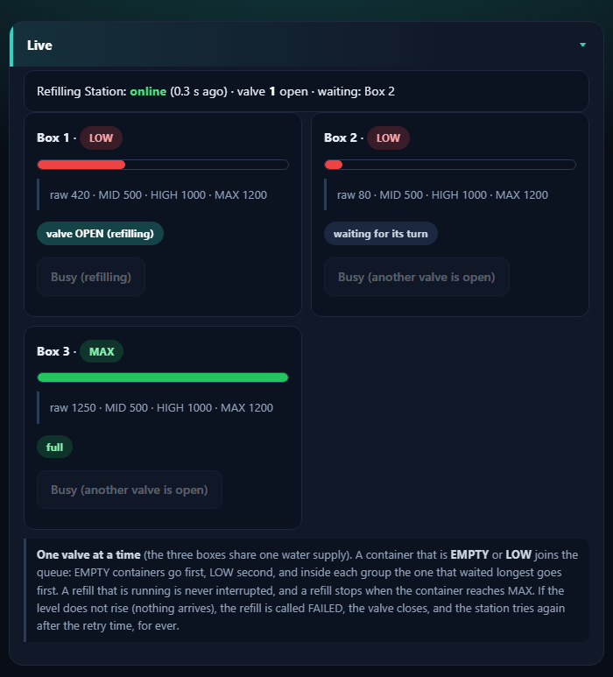
The Live card: station online, valve 1 open, Box 2 waiting, Box 3 full (example)
- The top line says whether the station is online, which valve is open and who is waiting.
- Each box has a card: its level (EMPTY, LOW, MID, HIGH, MAX), a bar, the raw reading with the MID, HIGH and MAX numbers, and a tag: valve OPEN (refilling), waiting for its turn, full, or FAILED.
- The same three levels sit on the Dashboard under Refilling Station, and on the online page as three dials.

Setting up the levels
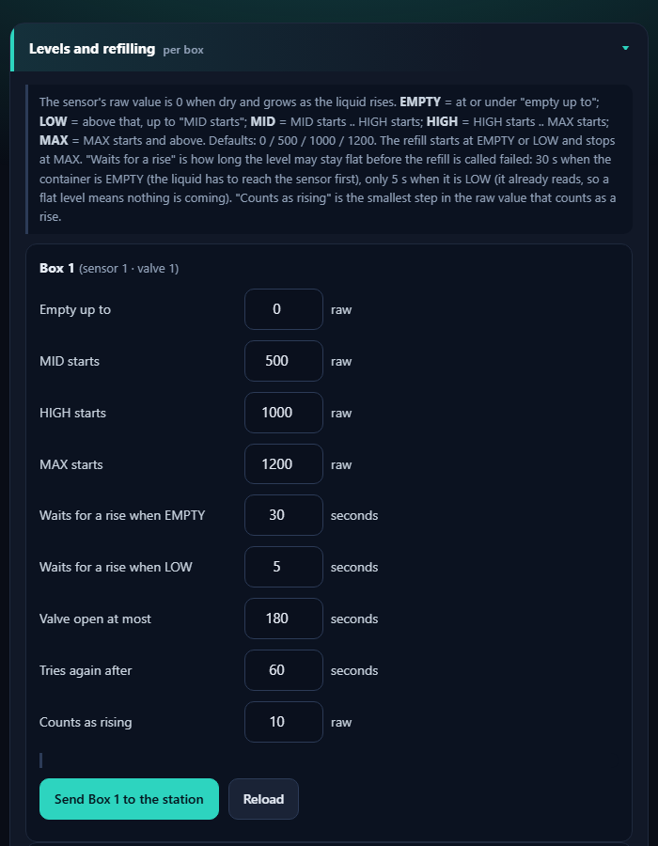
Levels and refilling, one form per box (Box 1 shown)
- Dry sensor: note the raw value on the Live card. Then put the sensor in the real liquid at the level you want to call LOW, MID, HIGH and MAX, and note the raw value each time (it is 0 when dry and grows as the liquid rises).
- Type the four edges for that box: Empty up to, MID starts, HIGH starts, MAX starts (they must grow in that order, up to 4095). Defaults: 0, 500, 1000, 1200.
- Tap Send Box 1 to the station (or 2, 3). A green tick means the station saved it. Copy Box 1's numbers into Box 2 and Box 3 fills the other forms when the containers are alike.

Field | What it does | Default | Range
Empty up to | At or under this raw value the container is EMPTY. | 0 | 0-4095
MID, HIGH, MAX starts | Where each level starts. A refill starts at EMPTY or LOW and stops at MAX. | 500 / 1000 / 1200 | 1-4095
Waits for a rise when EMPTY | How long the level may stay flat while EMPTY before the refill FAILED (the liquid first has to reach the sensor). | 30 s | 1-600 s
Waits for a rise when LOW | The same while LOW (the sensor already reads, so flat means nothing arrives). | 5 s | 1-600 s
Valve open at most | Longest time one valve may stay open. | 180 s | 10-1800 s
Tries again after | Pause before a failed box tries again. | 60 s | 5-3600 s
Counts as rising | Smallest step in the raw value that counts as a rise. | 10 | 1-500

Test a valve by hand
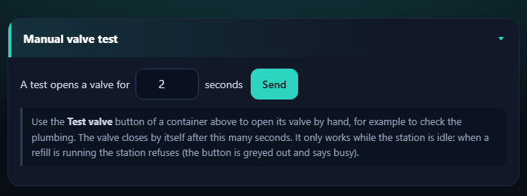
Manual valve test
- Set how long a test opens the valve (default 2 seconds, 1 to 30), tap Send, then tap Test valve on a container's card. The valve closes by itself.
- It only works while the station is idle. During a refill the button is greyed out and says busy. A test does not touch the queue or the failed flags.
- Do the first test with the supply connected and a bucket under the tube, one valve at a time.

When a refill fails
- The tag FAILED stays on until a refill works, or the container reads MID or higher for 3 seconds (somebody filled it by hand). The Online Server and the web page raise a warning.
- A sensor that reads 0 by mistake (unplugged, wrong wire, probe out of the liquid) looks like an EMPTY container, so the station keeps trying (valve open up to 30 seconds, then a pause of 60 seconds). The sensor check (next part) catches a wire on the 3.3 V rail and a floating wire, but not a dead sensor that reads 0. If a container is really full, close the supply and fix the sensor wire first. A drip tray under the containers is a good idea.
- Check the supply (tank full, tap open), then the decision tree "The Refilling Station does not fill" in the Reference chapter. The station keeps trying every 60 seconds by itself.
- If the station itself is not heard (OFFLINE on the Dashboard), every box offers DRYING only. That raises a critical alert on the online page.

Is a sensor still working?
The station checks every water-level sensor all the time. It cannot see inside the container, so it only catches the faults that show in the reading.

What the station sees | What it does | Caught?
The reading sits on the 3.3 V rail (4090 or more), for 5 seconds | SENSOR FAULT: the box offers drying only, is not refilled, and a warning shows on the Dashboard, the Refilling Station page and the online page. It clears by itself 10 seconds after the reading is normal. | Yes
The reading jumps about by more than 1500 inside one second while the valve is closed, for 5 seconds (a loose, broken or floating SIG wire) | The same SENSOR FAULT. | Yes
A dry sensor that reads 0 and a dead sensor that reads 0 | They look the same. A container that never rises while its valve is open is called a FAILED refill; the station tries again. | Not by the value alone

Check a sensor by hand:
- Open the Refilling Station page and watch the raw value of that box. Dry, it reads about 0 and stays steady. Put the probe in water: the number rises and the level changes. Take it out: it falls again.
- Wiggle the SIG wire. The reading must not jump about.
- On the serial console (115200) type sensors: it prints, for every sensor, the average, the smallest and biggest reading of the last second, the spread, and whether it looks fine. raw streams the readings.
- Use Test valve on a container that is not full: with the supply on, the raw value should climb after a few seconds.

When the hardware team has chosen the sensor, pull its SIG wire and type sensors. If a disconnected wire reads something different from a dry sensor, the limits can be tuned to catch that too.

Troubleshooting and care

Troubleshooting

Problem | What to do
Screen white or garbled | Box page, Force refresh the screen. If it returns, tick the relay that causes it or lower the auto-refresh time.
A board shows OFFLINE | Check its power and wiring, then watch its badge in the Devices list on the Dashboard.
Station shows OUT OF ORDER | One board of that box is silent (sensors or relay controller, or the main controller itself). See the offline badges. A helmet inside is released by itself: the door unlocks and the screen board beeps.
Only DRYING is offered (SELECT DRY ONLY) | The Refilling Station is offline, or the box's container is EMPTY or LOW. Open the Refilling Station page: check the station is online, then the supply and the valve (Refilling Station chapter).
Coins not counted | Use the coin check on the box page: pulses should rise by the coin's value.
Touch is off or upside down | The terminal needs its touch calibration or rotation checked.
Settings, This board, says last restart BROWNOUT | Power dipped. Use a stronger supply and a short cable.
Door will not open, helmet stuck | Slide the safety lock down (lower left of the enclosure door): it unlocks the door at once, with or without power. Then find the cause: box page, Maintenance, ENCLOSURE LOCK (Decision tree: The door will not open).
A red note says the board found damage in its memory, or the unit restarted by itself | Settings, This board, Crash reports kept on this board. Take a screenshot and send it to the developer. The reports stay after a power cut.
A red note says the log storage was damaged and re-created empty | Settings, Restore from backup CSV with your last downloaded log. Send the history file again from the ENTRY board if you use it.
A relay in Maintenance switches itself off | That is the 2-second safety. Tick Bypass Safety 2 Seconds Relay to keep it on, and untick it when you are done.
A phone cannot find the Control Center | Join the Wi-Fi JollyHelmet-Local (the old name ESP32_LOCAL is no longer used). Then open http://192.168.4.1.
A helmet is inside during a power cut or OUT OF ORDER | Box 3 unlocks the door by itself and the buzzer beeps (screen board, relay controller and sensors must still have power). If it stays locked, slide the safety lock down.
The online page does not show a Checklist, Fix it or Manual tab | They were taken out on 2026-10-23. The monthly checks are in the Technician guide (Maintenance) and the decision trees are in the Reference chapter.
A container shows SENSOR FAULT | The Refilling Station found its water-level sensor unusable (reading on the 3.3 V rail, or jumping about). Check the SIG wire and the probe. That box offers drying only and is not refilled until the reading has been normal for 10 seconds.

Care and spare parts

Daily check
- Dashboard: the Devices line says every board is online, no red banner.
- Open the Refilling Station page: the station is online, no container is FAILED, and the water supply is connected and full.
- Check the revenue and the number of users.

When a board breaks
- Keep one spare ESP32 per role, flashed and labelled (A1, S3B, Refilling Station...).
- Swap it in and wire it exactly like the old one.
- Watch its badge turn ONLINE in the Devices list on the Dashboard, then re-enter that box's settings if they were lost.
- After rewiring, test each relay or pump by hand in Maintenance first.

S3A, S3B, S3C and the LocalServer are ESP32-S3 boards (16 MB, OPI PSRAM). The relay boards A3 and B3 must be plain ESP32 boards.

Online page (Monitor, Alerts, Reports)
The online page shows your machines on a phone or a PC, wherever you are. It only watches: nothing on it can start, stop or change a machine. Open it with the address your technician gave you. The first time it asks for the Blynk token: paste it once, it stays in that browser.

The tabs

Tab | What it is for
Monitor | The live state of every box (drawn as a little machine), the level dials of the three containers read by the Refilling Station, the network map, the revenue and the customers served.
Alerts | What needs attention now, a log of what happened, and the sound of each alert.
Reports | Revenue and customers per day, the busiest hours and days, what each box earns. CSV files and a printable report.
QR button | The QR code and a printable sign for the customer page. Stick the sign on every machine.

Level dials
Every box has a dial for its main container, read by the Refilling Station. The dial is red when the container is EMPTY or LOW (the box then offers drying only), yellow at MID, yellow-green at HIGH and green at MAX. A small valve symbol above a dial lights blue while the station is filling that container. So you can see a problem before a customer does.
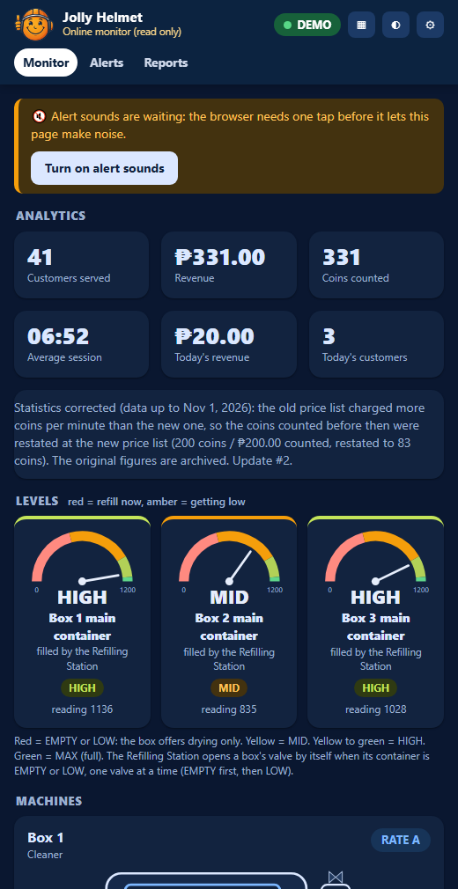
The Monitor tab: alerts at the top, the level dials, then the machines (demo data)

Alerts and sounds
When something needs attention the page shows a banner, puts a number on the tab and the tab icon, and plays a sound. Every kind of alert has its own sound, so you can tell them apart without looking.

Alert | Level | Sound | What to do
A box is OUT OF ORDER | Critical | Siren. Repeats. | See the decision tree "A box shows OUT OF ORDER" in the Reference chapter. Usually a board of that box is offline.
No board is heard at all | Critical | Alarm. Repeats. | Check the power and the radio at the site. Decision tree: A board shows OFFLINE.
A door was opened during a run | Warning | Three rising beeps, twice | The run continues when the door is shut. Find out why it was opened.
Cleaning is switched off (SELECT DRY ONLY), a refill failed, a board is offline | Warning | Two tones (ding-dong) | Open the Refilling Station page and the Dashboard. Use the decision trees.
The data is old, or Blynk cannot be read | Warning | Falling tones | Check the internet at the site and the Online Server. Decision tree: The web page says OLD DATA.
An alert cleared | Info | Chime | Nothing: it is back to normal.
The Refilling Station is offline | Critical | Alarm. | Every box then offers DRYING only. Check the station's power. Decision tree: A board shows OFFLINE.

- A browser keeps a page silent until you have tapped it once. Tap Turn on alert sounds, then keep the page open (a background tab is fine).
- Press Acknowledge to stop a repeating alarm. A new alert still sounds.
- In the Alerts tab you can change the sound of every alert, switch one off, set the volume, change how often a critical alert repeats and move the early warning line.
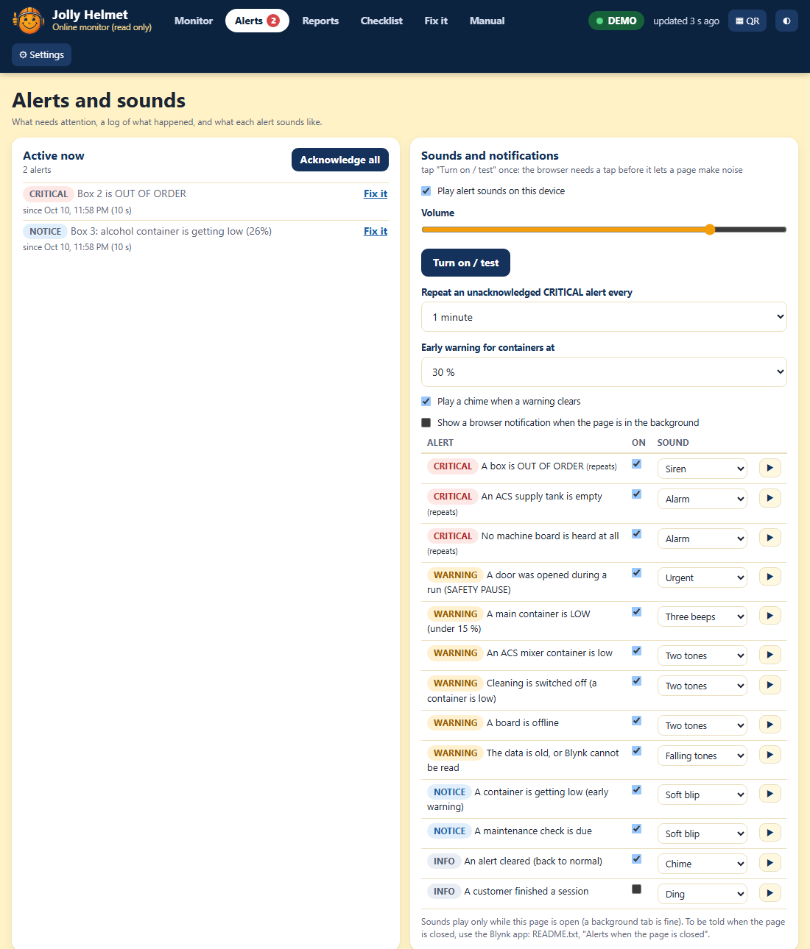
The Alerts tab: active alerts, the sound settings and the log (demo data)

A page that is closed, or a phone that is locked, cannot play a sound. For alerts on a closed page use the Blynk app (Technician guide, Online monitoring, Alerts when the page is closed).

Reports
- Revenue and customers per day for the last 14 days, with the 7-day average, and this week against the week before.
- Busiest hours and busiest days: when the customers come.
- What each box earns: sessions, revenue and the share of each box.
- Daily CSV, Last sessions CSV and Boxes and hours CSV open in Excel. Print / save as PDF makes a clean report page.
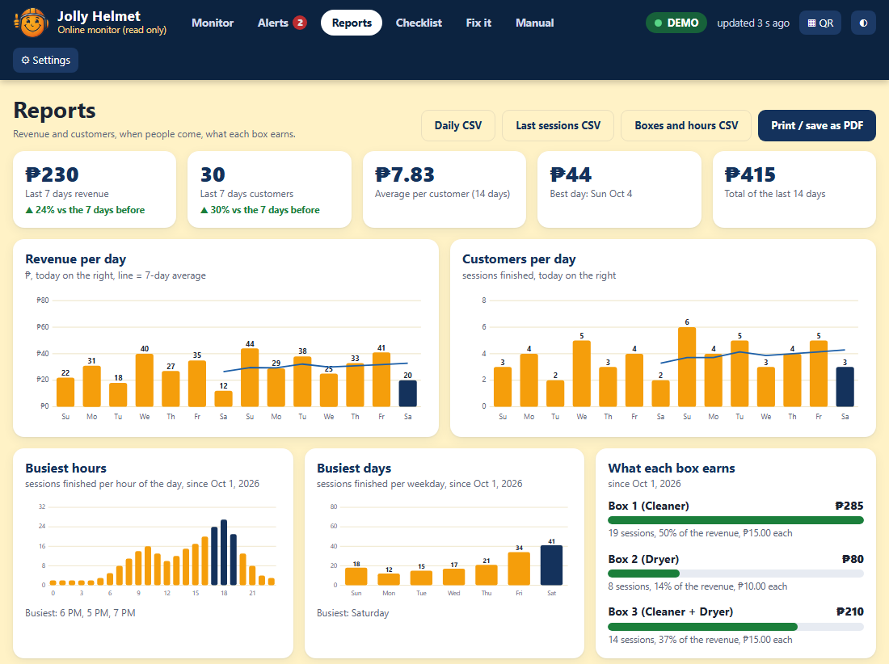
The Reports tab (demo data)

Technician guide (Hardware, online monitoring and maintenance)
Components, pinouts, wiring, firmware, online monitoring and maintenance

How it is built
Each machine is a small team of ESP32 boards that talk by radio (ESP-NOW, channel 1). The only wires between the boards are power wires.
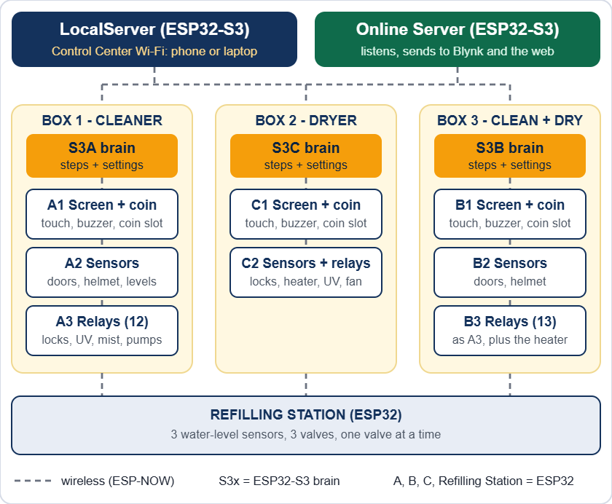
The whole installation: three boxes, the Refilling Station, the LocalServer and the Online Server

The 14 boards

Board | Where | What it does (sketch folder)
S3A | Box 1 | Main controller (brain). Runs every step and keeps the settings. (ESP32_S3A)
A1 | Box 1 | Touch screen, coin slot, buzzer. (ESP32_A1)
A2 | Box 1 | Sensors: 4 doors, helmet, 2 containers, 2 water sensors. (ESP32_A2)
A3 | Box 1 | 12 relays: 4 locks, 3 humidifiers, 2 UV, 2 drain pumps, coin power. (ESP32_A3)
S3C | Box 2 | Main controller. (ESP32_S3C)
C1 | Box 2 | Touch screen, coin slot, buzzer. (ESP32_C1)
C2 | Box 2 | 3 door sensors, helmet sensor and 6 relays: 3 locks, heater, UV, fan. (ESP32_C2)
S3B | Box 3 | Main controller. Runs the 36-step flow and reads the Refilling Station. (ESP32_S3B)
B1 | Box 3 | Touch screen, coin slot, buzzer. Shows OUT OF ORDER by itself and beeps when S3B is silent. (ESP32_B1)
B2 | Box 3 | Sensors: the helmet ultrasonic and the four door switches only. (ESP32_B2)
B3 | Box 3 | 13 relays (the two drain pump channels are never driven), including the heater. All off after 15 s without S3B; releases a trapped helmet. (ESP32_B3)
Refilling Station | Boxes 1 to 3 | 3 water-level sensors and 3 valves. Fills the three main containers from one supply, one valve at a time. (ESP32_REFILL)
LocalServer | Control Center | Wi-Fi JollyHelmet-Local, settings pages, revenue. Also broadcasts its revenue totals for the Online Server. (ESP32_LOCALSRV)
Online Server | Online | Listens to the machines and sends a snapshot to Blynk for the web page. Never controls anything. (ESP32_ONLINESRV)

Brains and terminals
- Brains (S3A, S3B, S3C, LocalServer, Online Server) are ESP32-S3 boards with 16 MB flash and 8 MB PSRAM. Nothing is wired to them except power.
- Terminals (the A, B, C boards and the Refilling Station) are plain ESP32 (WROOM) boards on screw-terminal expansion boards. They hold every sensor, relay and display wire. A3 and B3 must not be WROVER (PSRAM) boards, because GPIO 16 and 17 are relays.
- Settings are saved inside the brains (S3A, S3B, S3C) and the Refilling Station. The LocalServer only saves the revenue numbers. The Online Server saves its own Wi-Fi, Blynk token and the daily revenue history.
- If a terminal hears nothing from its brain for 15 seconds, it switches its relays off (heater, UV, mist, pumps, coin power). If a helmet is stuck behind a closed door, it also lets the enclosure lock go.
- Box 3 never traps a helmet. If the main controller S3B is silent, the relay controller B3 releases the enclosure lock when the sensors B2 see a helmet inside with the door shut, and the screen board B1 shows OUT OF ORDER with "Your helmet is still inside" and beeps. If S3B is alive but B2 or B3 is silent, S3B does the same. After a power cut, when S3B restarts, it hands a helmet that is still shut inside back first (OPEN B).
- UPS for Box 3: put B1, B2, B3 and the supply of the enclosure lock on a UPS, and leave the S3 boards, the LocalServer and the Online Server on mains. A power cut then silences the S3 and Box 3 goes OUT OF ORDER from any step, so the customer can take the helmet out. A paid session cut by the power is not restored.
- One number decides "helmet inside" for S3B, B3 and B1: Helmet counts as inside under (Box 3 page, default 15 cm). B3 and B1 learn it from S3B and keep it in their own memory.
- The enclosure door also has a mechanical safety slide (lower left) that unlocks it by hand, with no power and no firmware.

Component list
Quantities are for the whole installation: Box 1, Box 2, Box 3 and the Refilling Station.

Boards and display

Item | Qty | Used in
ESP32 DevKit (ESP32-WROOM-32) with screw-terminal expansion board | 9 | A1 A2 A3 B1 B2 B3 C1 C2 Refilling Station
ESP32-S3 DevKit N16R8 (16 MB flash, 8 MB OPI PSRAM) | 5 | S3A S3B S3C LocalServer Online Server
2.8 in SPI TFT with resistive touch (ST7789, 240 x 320) | 3 | A1, B1, C1
Allan multi-coin acceptor, 12 V | 3 | One per box
Active buzzer | 3 | A1, B1, C1
Resistor 10 kΩ | 3 | Coin signal lines

Sensors

Item | Qty | Used in
MC-38 magnetic door sensor (reed) | 11 | Box 1: 4, Box 2: 3, Box 3: 4
Ultrasonic distance sensor HC-SR04 (5 V) | 5 | Helmet: 3 (one per box). Main containers: 2 (Box 1 only; Box 3's are not used any more).
Analog water-level sensor | 5 | Box 1: 2, Refilling Station: 3 (one in each box's main container)

Relay boards

Item | Qty | Used in
16-channel relay board, active-LOW | 2 | A3 (12 used), B3 (13 used)
6-channel relay module | 1 | C2 (all 6 used)
Relay module, 3 channels or more, active-LOW | 1 | Refilling Station (3 used)

Loads

Item | Qty | Used in
12 V solenoid door lock | 11 | Box 1: 4 (enclosure, panel, back, side). Box 2: 3. Box 3: 4.
Humidifier (mist maker), 5 V | 6 | Box 1: 3, Box 3: 3 (alcohol, scented, both)
Drain pump, 5 V | 2 | Box 1: 2 (Box 3's two are not used any more: its drain is a manual valve)
Solenoid valve, normally closed | 3 | Refilling Station: one per box (coil voltage still to be decided: 12 V DC or 220 V AC)
UV-C germicidal disinfection lamp, 220 V | 5 | Box 1: 2, Box 2: 1, Box 3: 2
Heater (hair dryer), 220 V | 2 | Box 2, Box 3
Fan, 5 V | 1 | Box 2 cool-down

Power and protection

Item | Qty | Used in
12 V power supply | 5 | Locks, coin slots and the DC-DC modules
DC-DC power module, 12 V in, 3.3 V and 5 V out (multi output) | 5 | All ESP32 boards, screens, relay boards, sensors, mist makers, pumps
Diode 1N4007 | 11 or more | One across every lock solenoid
Fuses, 220 V inlet or outlets, earth | - | Mains side: UV-C lamps and heaters

Not electrical: the main containers (Box 1: alcohol and scented; every other box: one container), one water supply (a tank or a tap) for the Refilling Station, tubing and fittings.

What is in each unit

Item | Box 1 | Box 2 | Box 3 | Refilling Station
ESP32 terminal boards | 3 | 2 | 3 | 1
ESP32-S3 main controller | 1 | 1 | 1 | -
Touch screen, coin slot, buzzer | 1 | 1 | 1 | -
Door sensors | 4 | 3 | 4 | -
Ultrasonic sensors | 3 | 1 | 1 | -
Water-level sensors | 2 | - | - | 3
Door locks | 4 | 3 | 4 | -
Humidifiers | 3 | - | 3 | -
Drain pumps | 2 | - | - | -
Valves | - | - | - | 3
UV-C lamps (220 V) | 2 | 1 | 2 | -
Heater | - | 1 | 1 | -
Fan | - | 1 | - | -

Pinouts
GPIO numbers are the ESP32 pin names (D4 = GPIO4). Every relay input is active-LOW: the pin goes LOW to switch the relay ON. These tables match the flashed firmware and the pin sheet RevisedJollyHelmet_Checked.xlsx.

Relay input numbers (IN1, IN2...) come from the Cirkit drawing. The GPIO is what the firmware drives. If a relay sits on a different input, trust the GPIO and fix the label.

S3A, S3B, S3C and LocalServer - nothing to wire
These four boards have no external wiring: power (5 V) and the USB cable for flashing only. GPIO 35, 36 and 37 are used inside the module by the OPI PSRAM: never connect anything to them.

A1, B1, C1 - screen, coin slot, buzzer
Identical wiring on A1, B1 and C1, with one difference: the coin signal of C1 is on GPIO 32 (A1 and B1 use GPIO 23).

GPIO | Signal | Wired to
15 | TFT CS | Display CS
4 | TFT RESET | Display RST
2 | TFT DC | Display DC (RS)
13 | MOSI (shared) | Display SDI (SDA) and touch T_DIN
14 | SCK (shared) | Display SCK (SCL) and touch T_CLK
27 | Touch CS | Touch T_CS
12 | Touch MISO | Touch T_DO
23 (C1: 32) | Coin signal | Allan COIN, through a 10 kΩ resistor
21 | Buzzer | Active buzzer +
5V | Display power | Display VCC and LED (BLK)
GND | Ground | Display, coin acceptor, buzzer -

- Not connected: display SDO (MISO), touch T_IRQ, coin COUNTER.
- Coin acceptor 12 V: from the COIN POWER relay on A3 and B3 (Box 1, Box 3). Straight from the 12 V supply in Box 2.
- Free pins on A1 and B1: 5, 16, 17, 18, 19, 22, 25, 26, 32, 33. Free pins on C1: 5, 16, 17, 18, 19, 22, 23, 25, 26, 33.

A2 (Box 1) and B2 (Box 3) - sensors

GPIO | Signal | Wired to
26 | Helmet ultrasonic TRIG | Sensor TRIG
25 | Helmet ultrasonic ECHO | Sensor ECHO
32 | Alcohol container TRIG | Sensor TRIG
33 | Alcohol container ECHO | Sensor ECHO
23 | Scented container TRIG | Sensor TRIG
22 | Scented container ECHO | Sensor ECHO
27 | Enclosure door | MC-38 sensor S
14 | Panel door | MC-38 sensor S
19 | Back door | MC-38 sensor S
18 | Side door | MC-38 sensor S
34 | Alcohol water sensor | SIG (analog, input only)
35 | Scented water sensor | SIG (analog, input only)

- Ultrasonic VCC 5 V. Water sensors 3.3 V. Door sensors: the other wire goes to GND, the ESP32 supplies the pull-up (closed = LOW).
- Free pins: 2, 4, 12, 13, 15, 16, 21.
- B2 (Box 3) reads only the helmet ultrasonic (GPIO 26 and 25) and the four door switches (27, 14, 19, 18; the last one is the Side door). The container ultrasonics (32, 33, 23, 22) and the two water sensors (34, 35) are not read by the B2 firmware: the Refilling Station reads the containers.

A3 - Box 1 relays (16-channel board)

GPIO | Input | Load | Supply
4 | IN1 | Enclosure door lock | 12 V
16 | IN2 | Panel door lock | 12 V
17 | IN3 | Back door lock | 12 V
23 | IN4 | Side-door lock | 12 V
18 | IN5 | Humidifier 1 (alcohol) | 5 V
19 | IN6 | Humidifier 2 (scented) | 5 V
25 | IN7 | Humidifier 3 (both) | 5 V
22 | IN9 | Coin power (the coin slot's 12 V) | 12 V
27 | IN10 | UV-C lamp 1 | 220 V
21 | IN11 | UV-C lamp 2 | 220 V
33 | IN12 | Drain pump 1 (alcohol container) | 5 V
32 | IN13 | Drain pump 2 (scented container) | 5 V

- Supply column: what each load runs on. The UV-C lamps are 220 V: the relay contact switches the live wire (see Switching 220 V loads). Locks and the coin slot are 12 V, humidifiers and drain pumps 5 V.
- IN8 and IN14 to IN16 are not used. GPIO 2, 12 and 15 are left idle (boot pins).

B3 - Box 3 relays (16-channel board)
Pin for pin the same as A3, plus one more relay:
Box 3 notes: the two drain pump channels (GPIO 33 and 32) are never driven by the B3 firmware, whatever S3B or a dashboard asks (the drain is a manual valve). The lock on GPIO 23 is the SIDE LOCK (the lock of the side door).

GPIO | Input | Load | Supply
26 | IN14 | Heater (hair dryer) | 220 V via the relay contacts

C2 - Box 2 sensors and relays

GPIO | Signal | Wired to
26 | Helmet ultrasonic TRIG | Sensor TRIG
25 | Helmet ultrasonic ECHO | Sensor ECHO
27 | Enclosure door | MC-38 sensor S
14 | Panel door | MC-38 sensor S
19 | Back door | MC-38 sensor S

Relays (6-channel module):

GPIO | Input | Load | Supply
4 | IN1 | Enclosure door lock | 12 V
16 | IN2 | Panel door lock | 12 V
17 | IN3 | Back door lock | 12 V
18 | IN4 | Heater (hair dryer) | 220 V
23 | IN5 | Fan | 5 V
5 | IN6 | UV-C lamp | 220 V

- GPIO5 gives a short pulse when the board powers up, so the UV relay may click once. Recommended: when you next reflash C2, move the UV relay to a boot-safe pin (13, 21, 22, 32 or 33) so a 220 V UV-C lamp can never flash at power-up.

Refilling Station - sensors and valves
One plain ESP32 (WROOM) on a screw-terminal expansion board, plus a relay module with 3 channels used. The pins are in the pin sheet RevisedJollyHelmet_Checked.xlsx (block F1) and in ESP32_REFILL.ino.

GPIO | Signal | Wired to
34 | Water-level sensor, Box 1 container | SIG (analog, input only)
35 | Water-level sensor, Box 2 container | SIG (analog, input only)
32 | Water-level sensor, Box 3 container | SIG (analog)
21 | Valve 1 (Box 1) | Relay module IN1
19 | Valve 2 (Box 2) | Relay module IN2
18 | Valve 3 (Box 3) | Relay module IN3
3V3, GND | Sensor power | VCC and GND of the three sensors
5V, GND | Relay module power | VCC and GND of the relay module

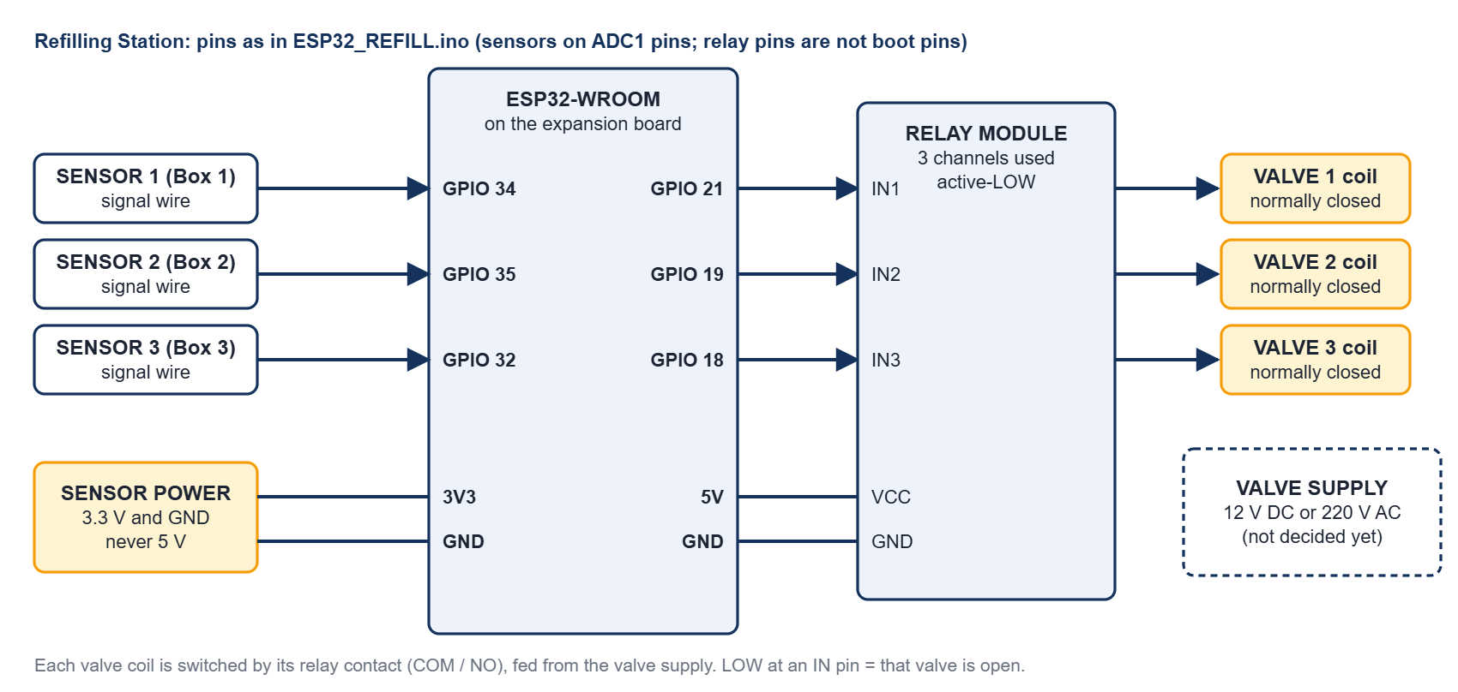
Refilling Station: sensors to the ADC1 pins, relay inputs to GPIO 21, 19 and 18, valve coils switched by the relay contacts
- The sensors are on ADC1 pins (GPIO 32 to 39) because ADC2 cannot be read while Wi-Fi or ESP-NOW runs. Power the sensors from 3.3 V: the ADC input must never see 5 V.
- The relay modules of this project are active-LOW (LOW at an input = relay on = valve open). The firmware assumes that (VALVE_ACTIVE_LOW 1); if the module you fit is active-HIGH, set it to 0.
- First power-up with the valves unplugged: the three relay LEDs must be OFF. The serial banner says which level the sketch assumes. Then use Test valve one valve at a time.
- The valve coil voltage (12 V DC or 220 V AC) is not decided yet. No flyback diode was asked for (the station stands apart from the boxes and has no coin signal). If the station resets when a valve switches, put a diode across a DC coil or an RC snubber across an AC coil.
- The relay pins are not strapping pins (0, 2, 5, 12, 15) and not flash pins, and stay quiet at power-up. The valves are driven closed before the pins become outputs.

Circuit and wiring

Circuit summary
- Every box is a group of ESP32 boards and the Refilling Station is one board. They share only power and the radio channel.
- Every lock, lamp, pump and heater is switched by a relay contact. Every sensor is read directly by a terminal board.
- Voltages: 12 V (door locks, coin slots), 5 V (ESP32 boards, screens, relay boards, HC-SR04 ultrasonic sensors, humidifiers, pumps), 3.3 V (water-level sensors, from the ESP32 3V3 pin or the DC-DC module), 220 V (the UV-C lamps and the heaters).

Power and grounding
- Measure every output of the DC-DC module (5 V and 3.3 V) with a meter before you connect boards. Never put 12 V on an ESP32 pin or on the 5 V rail.
- Join all grounds: 12 V -, 5 V - and every ESP32 GND. Never join a 12 V + to a 5 V +.
- A relay module has a JD-VCC jumper. Jumper on: the coils run from the module's VCC (one 5 V supply, shared ground). Jumper off: feed JD-VCC and its GND from a separate 5 V supply.
- Locks, pumps and heaters starting can pull the 5 V down. Symptoms: white screen, LocalServer restarts, odd resets. Cures: short thick 5 V wires, a 470 to 1000 µF capacitor next to the TFT and the ESP32, a separate 5 V for the relay coils. The firmware also switches relays on 25 ms apart.
- Put a fuse on every supply. Keep the 220 V wiring in its own enclosure, away from the boards.
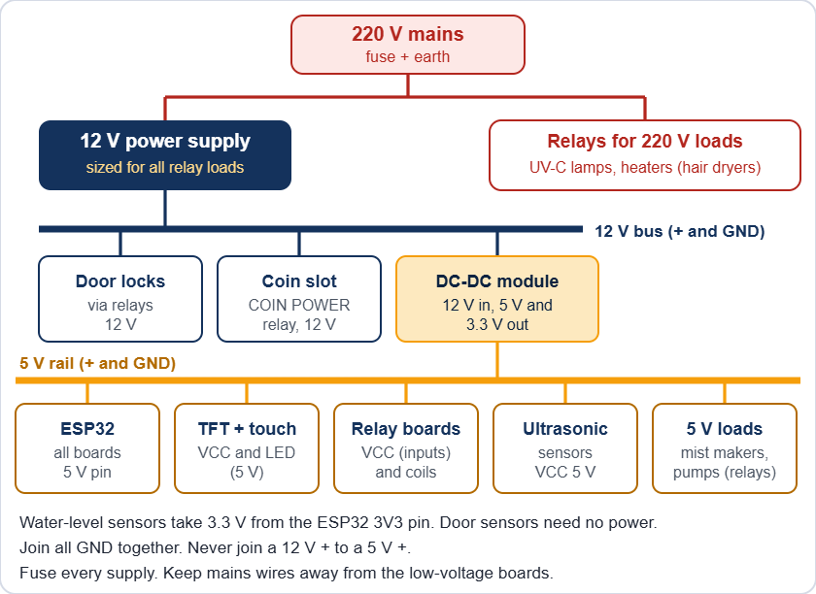
Power for one box (the exact rails are listed in the component tables)

Relay outputs
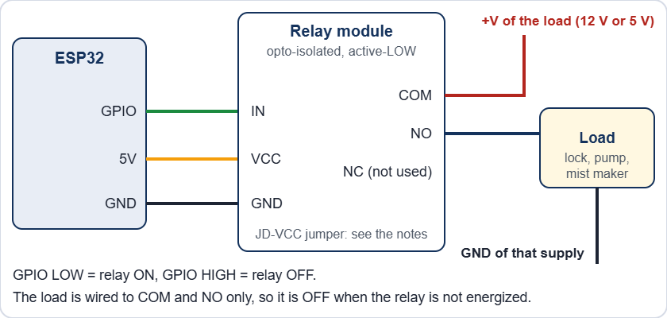
One relay channel
- Wire the load to COM and NO. Then it stays off when the relay or the board has no power. Leave unused channels unwired.
- Relay pins avoid GPIO 0, 1, 2, 3, 5, 12, 14, 15 because they pulse at boot. Safe output pins: 4, 13, 16 to 19, 21 to 23, 25 to 27, 32, 33.
- GPIO 34, 35, 36 and 39 are input only.

Switching 220 V loads (UV-C lamps and heaters)
- The UV-C germicidal lamps and the heaters (hair dryers) run on 220 V. The relay contact switches only the live wire. The neutral goes straight from the supply to the load. The relay board's low-voltage side (IN pins, VCC) stays on the ESP32 side.
- Use relay contacts rated for the load. Most relay boards are 10 A at 250 V AC. A hair dryer can draw 8 A or more (read its label). A UV-C lamp draws much less, but its ballast or driver can pull a high current at switch-on.
- Fuse the 220 V feed of each box. Connect the earth wire to every metal part. Use insulated terminal blocks, strain relief on every cable, and keep 220 V wires away from the low-voltage boards and the screen.
- Recommended: a door switch in series with the live wire of each UV-C lamp, so the lamp cannot be lit with a door open even if the firmware or a relay fails.

Never open a box with the 220 V connected. Unplug it first.

Door locks
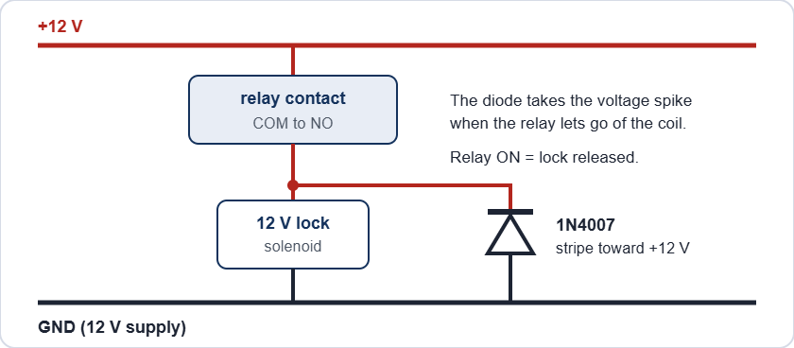
A door lock with its flyback diode
The locks are power-to-unlock: the relay is ON only while the door may open (the OPEN steps, Maintenance, or the trapped-helmet release). With no power a solenoid keeps its door locked, but the enclosure door also has a mechanical safety slide that opens it by hand (next block). The 1N4007 takes the voltage spike when the relay lets go of the coil. Without it the spike can reset the board and burn the relay contacts.

After a power cut the solenoid locks stay shut, but the enclosure door can be opened at once with the safety slide (lower left of the door, slide it down). When power is back, release a lock from the Control Center: Box page, Maintenance, ENCLOSURE LOCK. It switches itself off after 60 seconds.

Safety slide on the enclosure door
The enclosure door has a mechanical safety slide at its lower left. Sliding it down unlocks the door by hand. It works with no power, with a broken solenoid and without any help from the boards. It is the way out for a trapped helmet.
- The slide is part of the door. It is not wired and the firmware does not read it. When the door opens, the door sensor reports it: during a run the box shows SAFETY PAUSE and the UV-C, the mist and the heater are switched off within about 2 seconds.
- A door switch in series with each UV-C lamp (recommended, see Switching 220 V loads) cuts the lamp at once when the door opens, even before the firmware reacts.
- After the slide has been used, put it back in its normal position, close the door and check that the lock holds it. The Maintenance page of the Control Center switches the lock for a test.
- Test the slide every month (see the schedule in Maintenance): with the power off, sliding it down must unlock the door by hand. Never block, tape or remove the slide.

Coin slot and buzzer
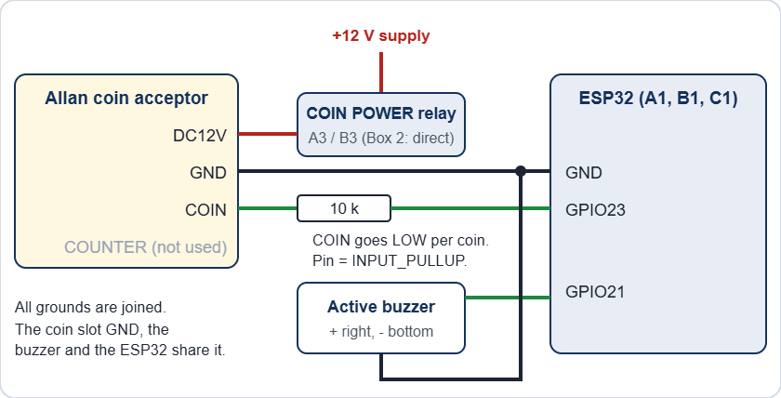
Coin acceptor and buzzer on A1, B1 and C1
- The Allan COIN output pulls to ground once per coin pulse. The pin is INPUT_PULLUP and the firmware counts falling edges, so the pin never sees more than 3.3 V. Check it once with a meter on every new unit.
- FAST, MED, SLOW and SET are switches on the acceptor itself, not wires. COUNTER is not used.
- The buzzer is the active type: GPIO21 HIGH = sound. If it sounds weak, or the board resets when it sounds, drive it through a transistor.

Sensors

Sensor | Wire | Goes to
Ultrasonic HC-SR04 | VCC | 5 V
 | TRIG | GPIO (output)
 | ECHO | GPIO (input), through a divider (the HC-SR04 gives 5 V)
 | GND | GND
Water-level | SIG | GPIO34 or GPIO35 (analog, input only)
 | VCC | 3.3 V
 | GND | GND
MC-38 door | S | GPIO (INPUT_PULLUP). Magnet near = closed = LOW
 | GND | GND

The HC-SR04 sends 5 V on ECHO and the ESP32 pins are not 5 V tolerant. Put a divider on every ECHO: ECHO to 1 kΩ to the GPIO, and 2 kΩ from that GPIO to GND. (A 3.3 V module such as the HC-SR04P needs none.) The pin sheet shows no divider, so check that every sensor has one.

Screen and touch
The display and the touch controller share the SPI lines MOSI (13) and SCK (14). Each has its own chip select (15 and 27). TFT_eSPI drives the display as an ST7789, 240 x 320. B1 is mounted upside down, so it runs setRotation(3).

Mains and UV safety

Mains can kill. The UV-C lamps and the heaters are on 220 V. Unplug the machine and wait before you open a box. Keep all 220 V wiring fused, earthed, in a closed enclosure with strain relief, away from the low-voltage boards.

UV-C light injures eyes and skin, even for a moment. Never look at a lit lamp and never test it with the door open. The firmware switches UV and mist off the moment a door opens, but firmware is not a safety device. Recommended: a door switch in series with the lamp's live wire, so the lamp cannot be on with a door open, and a warning label on every box.

Firmware and flashing

Arduino IDE settings

Board type | Settings
Terminals (A, B, C, Refilling Station) | Board: ESP32 Dev Module. esp32 core 3.3.7. Upload speed 921600. Other options default.
Brains (S3A, S3B, S3C), LocalServer and Online Server | Board: ESP32S3 Dev Module. USB CDC On Boot: Enabled. CPU 240 MHz. Flash mode QIO 80 MHz. Flash size 16 MB. Partition: 16M Flash (3MB APP/9.9MB FATFS). PSRAM: OPI PSRAM. Upload speed 921600.

Libraries
- TFT_eSPI 2.5.43: only A1, B1, C1 (edit its User_Setup.h, see below).
- ArduinoJson 7.4.3, Async TCP 3.5.0, ESP Async WebServer 3.12.0: only the LocalServer and the Online Server.
- Everything else (WiFi, ESP-NOW, Preferences) comes with the ESP32 core.

TFT_eSPI User_Setup.h

Setting | Value
Driver | ST7789_DRIVER (the only one not commented out)
TFT_WIDTH, TFT_HEIGHT | 240, 320
TFT_MISO, TFT_MOSI, TFT_SCLK | 12, 13, 14
TFT_CS, TFT_DC, TFT_RST | 15, 2, 4
TOUCH_CS | 27
SPI_FREQUENCY, SPI_TOUCH_FREQUENCY | 20000000, 1000000

Flash a new or replacement board
- Find the board in the table The 14 boards and open its sketch folder in the Arduino IDE.
- The folder must hold the same Shared_Common.h as ESP32_S3A (the master copy). Different copies make boards ignore each other's messages.
- Choose the settings above, plug in the USB cable and upload.
- Open the Serial Monitor at 115200 baud to read the board's log.
- Watch the board's badge turn ONLINE in the Devices list on the Control Center Dashboard.
- For a brain (S3) or the Refilling Station, enter its settings again on its Control Center page. A new board starts with the default values.

Never run a bench or settings sketch (ESP32_S3A_CONFIG_BENCH, ESP32_S3C_CONFIG_BENCH, ESP32_REFILL_FAKE (the stand-in station), ESP32_A1_WIDGET_TEST) at the same time as the LocalServer or the real brain. They send the same messages and fight over them.

Test sketches

Sketch | Use
ESP32_A3_BENCH_TEST | Tests A3 alone: it pretends to be S3A and A2.
ESP32_B3_RELAY_TEST | Wi-Fi page (BOX 3 B3 TEST, password 12345678) to switch each B3 relay by hand.
ESP32_BUZZER_ULTRASOUND_TEST | Wi-Fi page to test a buzzer and read an ultrasonic sensor.
ESP32_C1_CALIBRATE | Touch calibration: touch the 4 targets, copy the printed calData line into the terminal sketch.

Safety built into the firmware
- Every relay pin is set OFF before it becomes an output, so relays do not pulse at power-up.
- Relays that turn on are staggered 25 ms apart, so loads do not start in the same instant.
- A door that opens during a run switches UV and mist off at once (SAFETY PAUSE).
- A terminal that loses its brain for 15 seconds switches its relays off.
- Hand-set relays in Maintenance switch themselves off after 2 seconds (the box does it by itself; the drain pumps and the coin power are exempt, and the tick box Bypass Safety 2 Seconds Relay turns it off). With the bypass the heater still goes off after 5 minutes and the enclosure lock after 60 seconds.
- Box 3 never locks a helmet in: with a helmet shut inside, OUT OF ORDER and power cuts release the enclosure lock and the screen board beeps (see How it is built, Brains and terminals).
- The coin slot only has power while a payment is possible (Box 1 and Box 3).

The LocalServer must be flashed with the version that broadcasts its revenue totals every 10 seconds, or the Online Server shows no analytics. No other board needs a reflash for the Online Server.

Online monitoring
The Online Server is one more ESP32-S3 board. It listens to the machines (it never controls them), sends a snapshot to Blynk every minute, and a web page shows that snapshot from any phone or PC. Nothing on the web page can start, stop or change a machine.
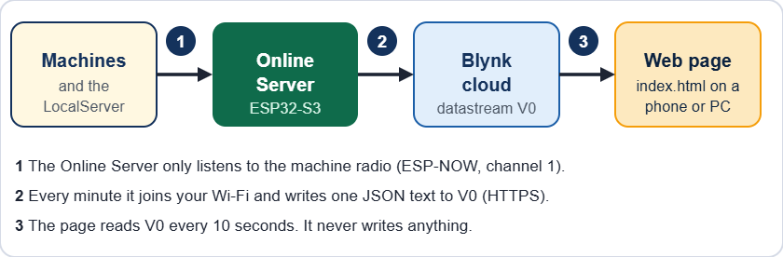
From the machines to the web page

What you need
- The Online Server (ESP32_ONLINESRV), powered with 5 V, near the machines so it hears every board by radio.
- The LocalServer switched on and flashed with the new version. It sends the revenue totals. Without it the analytics stay empty (the live data still works).
- A 2.4 GHz Wi-Fi network with internet: the school Wi-Fi or a phone hotspot, on any channel.
- A Blynk account and the Blynk Console (blynk.cloud).
- The folder ONLINE_WEB (the web page): put it on any web host, or just open index.html from a PC.

Step 1 - Set up Blynk (once)
- Sign in to the Blynk Console. Open Developer Zone, then My Templates, then New Template.
- Name: Jolly Helmet Online Server. Hardware: ESP32. Connection type: Wi-Fi. Click Done.
- Open the Datastreams tab. Click New Datastream, then Virtual Pin. Fill in V0 as in the table below and click Create.
- Optional: make V1 to V4 the same way (single numbers for Blynk's own dashboard and phone app). Default value 0.
- Optional: open the Events tab, click New Event, code alert (exactly), type Warning or Critical, and switch on a notification (push or e-mail).
- Click Save at the top right of the template. Without Save the device does not see the new datastreams.
- Open Devices, click New Device, choose From template, pick your template, name it Online Server and click Create.
- Open the device, tab Device info, and copy the Auth Token. Keep it private.

Name | Pin | Type | Min | Max | Needed?
live | V0 | String | - | - | Yes. The web page reads only this one.
revenue | V1 | Double | 0 | 100000000 | Optional (2 decimals)
customers | V2 | Integer | 0 | 10000000 | Optional
alerts | V3 | Integer | 0 | 30 | Optional
running | V4 | Integer | 0 | 3 | Optional

Step 2 - Set up the Online Server
- Flash ESP32_ONLINESRV (same settings as the LocalServer, see Firmware and flashing) and power it.
- On a phone, join the Wi-Fi JollyHelmet-Online (password 12345678). The setup page opens by itself. If it does not, open http://192.168.4.1.
- Tap Search for networks and tap your Wi-Fi, or type its name. Type its password.
- Paste the Blynk Auth Token.
- Choose how often to send. 1 minute is a good start. Tick "single numbers V1 to V4" and "Blynk event" only if you made them in Blynk. Under More settings: the time zone (8 for the Philippines) and, if you want the quota bar on the web page, the number of Blynk messages your plan gives per month.
- Tap Save and connect. The board tests the Wi-Fi and Blynk at once. The setup page may stop answering for a few seconds: this is normal, the board moves to your router's channel. It reconnects by itself and shows the result.
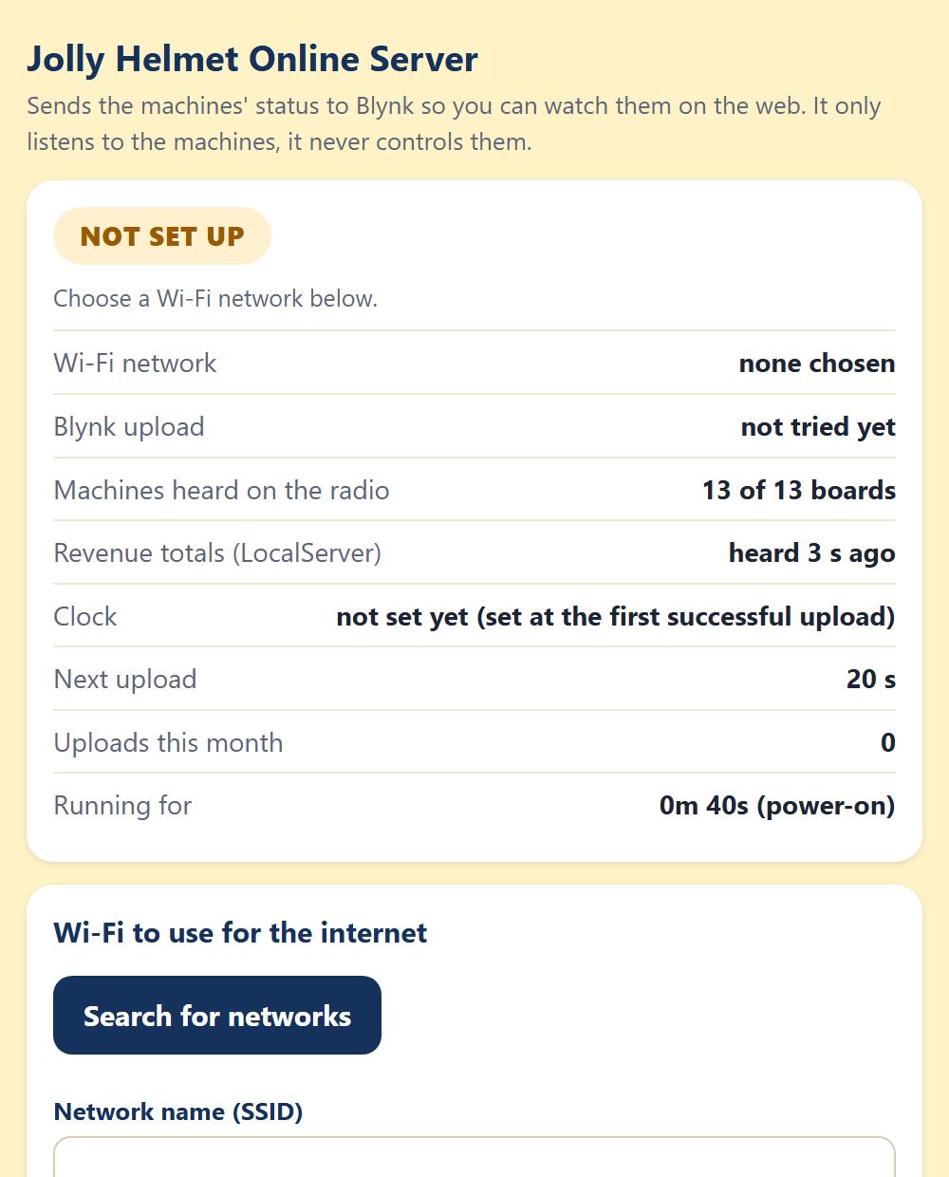 | 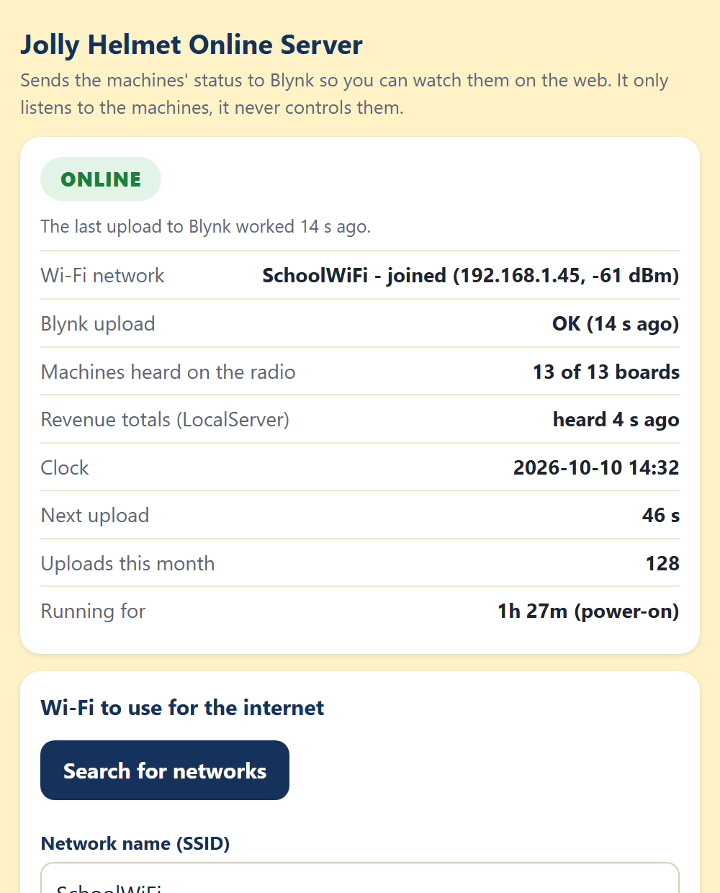 | 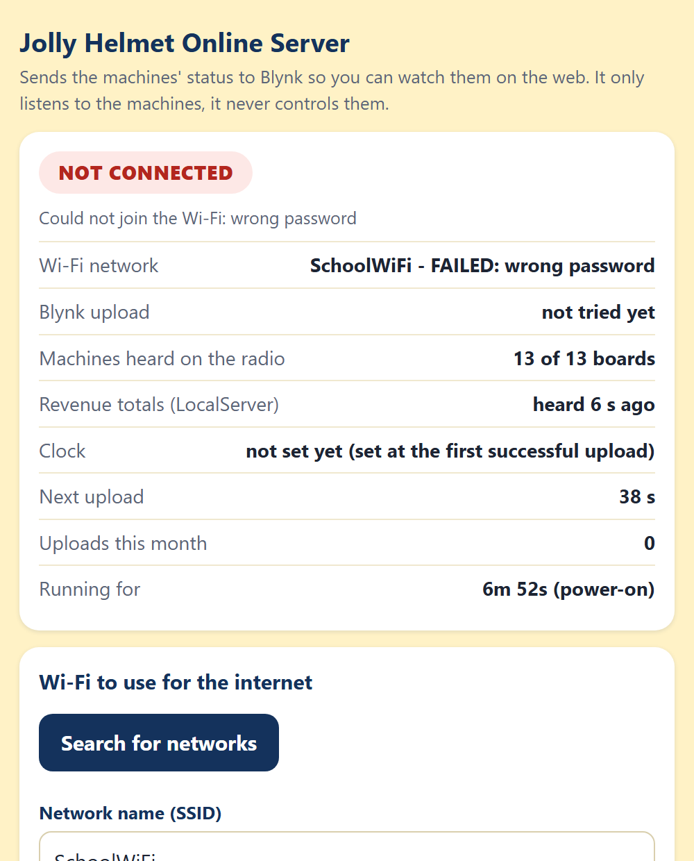
The setup page: not set up yet, online, not connected (wrong password)

On the setup page | Meaning
ONLINE (green) | The last upload to Blynk worked. It shows how many seconds ago.
NOT SET UP (amber) | No Wi-Fi or no token is saved yet.
TESTING (blue) | The board is joining the Wi-Fi and talking to Blynk.
NOT CONNECTED (red) | The Wi-Fi or Blynk failed. The reason is written under the badge.
Machines heard | Must be 12 of 12 when every board is on.
Revenue totals | "heard 4 s ago" means the LocalServer is on. "not heard yet": switch it on or reflash it.
Clock | Set at the first successful upload. The day charts and the secure connection need it.

While you use the setup page the board waits 90 seconds before its next upload, so the page does not drop while you type. A phone left connected to its Wi-Fi is disconnected for a moment at every upload.

Step 3 - Open the web page
- Put the folder ONLINE_WEB on a web host (GitHub Pages, Netlify, Cloudflare Pages, the school server) or open index.html on a PC.
- The first time, the page asks for the Blynk Auth Token. Paste it and click Connect. It is kept in that browser only. On a phone you can also open the page once as index.html#token=THE_TOKEN.
- To try the page without hardware, add ?demo to the address (or ?demo=alerts to see the warnings).
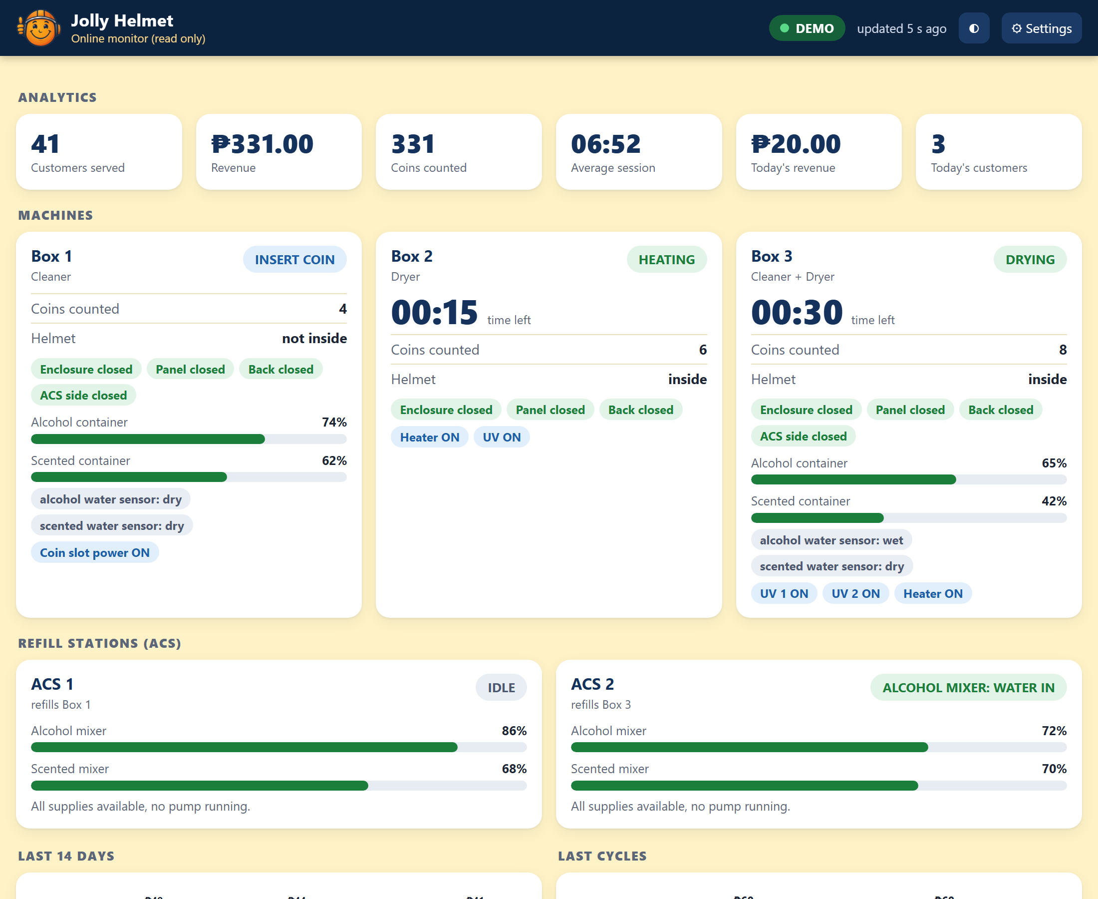 | 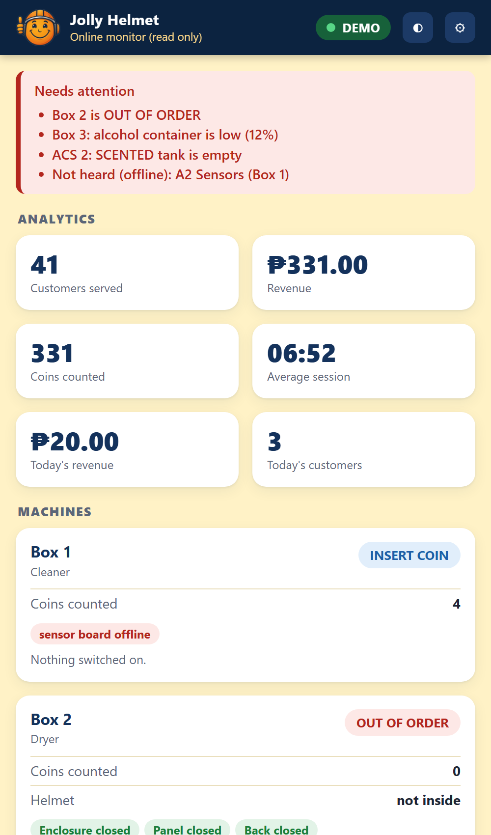
The web page on a PC and, on the right, on a phone with warnings (demo data)

Reading the web page

Part | What it shows
Badge (top right) | LIVE green: fresh data. DELAYED amber: a little late. OLD DATA red: nothing new for a long time. BAD TOKEN or NO LINK: the page cannot read Blynk. Next to it: "updated 5 s ago".
Needs attention (red box) | A box out of order, the Refilling Station offline, a failed refill, a board that is not heard.
Analytics | Customers served, revenue, coins, average session, today's revenue and customers.
Machines | The step (green = running, blue = a customer is using it, amber = needs attention, red = out of order), time left, coins, helmet, doors, container levels with a small graph, water sensors and the relays that are ON.
Refilling Station | The level of each main container as a dial, the valve that is open, and who is waiting.
Last 14 days, Last cycles | Revenue per day (today on the right) and the last 10 sessions (revenue and length).
Boards and Online Server | Online or offline for the 13 boards, the Online Server's uptime, restart reason, Wi-Fi signal, free memory and uploads this month.
Buttons | The half-moon switches light and dark. Settings: token, Blynk server and refresh time (5 seconds to 1 minute).

If a box shows "sensor board offline", the page does not hear that board, so it hides that box's doors, helmet and levels instead of showing wrong numbers.

Good to know
- The page only reads. A Blynk token can also write values, so do not publish it: leave it out of the page files and type it in the page.
- Blynk counts messages. One upload a minute is about 43,200 a month, plus one for V1 to V4 and one per alert event. Check your plan's limit.
- The Blynk Console may show the device as offline. This is normal: the board uses Blynk's web API, not a permanent connection. The page decides "alive" from the numbers inside the data.
- The board hears the machines on radio channel 1 and leaves it for about 5 to 10 seconds at every upload, so do not send faster than every 30 seconds.
- Only 2.4 GHz Wi-Fi works (the ESP32 cannot join 5 GHz).

Online troubleshooting

Message | Meaning | What to do
Requested datastream doesn't exist in the product | The template has no V0. | Create V0 (String) in the template and Save it.
Invalid token, BAD TOKEN | The token is wrong or belongs to another device. | Copy it again from Device info.
read Timeout, no answer | Blynk did not answer. The board tries once more with a shorter message. | Check that the Wi-Fi really has internet. Try your regional Blynk server in More settings. The status says if only the SHORT version went through.
network not found, wrong password | The Wi-Fi cannot be joined. | Check the name and password. It must be 2.4 GHz.
the clock could not be set | The Wi-Fi blocks the time servers (NTP). | Allow internet access. Last resort: tick "Skip the TLS certificate check".
Machines heard stays low after an upload | The radio did not return to channel 1. | Switch the Online Server off and on, and tell the builder.
Revenue totals not heard | The LocalServer is off or has the old version. | Switch it on, or reflash it.
V1-V4 failed, event failed | The optional datastreams or the alert event are missing in the template. | Create them, or untick them in the setup page.
The page says OLD DATA | The uploads stopped. | Open the board's setup page and read its status.

Customer status page (a second Blynk device)
The customer page (status.html) shows Box 1, Box 2 and Box 3 as FREE, IN USE or OUT OF ORDER. It is public, so it must not use your private token (a Blynk token can also write). It reads a second Blynk device that holds nothing but those three boxes.
- In the Blynk Console open Devices, New Device, From template, and pick the same template as before. Name it Jolly Helmet Public status.
- Open it, tab Device info, and copy its Auth Token. This token may be public. Never use the private token here.
- Open the Online Server setup page (Wi-Fi JollyHelmet-Online). Paste the token into Public status device token and tap Save and connect. The row Public status device on top then says OK.
- In the folder ONLINE_WEB open js/config.js and write the token in publicToken. (If you leave it empty, the QR code carries the token in the address.) Edit the prices and the "Something wrong?" line in the same file.
- Put the folder on the web host. Open the online page and tap the QR button. Paste the public token if it asks. Tap Print the sign and stick it on every machine.
- Test it: scan the QR code with a phone. The boxes must show FREE or IN USE. status.html?demo shows made-up data.

The public device holds | Meaning
b | For Box 1, Box 2 and Box 3: the step number, the seconds left and whether the brain is heard. Nothing else.
seq, ts, iv | A counter, the time and the upload interval. The page shows NO INFORMATION when the data is older than about 4 minutes.

If somebody misuses the public token, the worst they can do is write a wrong status into that one device (the next upload overwrites it within a minute) and use up some Blynk messages. They cannot reach the private device, the revenue or the machines. The page costs one more Blynk message per upload.

Online Server firmware of 2026-10-10
Flash ESP32_ONLINESRV again (same settings, see Firmware and flashing). The new version:
- counts every finished session per box, per hour of the day and per weekday, from the brains' own counters, and keeps the counts inside the board (this feeds Busiest hours, Busiest days and What each box earns in the Reports tab);
- writes the public status device when its token is set;
- shows two new rows on its setup page: Public status device and Sessions counted, and has a button Reset the per-box and busiest-hours statistics under More settings.
Until it is flashed, the three charts above say "Needs the Online Server firmware of 2026-10-10". Everything else works with the old firmware.

Optional customer names (Blynk V5)
A customer can type a nickname (12 characters at most) on the card of the machine that is running his or her cycle. Everybody who opens the customer page sees it ("Maria's helmet"), the customer's own phone says the helmet is done at the end, and the name clears by itself when the cycle ends. It is optional: no name, nothing shown.
- One extra datastream, once: in the Blynk Console, open the template of the public device, Datastreams, New, Virtual Pin V5, name names, data type String. Without it the page works as before and a customer who tries to add a name is told that names are not switched on yet.
- A name can be added only after the coins are in, so a payment that is cancelled never leaves a name behind. The phone that typed it can edit or remove it; other phones can only see it.
- The name is shown only while the box is looking after a helmet (OPEN A to ABORT) and only for that cycle. Flash the Online Server firmware of 2026-10-14 or later so it adds each box's session counter to the public value.
- Whatever sits in V5 is treated as untrusted text: the page strips < and > and control characters and shows it only as plain text. The page tells the customer to use a nickname, because the name is public to everybody who opens the page.
- Cost: a few Blynk messages for each customer who adds a name, nothing for the others. In js/config.js, names: false hides the feature and namesPin chooses the datastream.

Alerts when the page is closed (Blynk app)
A closed page cannot make a sound. The Blynk app can.
- On the Online Server setup page tick Send a Blynk event with code alert, then Save and connect.
- In the Blynk Console open the template, tab Events, and make sure the event with the code alert exists (see Step 1). Choose the type Warning or Critical and switch on its push notification. Click Save.
- Install the Blynk app on the phone, sign in with the same account and allow notifications. Every new alert (box out of order, Refilling Station offline, refill failed, board offline) now arrives as a notification, even with the page closed.

Online page problems

Symptom | Cause | What to do
No sound when an alert comes | The browser needs one tap. Or the page is closed, or sound is switched off. | Tap Turn on alert sounds. Keep the page open. Check Alerts, Sounds (the volume and the On boxes).
The customer page says NO INFORMATION | The public token is missing or wrong, the Online Server is not reflashed, or its data is old. | Check publicToken in js/config.js (or the QR address). The setup page row Public status device must say OK.
Busiest hours, days and box earnings are empty | The Online Server has the old firmware, or nothing was counted yet. | Flash the firmware of 2026-10-10 and wait for sessions.

Maintenance

Before you open a box: finish or cancel any run, switch the machine off at the mains and unplug it. Wait for the heater to cool.

Schedule

When | What to do
Every day | Dashboard: the Devices line says every board is online and there is no red banner. The online web page says LIVE. Look at the Refilling Station page (online, no FAILED container) and the water supply. Wipe the touch screens. Collect the coins and note the revenue.
Every week | Wipe the helmet chamber and the door seals. Open each door during a run: SAFETY PAUSE must show. Listen for each lock clicking. Look for leaks at the valves, the tubes and the containers. Test each UV-C lamp in Maintenance with the door closed (the relay must click; never look at a lit lamp). Check the humidifiers make mist.
Every month | Switch every relay by hand in Maintenance and listen for the click. Clean the ultrasonic sensor faces and the water-level probes. Compare each distance with a ruler (use live). Test the coin slot with every coin. Check screw terminals and plugs are tight and nothing is hot or discoloured. Clean the humidifier discs and the heater and fan air intakes. Test the safety slide of each enclosure door: with the power off, sliding it down must unlock the door by hand.
Every 3 months | Capture the water sensors again, dry and wet, with the real liquids. Check the touch accuracy. With the power off, check the mains wiring, earth and fuses. Take a screenshot of every Control Center settings page and keep it.
Once a year or when worn | Replace the UV-C lamps at the end of their rated hours (their output fades before they stop glowing). Replace pump tubing and slow pumps. Replace any lock that sticks or gets hot. Replace humidifier discs.

Calibrate

What | How (Control Center)
Helmet distance | Box page: put a helmet in, tap use live, then Send. Do the same on Box 2 (HEAT).
Container lines | LEVELS: fill to each line, tap use live. Bigger number = emptier.
Water sensors | LEVELS: dry now, then wet now in the real liquid (alcohol conducts poorly).
Refilling Station levels | Refilling Station page: the raw value of each sensor dry and in the liquid, then the four edges of each box.
Coin slot | Check the coin pulses on the box page: they must rise by the coin's value. Speed (FAST, MED, SLOW) is set on the acceptor.
Touch screen | Flash ESP32_C1_CALIBRATE on the terminal, touch the 4 targets, copy the calData line into the terminal sketch and flash it again. B1 (Box 3) may still need this.

Test every output by hand
- Put the box on its start screen (TAPS) or OUT OF ORDER.
- Control Center, box page, Maintenance. Tap each relay and check that the right thing happens.
- Do the three valves one at a time (Test valve on the Refilling Station page) and compare each with its label before you trust the automatic run.
- Tap Maintenance again. Everything switches off.

Replace a broken board
- Power off. Photograph the wiring, or print the pin table of that board.
- Move the wires one at a time to the same GPIO on the new board.
- Flash the right sketch (see Firmware and flashing). A3 and B3 must be plain ESP32 boards.
- Power on and wait for the ONLINE badge, then test each output by hand.
- Brain (S3) or Refilling Station replaced: enter its settings again. LocalServer replaced: the revenue numbers start from zero. Online Server replaced: join its Wi-Fi again and enter the Wi-Fi and the Blynk token; the 14-day history starts again.

Spare parts to keep
- One spare ESP32 per role, flashed and labelled: A1, A2, A3, C1, C2, B1, B2, B3, the Refilling Station, plus one ESP32-S3.
- One spare relay board of each size, 2 MC-38 sensors, 2 ultrasonic sensors, 2 water-level sensors.
- One door lock solenoid, one 12 V supply, 2 DC-DC converters, fuses.
- A spare valve, spare pumps (Box 1 drains) and tubing, one UV-C lamp, one humidifier, a 10 pack of 1N4007 and 10 kΩ, a few 470 to 1000 µF capacitors.

Hardware troubleshooting

Symptom | Likely cause | What to do
Screen goes white when a lock or pump switches | The 5 V dips | Force refresh or Auto hard refresh (Control Center). Add a 470 to 1000 µF capacitor at the TFT supply. Shorter, thicker 5 V wires.
A relay clicks once at power-up | A pin that pulses at boot (GPIO5 on C2) | Harmless. Move it to a boot-safe pin if it bothers you.
A relay stays ON with no command | A boot-active pin, or a wire on the wrong input | Use a boot-safe pin (GPIO13 was moved to 33 on A3 and B3). Check the wiring.
LocalServer restarts when a phone connects | Supply dip (Settings, This board, says BROWNOUT) | Own 5 V supply, short cable, a 470 to 1000 µF capacitor.
A board shows OFFLINE | No power, the wrong sketch, or a bench sketch running | Measure 5 V at the board. Flash the right folder. Switch off every bench sketch. All boards use ESP-NOW channel 1.
Door always open or always closed | Magnet too far, or a wrong wire | Check the gap (a few mm) and the wire from S to the GPIO. Closed must read LOW.
Ultrasonic reads 0 or jumps | No echo, dirty face, TRIG and ECHO swapped, loose wire | Clean the face, check both wires, read the board's log.
Water sensor always wet or always dry | Dirty probes, or a bad dry/wet capture | Clean the probes. Capture dry and wet again in the real liquid.
Coins not counted | Coin slot has no power, loose COIN wire, wrong speed setting | The slot is powered only in the pay steps. Measure its 12 V at DC12V then. Check the 10 kΩ and the COIN wire.
A valve opens for the wrong box | Relay input wired to the wrong valve | Use Test valve on the Refilling Station page, one valve at a time, and fix the wiring.
A lock does not release | No 12 V at the solenoid, or the door presses on the latch | Measure the solenoid while its relay is ON. Push the door in a little. The safety slide still opens the enclosure door.
A lock is hot | It was powered too long | Check for a stuck relay. The firmware limits how long a lock stays energized.
A UV-C lamp does not light | No click: relay or wire. Click but no light: fuse, door switch, lamp or its ballast | Test it in Maintenance. Then, with the power OFF and unplugged, check the fuse, the door switch and the lamp.
Helmet stuck after a power cut | Locks are power-to-unlock (the enclosure door also has a safety slide) | Slide the safety lock down (lower left of the enclosure door) at once. When power is back, test the solenoid with Maintenance, ENCLOSURE LOCK.
A container overflows, or the station keeps opening a valve | The water-level sensor reads 0 (loose or wrong wire, probe out of the liquid) while the container is full, so it looks EMPTY | Close the water supply. On the Refilling Station page read the raw value of that sensor (a dry one reads 0), or type sensors on the serial console. Fix the SIG wire and the probe, then set the edges again. The station tries again every 60 seconds by itself.

Reference (Safety, charts, settings and index)
Safety, flowcharts, decision trees, settings, schematics, policies, glossary, versions and index

Safety and emergencies
The customer side of every machine is safe to use. The dangers are behind the panels: 220 V mains, UV-C light, a hot heater and flammable alcohol. Read this page before you open anything.

In an emergency
- Stop the run. Touch CANCEL, then CONFIRM. The UV-C, the mist and the heater switch off (Box 3 then dries a cancelled cleaning for 3 minutes with UV light and warm air, and rests for 60 seconds after a cancelled drying; Box 2 cools down with the fan). The coins are not refunded.
- If a door is forced open during a run, the machine shows SAFETY PAUSE and switches the UV-C, the mist and the heater off at once. It carries on when the door is shut again with the helmet inside.
- Fire, smoke, burning smell, sparks or a person in danger: switch the machine off at the wall socket or the main breaker, step back, and call for help. Do not use water on anything electrical.
- A helmet is stuck, or the power is off: slide the safety lock down (lower left of the enclosure door). The door unlocks at once. More in the next block.

The solenoid locks are power-to-unlock: with the power off, or with a broken solenoid, they stay locked. The enclosure door has a mechanical safety slide at its lower left. Slide it down and the door unlocks, with or without power. Anybody can use it. Never block or remove it.

A helmet is stuck inside
- Fastest way: slide the safety lock down. It is at the lower left of the enclosure door. The door unlocks at once, even with no power or a broken solenoid. If the machine was running it pauses (SAFETY PAUSE) and the UV-C, the mist and the heater switch off. The helmet may be warm.
- Check that the machine has power. After a power cut, wait until the Devices line on the Control Center Dashboard shows the boards online again.
- Control Center, the box page, Maintenance, tap ENCLOSURE LOCK. The door unlocks for up to 60 seconds, then rests for 5 seconds. Tap Maintenance again when you are done.
- If the brain of the box stops answering for 15 seconds while a helmet is behind a closed door, the terminal board lets the enclosure lock go by itself.
- Box 3 with S3B alive but a sensor or relay board silent: the screen says OUT OF ORDER, and with a helmet shut inside the lock is released after 2 seconds and the screen board beeps (100 ms on, 500 ms off) until the door is seen open (180 seconds at most). The screen also says "Your helmet is still inside. Take it out, then close the door."
- Box 3 after a power cut (screen, sensor and relay boards on a UPS, S3 on mains): the S3 restarts. About 12 seconds after it is back, if nobody has paid yet and a helmet is still shut inside, it hands the helmet back first (OPEN B, the buzzer beeps), then returns to the start. A paid session that was cut by the power is not restored.
- These checks use Helmet counts as inside under (Box 3 page). Set it a little above the distance the sensor reads with a helmet inside (use live).
- Still locked? Follow the decision tree The door will not open in this reference.

Dangers inside the machine

Danger | Where | Rule
220 V mains | UV-C lamps, heaters, power inlet, fuses | Only a qualified electrician works on the mains side. Unplug first and wait before touching anything. The relays switch the live wire, so a clicking relay does not mean the wire is dead.
UV-C light | Box 1: 2 lamps, Box 2: 1, Box 3: 2 | UV-C harms eyes and skin. Never look at a lit lamp. Test a lamp only with the door closed. A door switch that cuts the lamp when the door opens is recommended.
Hot heater and air | Box 2 and Box 3 | Let it cool (the machine runs a cool down). Never cover the air intakes. The heater switched on by hand in Maintenance turns itself off after 5 minutes.
Alcohol | Containers in every box, the supply tank | Flammable. Keep it away from the heater, sparks and flames. Keep the lids closed and wipe spills at once. Keep a fire extinguisher near the machines.
Water and electricity | Valves, tubes, humidifiers, drain | Fix leaks straight away. Keep tubes and containers away from the boards and relay modules.
Door lock coils | 11 solenoid locks, 12 V | A coil held on for a long time overheats (once it caused a fire-risk incident). The machine never holds one on for more than 60 seconds in a row.

Safety features built into the firmware

Feature | What it does
Door during a run | Door opened mid-run: SAFETY PAUSE, UV-C, mist and heater off. The run resumes when the door is closed and the helmet is still inside.
Door shut, no helmet | While paused, if the door is shut with nothing inside, the lock is released so the door can be opened again.
Lock duty cap | A lock is never on for more than 60 seconds in a row, then it rests for 5 seconds.
Brain-loss watchdog | If a terminal hears nothing from its brain for 15 seconds, it switches the heater, UV-C, mist, pumps and coin power off.
Hand-set limits | In Maintenance the heater stops after 5 minutes, locks after 60 seconds.
Cool down | After heating, Box 2 runs the fan only and Box 3 lets everything rest, for 60 seconds by default. Also after a cancel (a cancelled Box 3 cleaning goes through its 3-minute auto-dry first).
Empty containers | Box 3: when its container is EMPTY or LOW, or the Refilling Station is silent, only DRYING is offered; the station refills the container by itself.
Safety slide | A mechanical slide at the lower left of the enclosure door unlocks it by hand, with no power and no firmware. Opening the door then starts SAFETY PAUSE if a run was on.
Box 3 OUT OF ORDER release | Door shut with a helmet inside while Box 3 is out of order: the enclosure lock is released after 2 seconds and the buzzer repeats until the door is opened (S3B: 180 seconds at most; if S3B is dead, B3 uses up to three 60-second windows and B1 beeps up to 200 seconds).
Box 3 restart check | After a restart, 10 to 18 seconds after boot, if nobody has paid and a helmet is shut inside, S3B hands it back first (OPEN B). Once per start.
Refilling Station safety | The three valves are closed at power-up, only one valve is ever open, a valve is open at most 180 seconds, and a refill that does not rise is stopped and retried after 60 seconds.

First aid
- Electric shock: switch the power off first, then help. Do not touch the person while they are still in contact with a live part.
- UV-C in the eyes or on the skin: move away from the light, and see a doctor if the eyes hurt or the skin is red.
- Alcohol or scented liquid in the eyes: rinse with clean water for 15 minutes and get medical advice.
- Burn from the heater: cool it under cool running water and cover it with a clean cloth.

Who to call

Role | Name | Phone
Owner or supervisor | Sir Jolly Ropal | [Number]
Technician (MEJEZ STUDIO) | Jerahmeel Alzel M Mejes | 0975 791 5832
Electrician | Jerahmeel Alzel M Mejes | [0975 791 5832
Fire department | [Local number] | [Number]
Nearest clinic or hospital | [Name] | [Number]

Box flowcharts
One chart per stage of a run, with the same screen names the customer sees. A black rounded box is where a chart starts or ends. White boxes are screens or steps. A box with a thick border is where the machine is running. A box with a double border is a fault. A diamond is a decision. A thin rounded box says where the chart goes on. A dashed box is a note.

Box | Charts
Box 1 Cleaner | 1. From TAPS to INSERT COIN. 2. Open A, cleaning, open B, rating, free retry, finish.
Box 2 Dryer | 3. From TAPS to INSERT COIN and door A. 4. Heating, cool down, open B, rating, free retry, finish.
Box 3 Cleaner + Dryer | 5. From TAPS to INSERT COIN: CHECKING reads the Refilling Station, SELECT MODE or SELECT DRY ONLY. 6. Cleaning (then auto-dry) or drying (then cool down), open B, finish.

Box 1, chart 1: paying
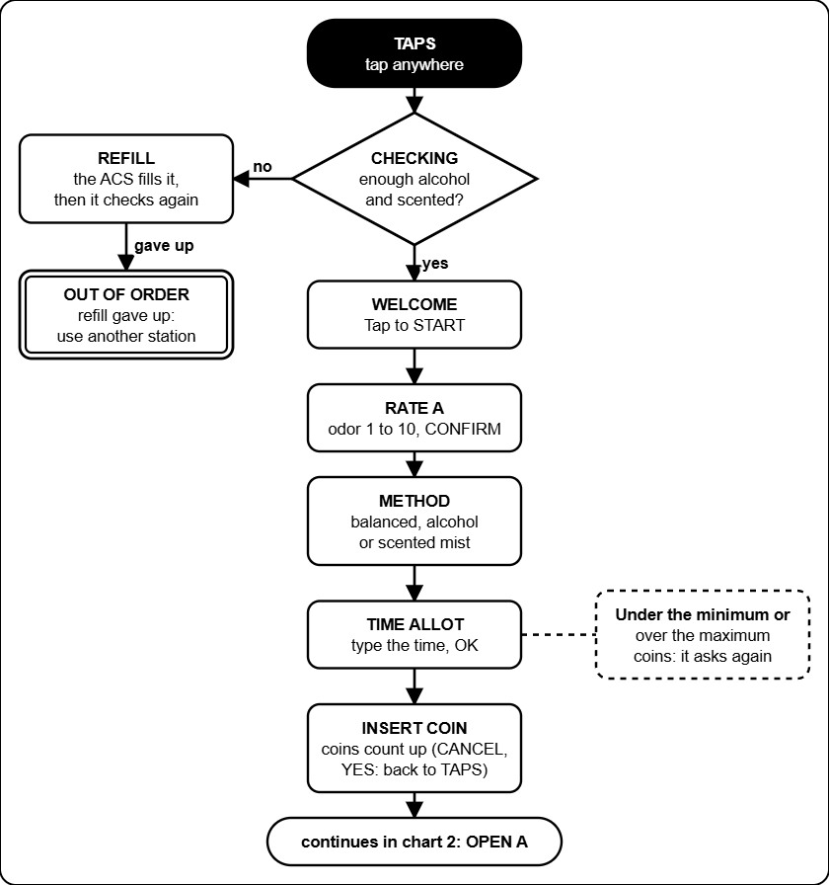
Box 1: from TAPS to INSERT COIN. Containers are checked first; the ACS refills them if they are low.

Box 1, chart 2: the run
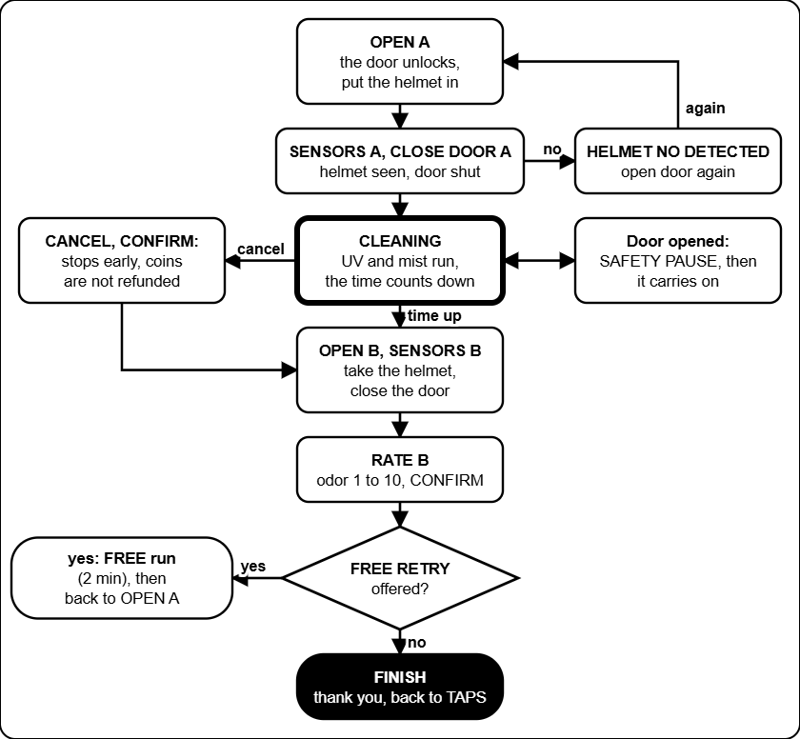
Box 1: cleaning, taking the helmet out, the second rating and the free retry.

Box 2, chart 3: paying
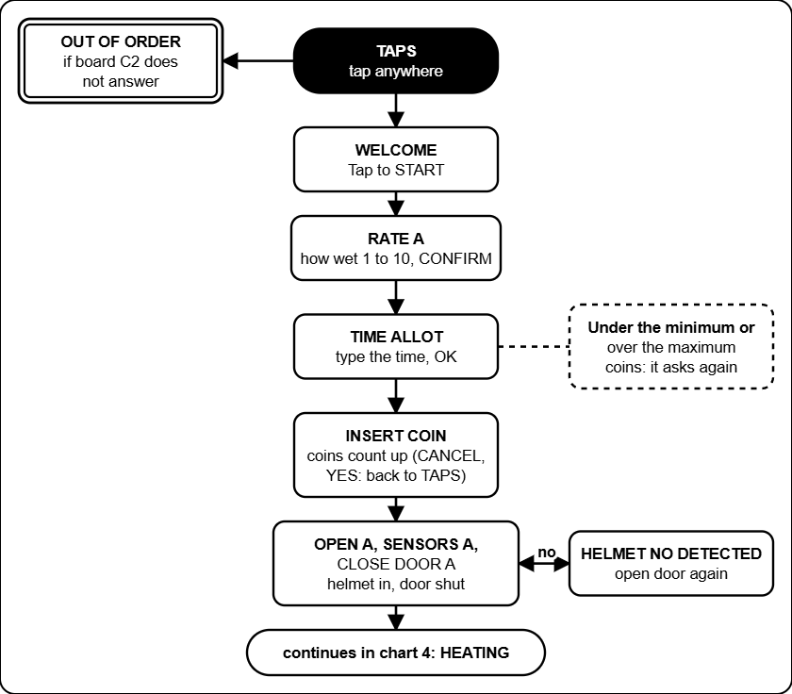
Box 2: from TAPS to the door. The box has no containers to check; it is out of order only if its terminal board stops answering.

Box 2, chart 4: the run
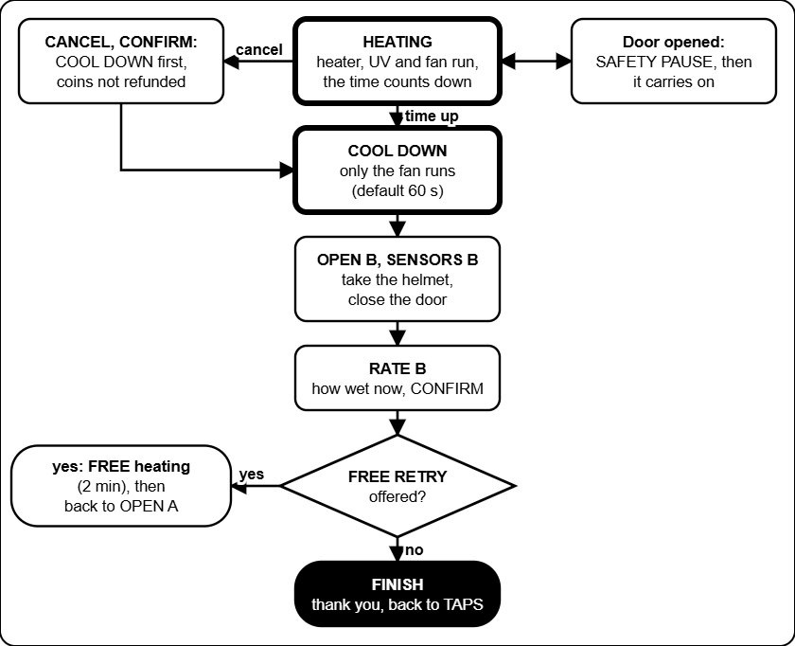
Box 2: heating, cool down with the fan, taking the helmet out and the free retry.

Box 3, chart 5: paying
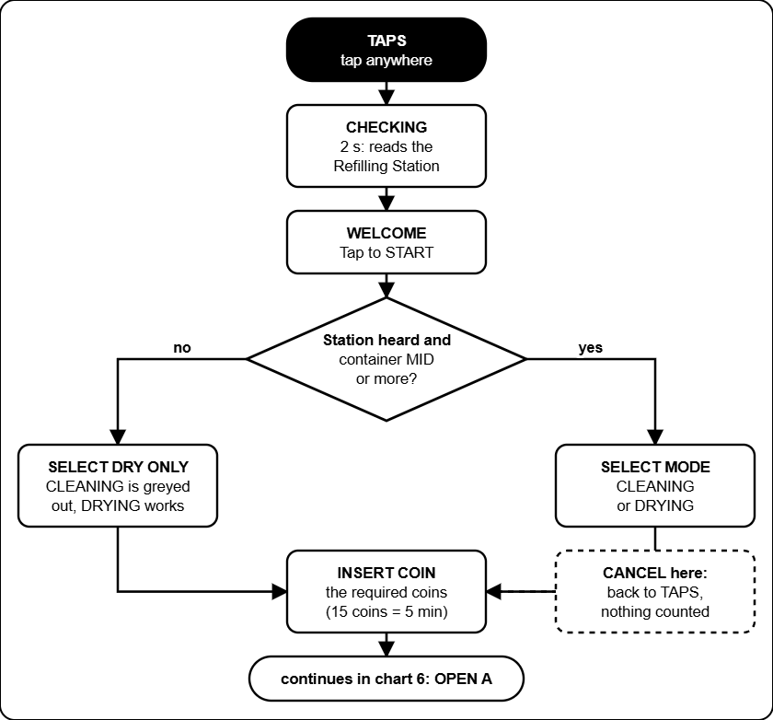
Box 3: CHECKING reads the Refilling Station, then SELECT MODE. With the station silent or the container EMPTY or LOW only DRYING is offered (SELECT DRY ONLY). The customer pays the required coins.

Box 3, chart 6: the run
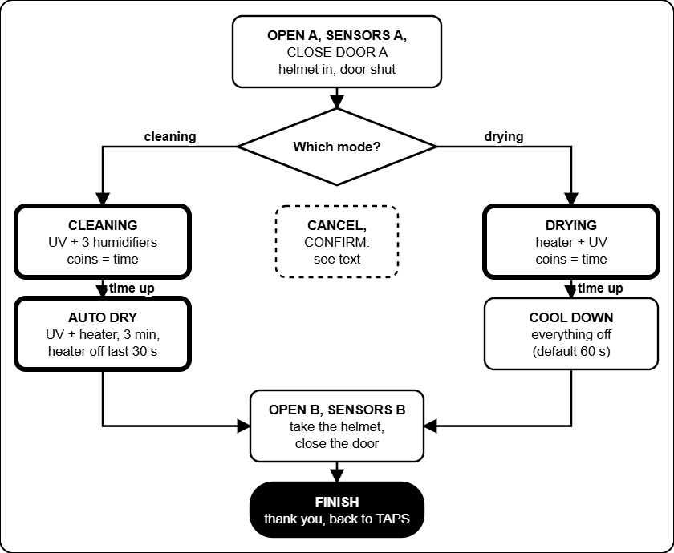
Box 3: cleaning (UV-C and mist) then AUTO DRY, or drying (heater and UV-C) then COOL DOWN, then OPEN B and FINISH. CANCEL during a cleaning goes to AUTO DRY, during a drying to COOL DOWN. More coins can be added while it runs.

Troubleshooting decision trees
Start at the black box at the top. Answer each question (the diamonds) with yes or no and follow the arrow. Boxes with a thick border tell you what to do. These trees cover the problems that happen most; the tables in the Admin and Technician guides have the rest.

Symptom | Tree
The screen says OUT OF ORDER | 1. A box shows OUT OF ORDER
A board is OFFLINE in the Devices list | 2. A board shows OFFLINE
A coin goes in and nothing counts | 3. Coin inserted, the count does not move
A helmet is trapped, a door will not open | 4. The door will not open
The Refilling Station does not fill | 5. A container stays EMPTY or LOW
The web page shows old data or no link | 6. The web page says OLD DATA or NO LINK
The touch screen is white, blank or wrong | 7. Screen white, blank or the touch is wrong

Tree 1: a box shows OUT OF ORDER
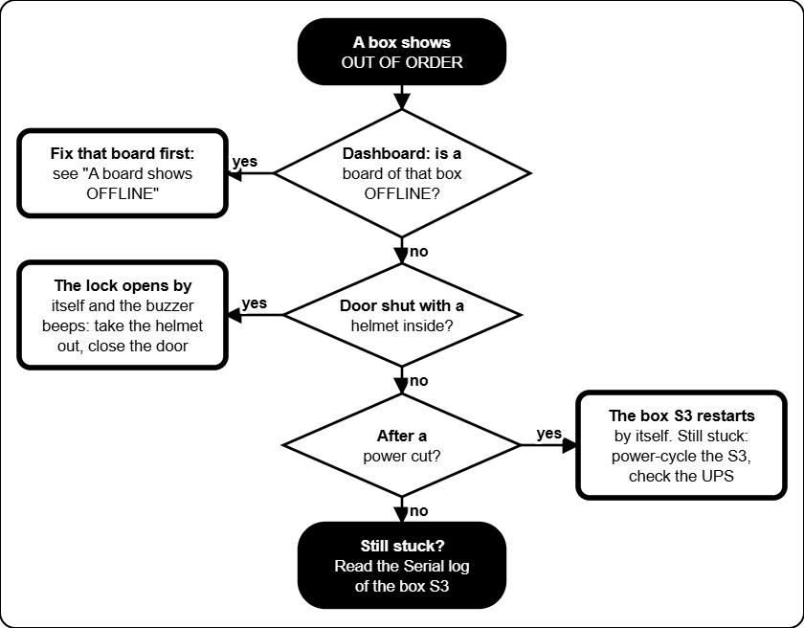
OUT OF ORDER means a board of that box is silent. A helmet that is shut inside is released by itself.

Tree 2: a board shows OFFLINE
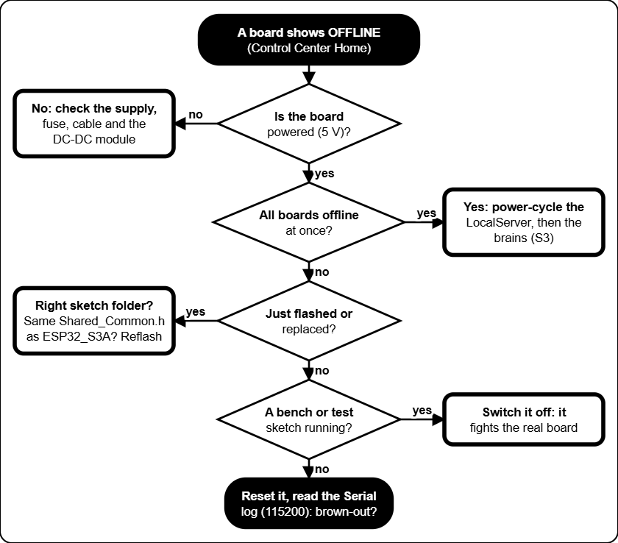
A board is OFFLINE when the LocalServer has heard nothing from it for a while.

Tree 3: coin inserted, nothing counts
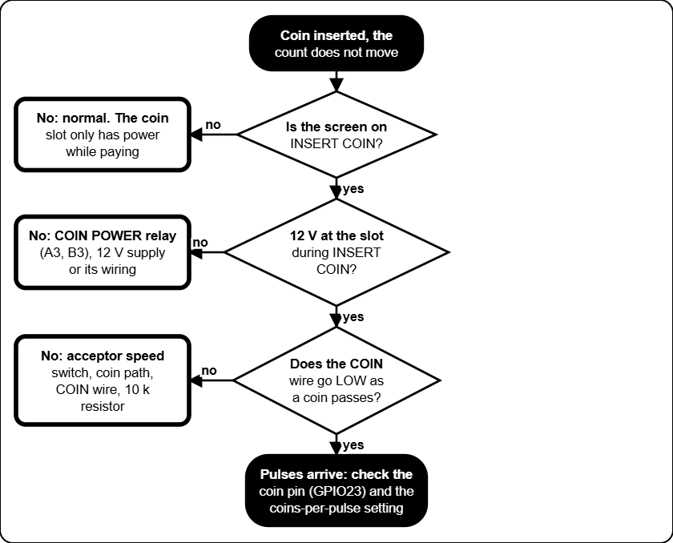
In Box 1 and Box 3 the coin slot has power only while the screen shows INSERT COIN.

Tree 4: the door will not open
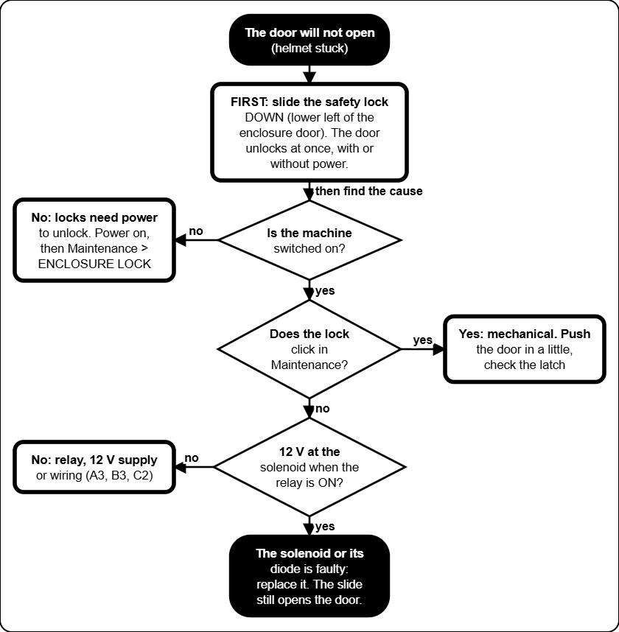
The locks are power-to-unlock: with no power a solenoid door stays shut, but the safety slide (lower left of the enclosure door) opens it by hand. Switch the mains off before reaching in.

Tree 5: the Refilling Station does not fill
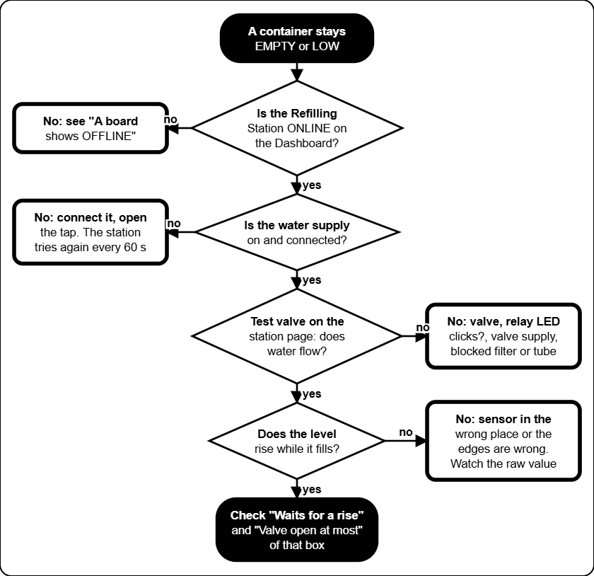
The Refilling Station reads "the level does not rise" as a failed refill: check the supply and the valve.

Tree 6: the web page shows old data
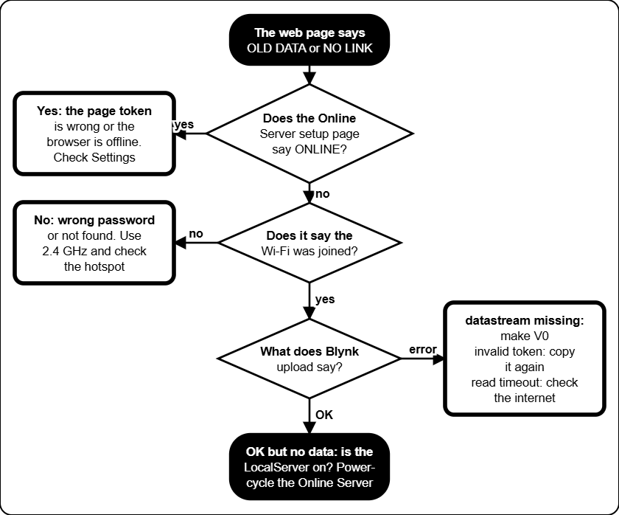
The web page is read only. It shows what the Online Server last sent to Blynk.

Tree 7: the touch screen is white or wrong
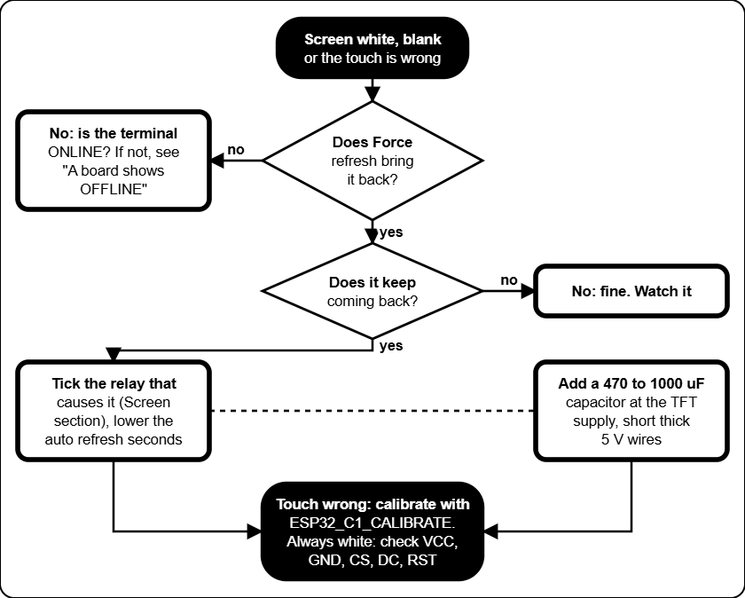
A white screen is almost always a supply dip when a heavy load switches. Force refresh re-initialises the screen.

Settings reference
Every setting you can change, with the value the firmware starts with and the range it accepts (a value outside the range is refused). Write the value you use in the last column. The firmware defaults are what a freshly flashed board starts with; the machine you are looking at may have been changed. Settings are saved inside the boards, so they survive a power cut and a LocalServer swap. Where to change them: Control Center, the box page (or /acs).

Prices and time (Box 1, Box 2 and Box 3)

Setting | What it does | Default | Allowed | Yours
Rating bands (4) | From and to rating, and the minutes suggested for that rating. | Box 1: 1-5 = 5, 6-7 = 10, 8-9 = 15, 10 = 20 min. Box 2: 1-3 = 3, 4-6 = 5, 7-8 = 8, 9-10 = 10 min. Box 3 has none. | Rating 1-10 (from not above to), 1-120 min
Minimum time | Shortest session the customer can buy. | Box 1: 5 min. Box 2: 3 min. Box 3: the required coins (one coin rate step) | 1-120 min
Coin rate | N coins buy X minutes (or seconds). | Box 1, 3: 15 coins = 5 min (20 s a coin). Box 2: 10 coins = 3 min (18 s a coin) | 1-500 coins, 0.1-9999 time
Most coins | Largest number of coins one session can take. | Box 1, 3: 90. Box 2: 100 | 1-999
Free retry | One free run after the final rating. | On | On or off
Free retry from rating | Lowest final rating that gets the free retry (1 = everyone). | 1 | 1-10
Free retry length | How long the free run lasts. | 2 min | 1-60 min
Cool down (Box 2, Box 3) | How long the cool down lasts, also after a cancel. | 60 s | 5-900 s
Auto-dry (Box 3) | How long the auto-dry after every cleaning lasts (UV and the heater). | 180 s | 10-900 s
Heater off at the end (Box 3) | How long the heater is off at the end of the auto-dry. | 30 s | 0-900 s
Refilling Station offline after (Box 3) | The station counts as offline when it was not heard for this long: only DRYING is offered. | 15 s | 5-120 s

Containers and sensors (Box 1; helmet detect also Box 2 and Box 3)
The distances are what the ultrasonic sensor on the main container reads, from the sensor down to the liquid. A bigger number means emptier. The defaults are placeholders: measure your real containers.

Setting | What it does | Default | Allowed | Yours
Check levels | Refuse to run (OUT OF ORDER) when a container is low. | Off | On or off
Alcohol low | At or over this distance the alcohol container is LOW. | 20 cm | 0-400 cm
Alcohol full | At or under this distance it counts as refilled. | 8 cm | 0-400 cm
Scented low | Same for the scented container. | 20 cm | 0-400 cm
Scented full | Same for the scented container. | 8 cm | 0-400 cm
Helmet detect | The helmet counts as inside when its sensor reads under this. | Box 1, 3: 15 cm. Box 2: 30 cm | 1-200 cm
Water sensor WET (alcohol, scented) | Raw reading at which the sensor means wet. | 600 | 0-4095
Water sensor DRY (alcohol, scented) | Raw reading at which it means dry again (the gap stops flicker). | 400 | 0-4095
Reading goes up when wet | Direction of the water sensor. | Yes | Yes or no
Refill tries | Refill attempts before the box gives up. | 10 | 1-99
Refill interval | Seconds between tries. | 10 s | 1-250 s
Ask the ACS to refill | Off: only count the tries. On: really send the refill request. | Off | On or off

Check levels and Ask the ACS to refill are off when a board is flashed, so a box with uncalibrated sensors still serves customers. Measure the four distances, then switch both on.

Cleaning phases (Box 1; Box 3 has none)
A paid run is cut into a start part, a middle part (all that is left) and an end part. Each relay is on or off in each part. The lengths are in percent, seconds or minutes.

Setting | What it does | Default | Allowed | Yours
Phases in a paid run | Use the start, middle and end parts. | On | On or off
Phases in the free retry | Same, for the free run. | Box 1: off | On or off
Start part, end part | Length of the first and the last part. | 1 min each | 0-7200 (0-100 if percent)
Humidifiers (3) | Parts in which each mist maker runs. | Middle only | Any of start, middle, end
UV-C lamps (2) | Parts in which each lamp is on. | Start and end | Any of start, middle, end

Screen refresh (all boxes)

Setting | What it does | Default | Allowed | Yours
Refresh when a relay switches on or off | Which relay changes force a full re-initialisation of the touch screen (the white-screen cure). One tick per relay, for ON and for OFF. | Box 1, 2: when the enclosure lock turns off. Box 3: heater on; lock and heater off | Any relay
Auto refresh | Every N seconds the box re-sends the current page as a full re-init. Screens where the customer types or picks a rating are skipped. | 2 s | 0 (never) to 60 s

Refilling Station
The Refilling Station keeps the main container of every box topped up from one supply, one valve at a time. The first four numbers and the next five are set per box (the forms on the Refilling Station page); the manual test length is for all boxes. The numbers are raw sensor values (0 when dry, growing as the liquid rises).

Setting | What it does | Default | Allowed | Yours
Empty up to (per box) | At or under this raw value the container is EMPTY. | 0 | 0-4095
MID starts (per box) | Where MID starts. Above Empty up to and under this, the level is LOW. | 500 | 1-4095
HIGH starts (per box) | Where HIGH starts. | 1000 | 1-4095
MAX starts (per box) | Where MAX starts. The refill stops here. | 1200 | 1-4095
Waits for a rise when EMPTY | How long the level may stay flat while EMPTY before the refill FAILED. | 30 s | 1-600 s
Waits for a rise when LOW | The same while LOW. | 5 s | 1-600 s
Valve open at most | Longest time one valve may stay open. | 180 s | 10-1800 s
Tries again after | Pause before a failed box tries again (for ever). | 60 s | 5-3600 s
Counts as rising | Smallest step in the raw value that counts as a rise. | 10 | 1-500
Manual test length | How long Test valve opens a valve. | 2 s | 1-30 s

LocalServer and Online Server

Setting | What it does | Default | Allowed | Yours
Control Center Wi-Fi | Name and password of the LocalServer Wi-Fi. Open 192.168.4.1. | JollyHelmet-Local, 12345678 | Set in the firmware
Coin value | Pesos one coin pulse adds to the revenue. | 1.00 | Any positive number
Online Server setup Wi-Fi | Wi-Fi to open the setup page on. | JollyHelmet-Online, 12345678 | Set in the firmware
Send to Blynk every | How often the Online Server uploads. | 1 minute | 30 s, 1, 2 or 5 min
Time zone | Hours from UTC, for the daily revenue. | As set in the portal | -12 to 14
Extra datastreams, events, skip TLS check | V1 to V4, the alert event, and the certificate check. | Off, off, off | On or off
Blynk server | Server name. | blynk.cloud | Text
Public status device token | Token of a second Blynk device for the customer page (status.html). Type - to remove it. | Empty (not used) | A token
Reset statistics | Button in More settings: starts the per-box, busiest-hours and busiest-days counts again from zero. | - | Button
Bypass Safety 2 Seconds Relay | Box page, Maintenance. When ticked, relays you switch on by hand stay on until you switch them off. The heater still stops after 5 minutes and the enclosure lock rests after 60 seconds. | Off (relays go off after 2 s) | Tick or untick
OPEN A / OPEN B beep | Box page. Length of the beep and the wait between beeps while OPEN A or OPEN B waits for the door. Kept in the box. | 100 ms beep, 500 ms wait | Beep 20 to 1000 ms, wait 0 to 10000 ms (0 = one beep)
Date and time (clock) | Settings tab. Set by a phone when the Control Center is opened after a power-on, or typed by hand. A power cut loses it. | Phone's time | Any date and time
Restore from backup CSV | Settings tab. Puts back the sessions of an unchanged Download log (CSV) file. The totals are raised to at least the log's tally. | - | A CSV exactly as downloaded
Previous data (history.json) | Settings tab. Customers from before the log existed, drawn lighter in the chart and counted in the Finished and cancelled card. Never a name. | None | Up to 1000 rows, 64 KB
ENTRY board Wi-Fi | The form board for the previous data. Opens by itself, or go to 192.168.5.1. It joins JollyHelmet-Local only to push the file. | JollyHelmet-Entry, 12345678 | Set in the firmware
Crash reports | Settings, This board. The last restarts kept on the board. Delete these reports clears them. | None | The last 3 are kept

Online web page (kept in each browser)

Setting | What it does | Default | Allowed | Yours
Refresh every (Settings window) | How often the page reads Blynk. | 10 s | 5, 10, 30, 60 s
Early warning for containers (Alerts tab) | The dial turns amber and a notice alert starts here. | 30 % | Off, 20-40 %
Play alert sounds, Volume | Master switch and loudness on this device. | On, 80 % | On or off, 0-100 %
Repeat a critical alert every | An unacknowledged critical alert sounds again. | 1 minute | Never, 30 s, 1, 2, 5 min
Sound of each alert | Which sound, or none, each kind of alert plays. | See Alerts and sounds | 9 sounds or silent
Chime when a warning clears | Plays when an alert goes away. | On | On or off
Browser notifications | A notification when the page is in the background. | Off | On or off
publicToken (js/config.js) | Token of the public status device for the customer page. | Empty (the QR address carries it) | A token
prices, contact (js/config.js) | Texts on the customer page. | The firmware prices | Any text

Fixed values (not settings)

Value | Where it comes from
Radio channel 1 | ESP-NOW and the Wi-Fi of the LocalServer must stay on channel 1.
15 s watchdog | No sign of the brain for 15 s: relays off, a trapped helmet is released.
60 s lock, 5 s rest | A lock never stays on longer than that.
5 min heater | Limit of a hand-set heater, in Maintenance.
One free retry | A session can have only one (Box 1 and Box 2).
Coin signal on GPIO 23 | On A1, B1 and C1.
Safety slide | Mechanical, lower left of the enclosure door. Not a setting: it always works.
Box 3 helmet release | OUT OF ORDER with a helmet shut inside: lock released after 2 s, buzzer 100 ms on / 500 ms off, at most 180 s (S3B) or three 60 s windows (B3). Restart check 10 to 18 s after boot.
One valve at a time | The Refilling Station never opens two valves. Valves are closed at power-up and open at most 180 s.
Sensor health | A water-level sensor at 4090 raw or more (3.3 V rail), or jumping by more than 1500 raw within a second while its valve is closed, for 5 s = SENSOR FAULT; it clears after 10 s of normal readings. Not a setting.

Circuit schematics
The wiring of the machines was drawn in Cirkit Designer. The pictures below are exports of that drawing. Where a picture is missing a dashed box shows the file name to use: save the export in MANUAL\images\cirkit under that name, then rebuild the manual (see the README). The drawings in the Technician guide (power, relay stage, locks, coin slot, Online Server) are a simplified view of the same wiring.

Picture | Shows | File name
Whole installation | All boards and how they are powered | cirkit_overview
Box 1 | A1, A2, A3, S3A | cirkit_box1
Box 2 | C1, C2, S3C | cirkit_box2
Box 3 | B1, B2, B3, S3B | cirkit_box3
Refill station | Refilling Station: sensors, valves and relay module (drawn for this manual) | (drawn for this manual)

The Cirkit drawing was checked against what was really built. Where the two differ, the pinout tables in the Technician guide are right (they come from the flashed firmware). Relay input numbers (IN1 ...) come from the drawing.

Whole installation

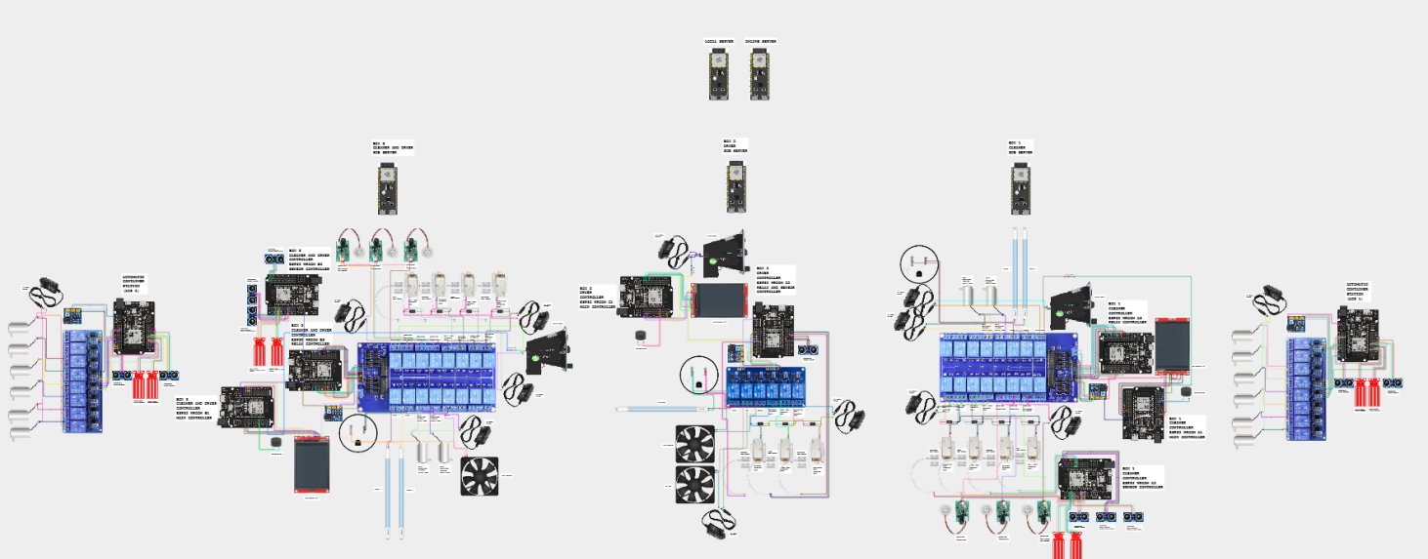
Cirkit Designer picture goes here
Delete this text and use Insert, Pictures. (For the PDF the picture is saved as images\cirkit\cirkit_overview.png.)
Whole installation (Cirkit Designer)

Box 1: A1, A2, A3

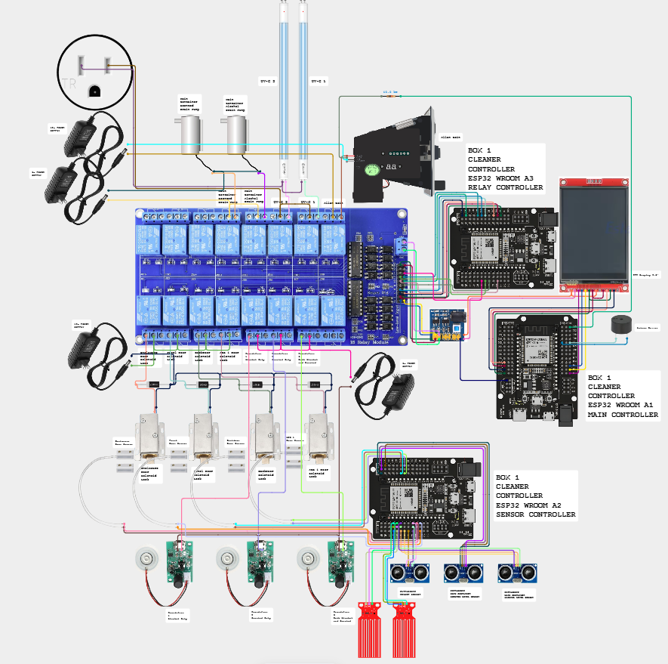

Box 1 (Cirkit Designer)

Box 2: C1, C2

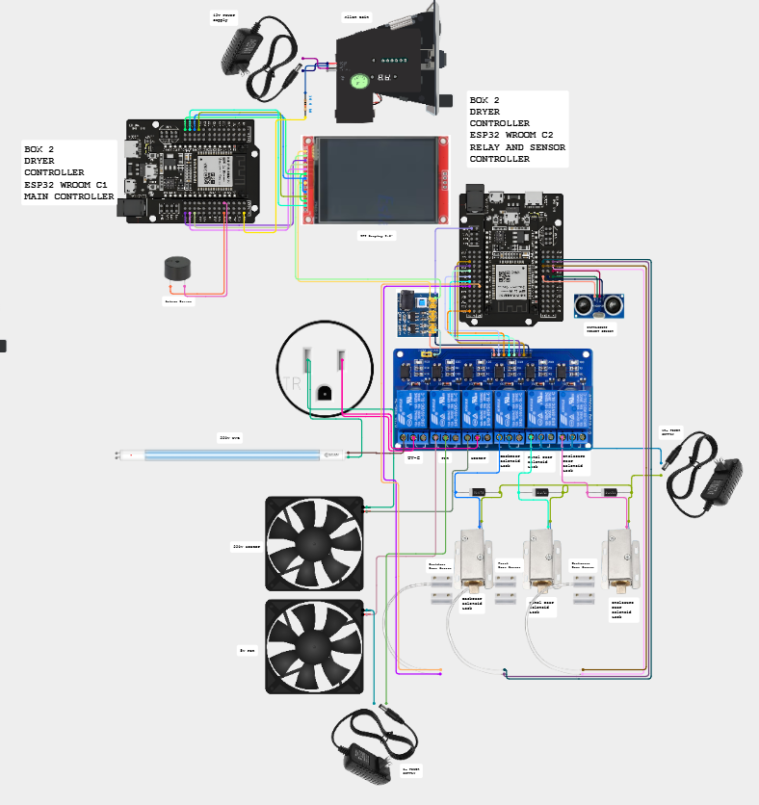

Box 2 (Cirkit Designer)

Box 3: B1, B2, B3

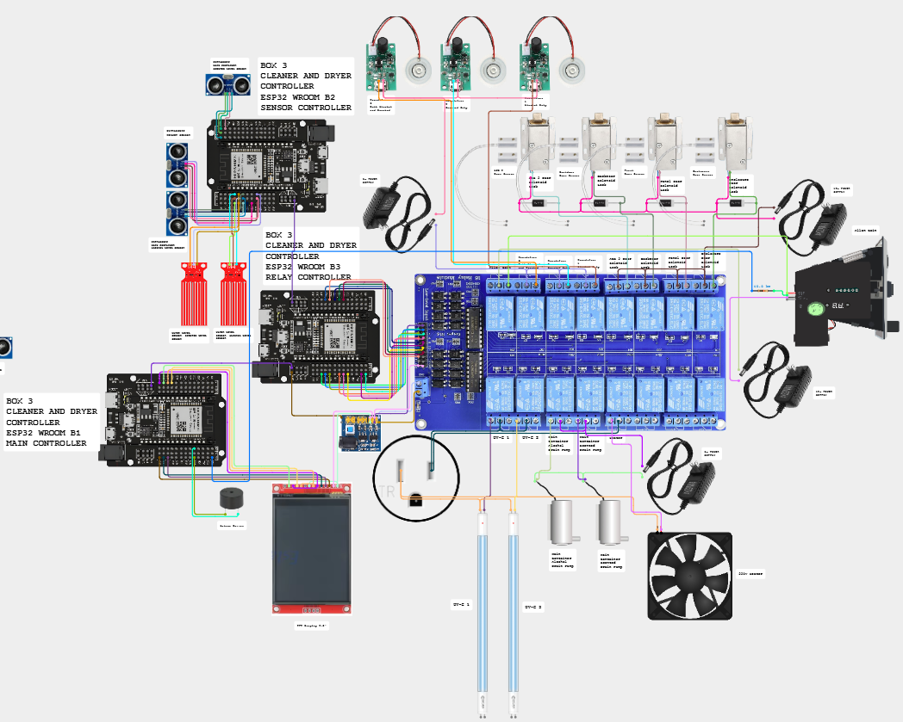

Box 3 (Cirkit Designer)

Refilling Station
The wiring of the Refilling Station was drawn for this manual from ESP32_REFILL.ino and the pin sheet; there is no Cirkit Designer export of it.
Refilling Station: sensors, relay module and valves

Policies
What the machine does is fixed by the firmware. The rules around it are the owner's decisions. Items marked confirm are proposals: edit them to match what the owner decides, then post the customer rules at the machine.

Coins and refunds

Situation | What the machine does | Policy
Customer cancels a run | Asks CONFIRM or RESUME and warns that coins will not be refunded. The coins are not refunded. | No refund after a run starts.
Customer cancels while inserting coins | Asks YES or NO and warns that coins will not be refunded. The machine does not return coins already inserted. | No refund after inserting the coin
Fault or power cut during a run | The run stops. Box 3 releases a trapped helmet and beeps. The machine does not return coins, and a session cut by the power is not restored. | A power cut is outside the owner's control: no refund by default. Staff may still decide to help (confirm).
Machine OUT OF ORDER | It does not take coins. | A sign: use another machine.
Free retry | One free run after the final rating (default 2 minutes, for everyone). Not repeatable. | Set who gets it in Settings (lowest final rating).
Too few or too many coins | The time allot screen asks again. The most that can be bought is 90 coins in Box 1 and Box 3, 100 in Box 2. | Posted on the machine.
No change is given | The slot takes coins only. | Say so on the sign.

Using the machine
- Motorcycle helmets only. Take out gloves, phones, cameras and speakers first.
- Children use the machine with an adult.
- Never block, tape or remove the safety slide of the enclosure door. It is how a trapped helmet is freed when the lock or the power fails.
- The owner is not responsible for items left inside or for damage that comes from a helmet's own condition. Nothing is stored in the machine after a run.
- The machine cleans and dries. It does not guarantee that every smell or every drop of water is gone.
- In Box 1 and Box 2 rating the helmet before and after is part of the run (Box 3 has no rating). The ratings are kept only as numbers.

Data and privacy
- The machines have no camera and no microphone. They record only counts: sessions, coins, minutes, ratings and the state of each board.
- The machines and the LocalServer store no names, no phone numbers and no payment cards. Payment is coins only. The one exception is the optional nickname a customer can type on the customer status page: it is public to everybody who opens the page, it lives only in the public Blynk device while the cycle runs, and it clears when the cycle ends.
- The backup log (CSV) and the previous-data file (history.json) hold only dates, times, boxes, coins, minutes and Finished or Cancelled. Keep them like any other record of the business. The CSV ends with a check line, so a copy that was edited is refused by the LocalServer.
- The Online Server sends only totals and status to Blynk. The Blynk token is a secret: keep it out of the manual, the web page and any file that is shared.
- The customer status page shows only whether each machine is free, in use or out of order. The public Blynk device behind it holds nothing else.
- The Control Center and the setup Wi-Fi use a password printed in this manual. Change both before the machines are used in public, and give the admin and technician parts of this manual only to the team.

Staff and safety
- Only trained staff refill the containers, open the panels or use Maintenance.
- Mains work is for a qualified electrician (see Safety and emergencies).
- Run the weekly and monthly checks in the Maintenance chapter and write the date down.
- Alcohol and scented liquid: keep the supplier's safety data sheet near the machines. Decide where the drain water may go.

Operating hours and notices

Item | Decision
Operating hours | 9:00 AM – 5:00 PM
Where to report a fault or a lost item | MEJEZ STUDIO || 0975 791 5832
Price list posted at the machine | Prices and time chapter, or the printable panel cards.

Glossary
Words used in this manual, in plain language.

Term | Meaning
2-second safety | In Maintenance a relay you switch on by hand switches itself off after 2 seconds, done by the box itself. Drain pumps and coin power are exempt. See Bypass Safety 2 Seconds Relay.
Acknowledge | The button on the online page that stops a repeating alarm. A new alert still sounds.
ACS | Auto Container System. The two refill boards used before 2026-11-03; the Refilling Station replaced them.
Alert sound | The beep pattern of one kind of alert (siren, alarm, three beeps, two tones, chime...). Each can be changed in the Alerts tab.
Allan coin acceptor | The coin slot. It sends one pulse for each coin value it accepts.
Auto dry | The drying that ends every Box 3 cleaning: UV light and the heater for 3 minutes by default, the heater off for the last 30 seconds.
Backup log (CSV) | The file that Download log (CSV) gives you: every session the machines recorded, with date, time, box, coins and minutes. Keep copies: Restore from backup CSV reads it.
Blynk | The online service the Online Server sends its snapshot to. The web page reads it from there.
Brain | The ESP32-S3 board of a box (S3A, S3B, S3C). It runs every step and keeps the settings. A box has one brain and several terminals.
Bypass Safety 2 Seconds Relay | The Maintenance tick box that turns the 2-second safety off, so hand-set relays stay on until you switch them off.
Captive portal | The page that opens by itself when a phone joins the setup Wi-Fi of the Online Server.
Channel 1 | The radio channel all the boards use for ESP-NOW. The LocalServer Wi-Fi stays on it too.
CHECKING | The 2-second "Checking Main Container" screen after the first tap: Box 3 reads the Refilling Station.
Control Center | The pages of the LocalServer (Dashboard, Settings, Box 1, Box 2, Box 3, Refilling Station) where settings, calibration and Maintenance are done.
Cool down | The time after heating when nothing heats and the helmet can cool. Box 2 runs the fan; Box 3 lets everything rest.
Crash report | A note the LocalServer keeps in its own flash after a restart it did not plan (the last three are kept). Read it in Settings, This board, and send a screenshot to the developer.
Customer status page | status.html: the public page that shows which machine is free, in use or out of order.
Dashboard | The first tab of the Control Center (called Home in older pages): the three boxes, the Refilling Station, the statistics and the Devices line.
Datastream | A named value in Blynk. This project uses V0 (a text) and, if you switch them on, V1 to V4.
Day viewer | The card that opens when you tap a bar of the Daily chart or pick a date: the customers of that day, with a Machine tab and a JSON tab.
DC-DC module | The power module that turns 12 V into 5 V and 3.3 V for the boards, sensors and small loads.
Devices line | The line on the Dashboard that says how many boards answer (for example 12 of 12 online). Tap it for the badge of every board.
Early warning | The level (30 % by default) where a container dial turns amber and a notice appears, before the box runs out.
Enclosure lock | The solenoid lock of the main door of a box. It is the one released for a trapped helmet.
ENTRY board | The spare ESP32 with a form (Wi-Fi JollyHelmet-Entry, address 192.168.5.1) for typing the previous customers and sending them to the LocalServer.
ESP-NOW | The radio link the boards talk over. No router is needed.
ESP32 and ESP32-S3 | The two kinds of board. The plain ESP32 boards are terminals. The S3 boards are brains and servers.
Free retry | One free run after the final rating (2 minutes by default).
GPIO | A numbered pin of an ESP32 board.
history.json (previous data) | The file of customers the team collected from its own records before the log existed. The chart draws it lighter and the Finished and cancelled card counts it, but it never changes the machine log, the totals or the CSV.
Humidifier | The ultrasonic mist maker that makes the alcohol and scented mist (5 V).
Hysteresis | The gap between the WET and the DRY reading of a water sensor, so it does not flicker.
Integrity line | The last line of the backup CSV. It lets the LocalServer refuse a file that was edited or saved again. It protects against mistakes; it is not a lock.
JD-VCC | The separate power input of a relay module's coils, with a jumper to the logic supply.
Level (EMPTY, LOW, MID, HIGH, MAX) | How full a main container is, worked out by the Refilling Station from its water-level sensor and the four edges set for that box.
Level dial | The half-circle gauge of a container on the Monitor tab. Red = EMPTY or LOW, green = MAX.
LocalServer | The board that makes the JollyHelmet-Local Wi-Fi and the Control Center, and counts the revenue.
Main controller | The plain name of a box's brain (S3A, S3B, S3C).
Maintenance mode | A page where a technician switches relays or pumps by hand. The machine shows MAINTENANCE. Hand-set relays go off after 2 seconds unless the safety is bypassed.
Mist | The alcohol or scented vapour used in cleaning. Mist method: balanced, more alcohol, more scented.
Navigation bar | The row at the top of every Control Center page: Dashboard, Settings, Box 1, Box 2, Box 3, Refilling Station.
Nickname | The optional name of up to 12 characters a customer can type on the status page while the cycle runs. It is public and clears when the cycle ends.
NVS | The memory inside a board where settings are saved (they survive a power cut).
Online Server | The ESP32-S3 that listens to the machines and sends a snapshot to Blynk. It never controls anything.
OUT OF ORDER | The screen shown when a box cannot serve customers.
Phase | A part of a cleaning run: start, middle or end. Each relay is on or off per part.
Power-to-unlock | A lock that opens only while it has power. With no power the door stays locked.
Public status device | The second Blynk device whose token may be public. It holds only the step and time left of each box.
QR code | The square code on the sign at each machine. A phone camera opens the customer status page with it.
Queue | The containers waiting for the Refilling Station's valve: EMPTY first, then LOW, first come first served.
Rating | The 1 to 10 score the customer gives the helmet before and after: odor (Box 1) or dryness (Box 2). Box 3 has no rating.
Refilling Station | The one board with three water-level sensors and three valves that keeps the three main containers full. It replaced ACS 1 and ACS 2.
Relay | An electrically operated switch. The boards use relays to switch locks, pumps, mist makers, lamps and the heater.
Required coins | The number of coins INSERT COIN asks for in Box 3: one step of the coin rate (15 coins in the default).
SAFETY PAUSE | The screen shown when a door opens during a run. The loads switch off until the door is closed.
Safety slide | The mechanical slide at the lower left of the enclosure door. Slide it down and the door unlocks by hand, with no power and no help from the boards.
SELECT DRY ONLY | The Box 3 mode screen with CLEANING greyed out: the liquid is low or the Refilling Station is not answering.
SENSOR FAULT | What the Refilling Station reports for a container whose water-level sensor reads on the 3.3 V rail or jumps about wildly. The box offers drying only until the reading is normal for 10 seconds.
Serial Monitor | The Arduino IDE window that shows what a board prints over USB (115200 baud).
SoftAP | A Wi-Fi network made by a board itself (JollyHelmet-Local, JollyHelmet-Online).
Terminal | A plain ESP32 board that holds a box's sensors, relays and display. It follows its brain.
TFT | The 2.8 inch colour touch screen of a box.
Time allot | The screen where the customer types the minutes to buy.
Token | The secret key that lets the Online Server write to your Blynk template. Keep it private.
Ultrasonic sensor | The HC-SR04. It measures the distance to the helmet or to the liquid in a container.
UPS | A battery backup. In Box 3 it keeps the screen, sensor and relay boards alive during a power cut, so the helmet can be released.
UV-C lamp | The 220 V germicidal lamp. Never look at it when it is lit.
Valve | The normally closed solenoid valve that lets water into one main container when the Refilling Station opens it.
Watchdog | A safety check: if a board stops hearing its brain for 15 seconds it switches its loads off.

Version and revisions

Item | Value
Manual | Jolly Helmet User Manual, revision 10, 2026-11-04
Made by | MEJEZ STUDIO
Covers | Box 1, Box 2, Box 3, Refilling Station, LocalServer, Online Server
Protocol file | Shared_Common.h, identical in every sketch folder (checksum fb00a2ec)

Revision history

Rev | Date | What changed
1 | 2026-10-07 | First manual: customer guide and admin guide for Box 1, 2 and 3, prices, Control Center, ACS. PDF and Word, new logo, Arial.
2 | 2026-10-07 | Technician guide: components, pinouts, circuit and wiring, firmware and flashing, maintenance, hardware troubleshooting. Corrected from the Cirkit Designer document to what was really built.
3 | 2026-10-10 | Online Server, Blynk setup and the web page. Real parts: UV-C 220 V lamps, HC-SR04, 5 V mist makers and pumps, DC-DC module. Team names on the cover.
4 | 2026-10-10 | Reference section: safety and emergencies, box flowcharts, troubleshooting decision trees, settings reference, schematic pages, policies, glossary, this page and the index.
5 | 2026-10-11 | Online page: level dials with early warning, Alerts with a sound for every kind of alert, Reports (busiest hours and days, what each box earns), Checklist, Fix it, customer status page and QR sign, Manual tab with a team password. New Online Server firmware (per-box statistics, public status device).
6 | 2026-10-11 | The safety slide of the enclosure door (lower left, slide down to unlock by hand when the solenoid lock is broken or there is no power): customer guide, admin guide, technician guide, safety and emergencies, decision tree 4, settings reference, glossary and policies.
7 | 2026-10-11 | Box flowcharts and troubleshooting decision trees redrawn in black and white (no colours): thick border = the machine is running or "do this", double border = a fault, black box = start or end.
8 | 2026-10-16 | The LocalServer Wi-Fi is now called JollyHelmet-Local (it was ESP32_LOCAL; the password and the address 192.168.4.1 are unchanged). Updated in the join steps, the settings reference, the glossary and the index. Phones that saved the old name must join the new one; the spare ENTRY board must be flashed with the matching name.
9 | 2026-10-16 | One navigation bar and a Devices line instead of the menu button; the Dashboard, the day viewer (Machine and JSON tabs), the combined Finished and cancelled tally, the Settings tab with the backup restore, the previous-data label and the crash reports kept on the board. Maintenance 2-second safety with its bypass and the drain pump warning; the OPEN A / OPEN B beep settings. The ENTRY board (coins and minutes both ways, captive portal). C1 coin signal moved to GPIO 32. Optional customer names on the status page. Firmware dates and all Control Center screenshots renewed.
10 | 2026-11-04 | The Refilling Station (3 water-level sensors, 3 valves, one valve at a time) replaces ACS 1 and ACS 2: new chapter, wiring, pinout, settings, charts and decision tree 5. Box 3 runs the trimmed 36-step flow (CHECKING, SELECT MODE or SELECT DRY ONLY, required coins, auto-dry, cancel paths, no ratings): customer pictures, charts 5 and 6, prices, settings page. OUT OF ORDER never traps a helmet; UPS design; restart check; one helmet cut-off for S3B, B3 and B1. 14 boards, 12 devices on the Dashboard. The online page chapter no longer mentions the removed Checklist, Fix it and Manual tabs. Box 1 and Box 2 are unchanged (earlier program). Sensor check of the Refilling Station (SENSOR FAULT) added.

Firmware in this manual
The date is when the sketch file was last saved. The board in the machine may carry an older build: compare with what it prints when it starts (Serial Monitor, 115200).

Sketch folder | Board | Role | File date
ESP32_S3A | S3A | Box 1 brain | 2026-10-15
ESP32_A1 | A1 | Box 1 screen, coin, buzzer | 2026-10-13
ESP32_A2 | A2 | Box 1 sensors | 2026-10-13
ESP32_A3 | A3 | Box 1 relays | 2026-10-13
ESP32_S3C | S3C | Box 2 brain | 2026-10-15
ESP32_C1 | C1 | Box 2 screen, coin, buzzer | 2026-10-15
ESP32_C2 | C2 | Box 2 sensors and relays | 2026-10-13
ESP32_S3B | S3B | Box 3 brain | 2026-11-03
ESP32_B1 | B1 | Box 3 screen, coin, buzzer | 2026-11-03
ESP32_B2 | B2 | Box 3 sensors | 2026-11-03
ESP32_B3 | B3 | Box 3 relays | 2026-11-03
ESP32_REFILL | Refilling Station | Boxes 1 to 3 containers: sensors and valves | 2026-11-03
ESP32_LOCALSRV | LocalServer | Control Center, revenue | 2026-11-03
ESP32_ONLINESRV | Online Server | Blynk monitor | 2026-11-03
ESP32_ENTRY | ENTRY | Spare board: form for the previous data | 2026-10-16
ESP32_REFILL_FAKE | Test tool | Stand-in for the Refilling Station on a spare ESP32 (own Wi-Fi page) | 2026-11-03

Tools and libraries

Item | Version
Arduino IDE board package: esp32 by Espressif | 3.3.7
TFT_eSPI | 2.5.43
ArduinoJson | 7.4.3
ESP_Async_WebServer | 3.12.0
Async_TCP | 3.5.0
Blynk | Blynk Cloud HTTPS API (no library on the board)

Check before you hand over
- Refilling Station: measure the raw value of each sensor dry and in the liquid, set the four edges of every box, connect the supply, then test each valve by hand (Test valve) before the first automatic refill.
- Run every relay and every pump by hand in Maintenance before the first automatic run.
- Box 3: set Helmet counts as inside under (use live). Then unplug S3B with a helmet inside and the door shut: after about 15 seconds the lock must release and the screen board must beep. Plug S3B in again: about 12 seconds after it is back it must hand the helmet back (OPEN B).
- Calibrate the touch screen of B1 (it still has the A1 numbers) with ESP32_C1_CALIBRATE.
- Online Server: after its first upload, the Control Center must still hear every board (12 of 12). If it does not, check the radio channel.
- Online page: flash the Online Server firmware of 2026-10-10, create the public status Blynk device, print the QR sign for every machine, and run build_web_manual.ps1 after every change to this manual.

Index
Page numbers refer to this manual. In the Word file, right-click the index and choose Update field to refresh it after editing.
1N4007 diode
12 V power supply
220 V mains
A1 (Box 1 screen board)
A2 (Box 1 sensor board)
A3 (Box 1 relay board)
ACS 1 and ACS 2 (refill station)
Allan coin acceptor (coin slot)
Arduino IDE
B1 (Box 3 screen board)
B2 (Box 3 sensor board)
B3 (Box 3 relay board)
Blynk
Board settings (flashing)
Buzzer
C1 (Box 2 screen board)
C2 (Box 2 relay and sensor board)
Calibration
Captive portal
Cirkit Designer
Cleaning phases
Coin value and revenue
Control Center
Cool down
DC-DC module
Door lock (solenoid)
Door sensor (MC-38)
Drain pump
Emergency
ESP-NOW and channel 1
Fan
Flowcharts
Free retry
Fuse
Heater
Humidifier (mist maker)
Level checks (containers)
LocalServer
Maintenance mode
Mixer container
Online Server
OUT OF ORDER
Pinouts
Policies and refunds
Power cut (power-to-unlock)
Prices
Rating (odor and dryness)
Refill pump
Relay
S3A (Box 1 brain)
S3B (Box 3 brain)
S3C (Box 2 brain)
SAFETY PAUSE
Screen refresh (white screen)
Serial Monitor
Time allot
Token (Blynk)
Touch screen (TFT)
Trapped helmet
Ultrasonic sensor (HC-SR04)
UV-C lamp
V0 datastream
Watchdog (15 seconds)
Water-level sensor
Web page (monitor)
Wi-Fi JollyHelmet-Local

Thank you for using
Jolly Helmet
We hope to see you again!
Make your Helmet Happy Again.
MEJES, JERAHMEEL ALZEL M.
CRUZ, DEAN RYAN P.
MENDOZA, RICAH S.
MARTOS, KRISTINA E.
DEVELOPERS AND DESIGNERS
USER MANUAL

